Guidance for use of the Capita Professional Portal
Access the Capita Professional Portal Live environment at https://admissions.redcar-cleveland.gov.uk/ProfessionalPortal_LIVE/
You will now need to register on the Professional Portal using your professional/work email address.
The Professional Portal will be used by school staff e.g., SENDCOs and other professionals that support children and young people with an EHCP or who are going through an EHC Needs Assessment.

All users of the Professional Portal are required to self-register. These registrations will then be verified in the back office by the SEND Team, so SEND information/data from the back office can be shared via the portal with these professionals.
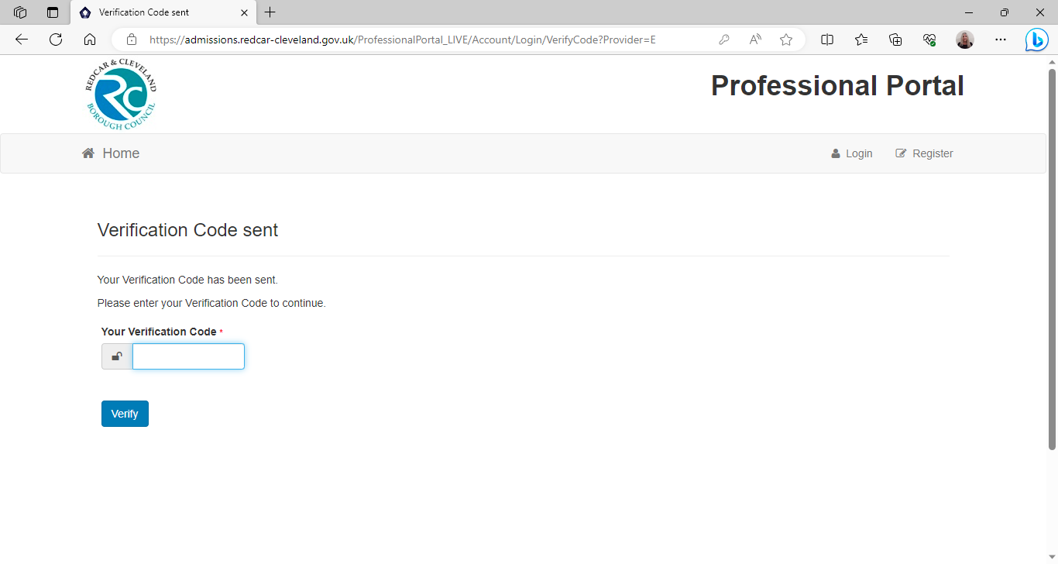
Please click to register and follow the instructions to complete registration. Once complete, enter your email address and the password that you have created. A verification email will be sent to you by your email address for security purposes. This will happen every time you log into the Portal.


You will then be taken to the Professional Portal Home Screen. There are two tiles only as this is currently only being used by SEND. You will need to use the messages tile to access any messages that are generated from the system, either to advise you that a Portal form has been submitted or to advise you of some action you need to take.
If you click on the SEND tile this will take you to the SEND Home area. This is likely to show no child, so, you will need to add details of the child or young person by clicking the ‘Add Person’ button.
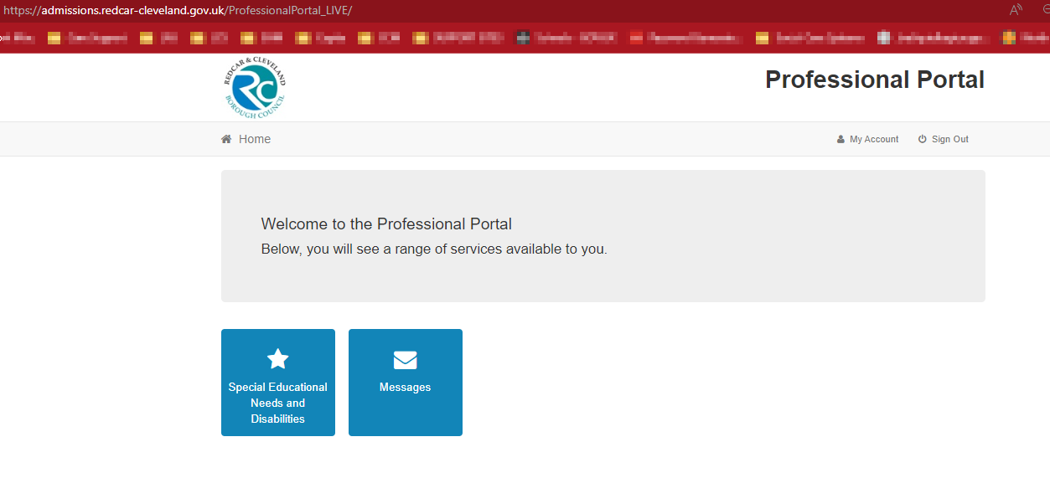
You can also complete the child’s details to create a record using ‘Add Person’. If there are a large number of records, you can use the ‘Person Filter’ search facility or drop down to select ‘Active’, ‘Hidden’ or ‘Recent 18 months. There is also a ‘Hide Person’ facility, if not currently working on these forms (see above).
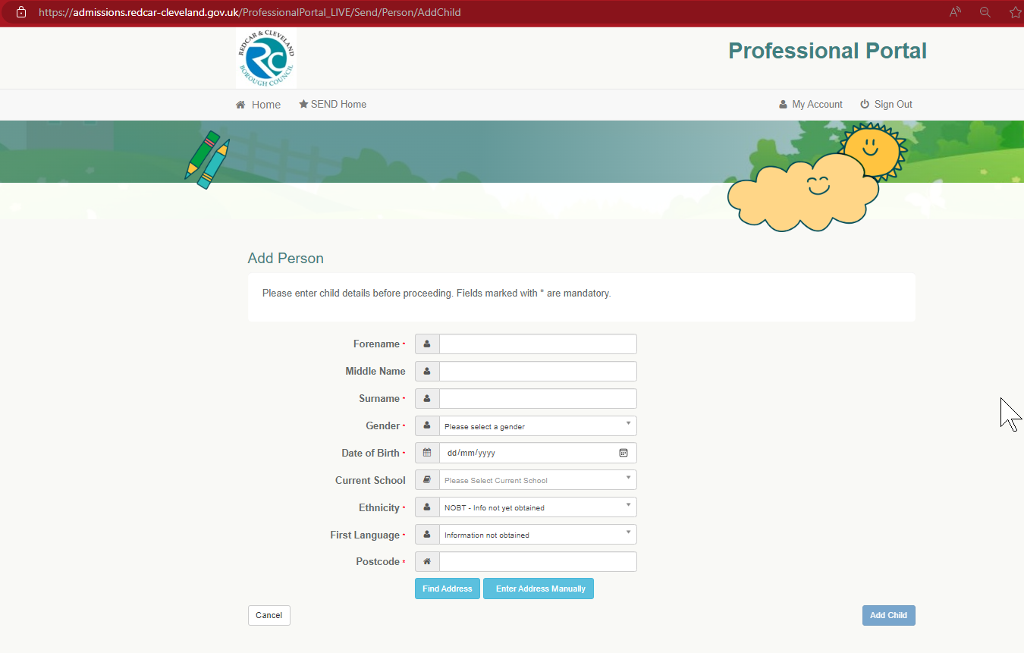
Select the child’s record you wish to complete a Portal form for by either clicking the hyperlink on the child’s name or by ticking the ‘Select’ box at the right-hand side (see above). This will ask you to verify the details of the child you have selected and then click the ‘Continue’ button at bottom right hand side.
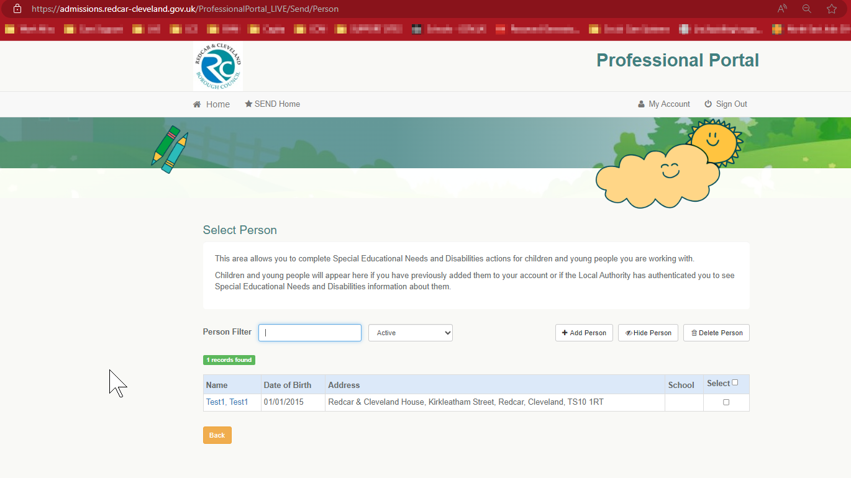
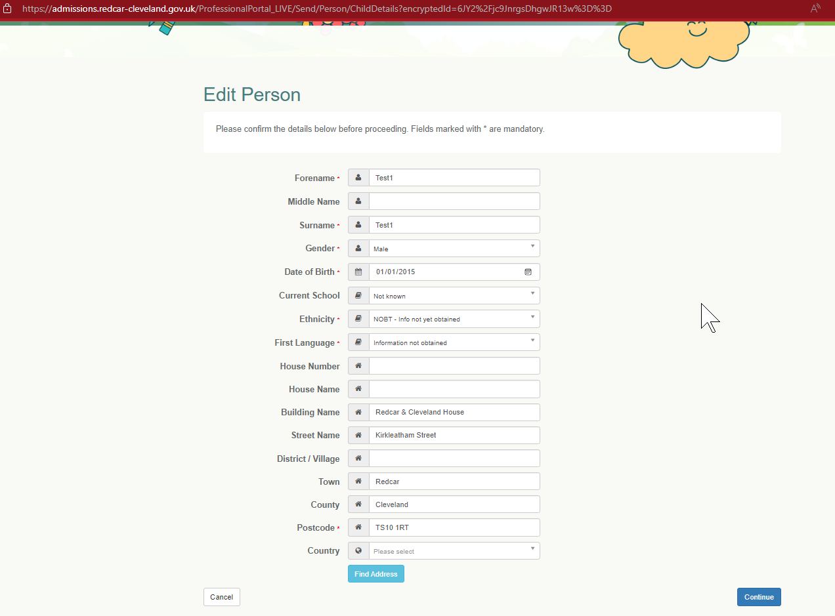
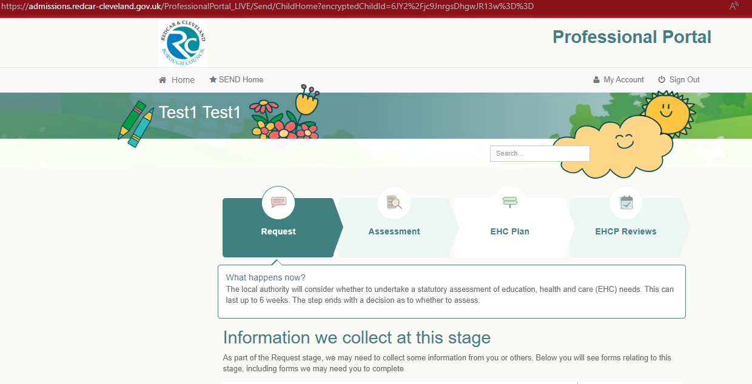
What next?
This will then take you to the SEND Home Screen (see below). The top of this screen shows you which stage of the process you are currently in depending on the highlighted area. Longer term, each of these sections will also be populated with key dates within each section that can be viewed by both professionals and families through both portals. For example, date request received, decision to assess due date etc.
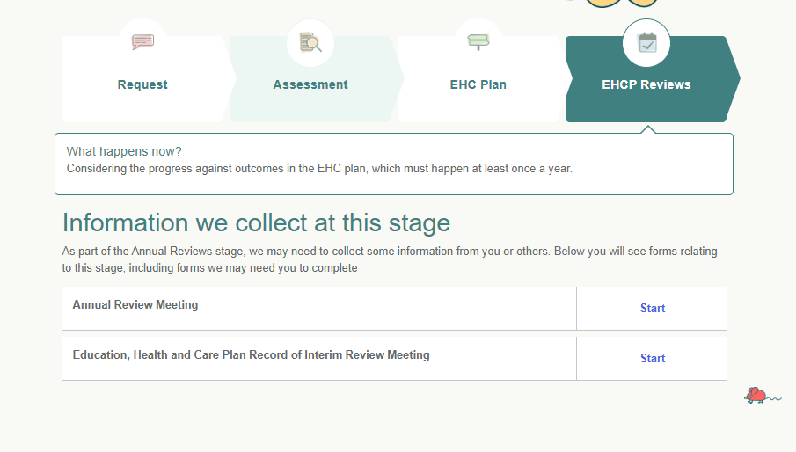
The bottom of this screen shows the forms that are available to you or that have been shared with you (see below).
It will first ask to confirm you details as the professional.
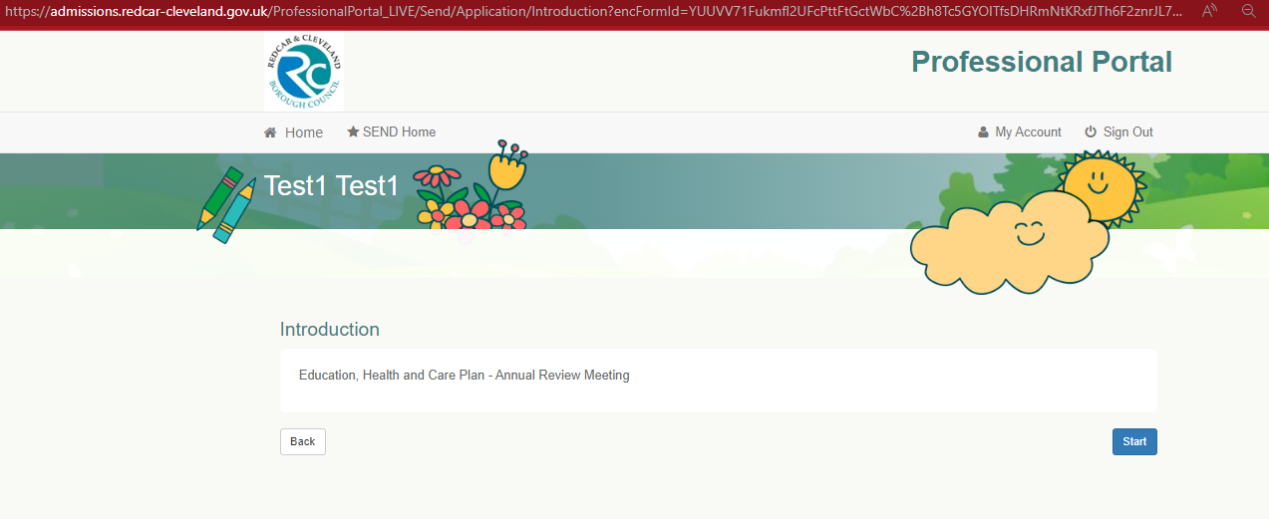
If you click ‘Start’ at right of form, it will take you into the introduction to the form.
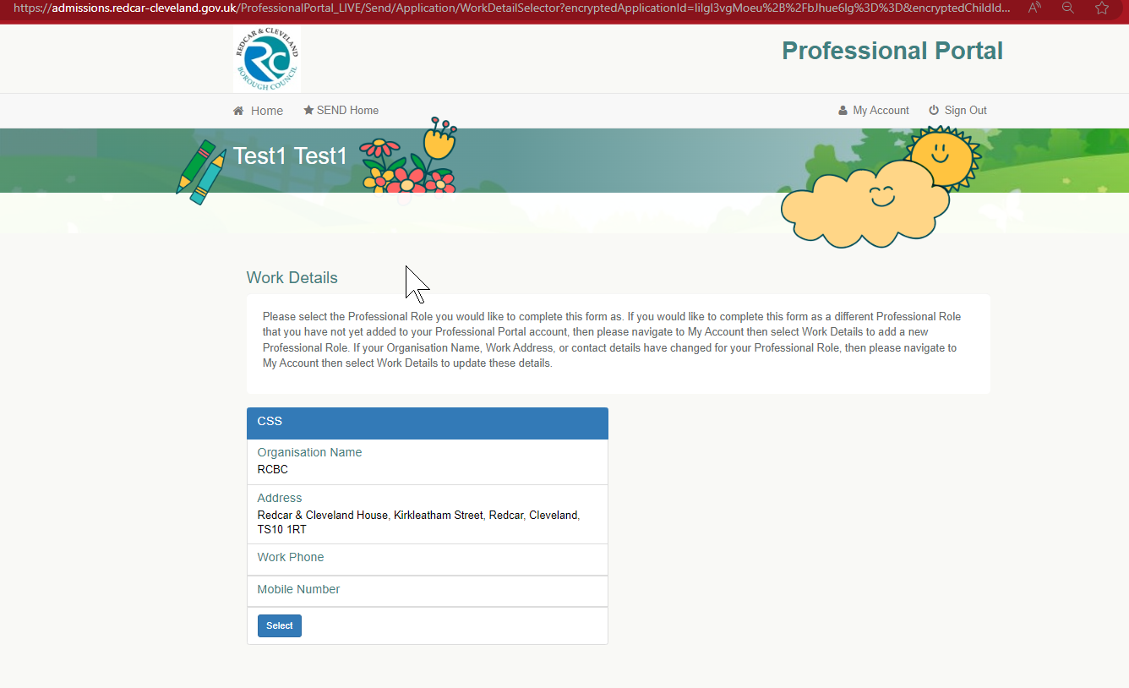
You will need to complete each step. As each step is saved this will turn green. This will mean that if you need to leave the form and complete later, you can return to any step that has already been completed and shows as green.

PLEASE NOTE: YOU WILL BE TIMED OUT AFTER 20 MINUTES, SO IF YOU NEED TO LEAVE THE FORM YOU WILL NEED TO ENSURE YOU HAVE COMPLETED THAT SECTION AND CLICKED SAVE AND CONTINUE TO ENABLE YOU TO RETURN TO THIS SECTION.
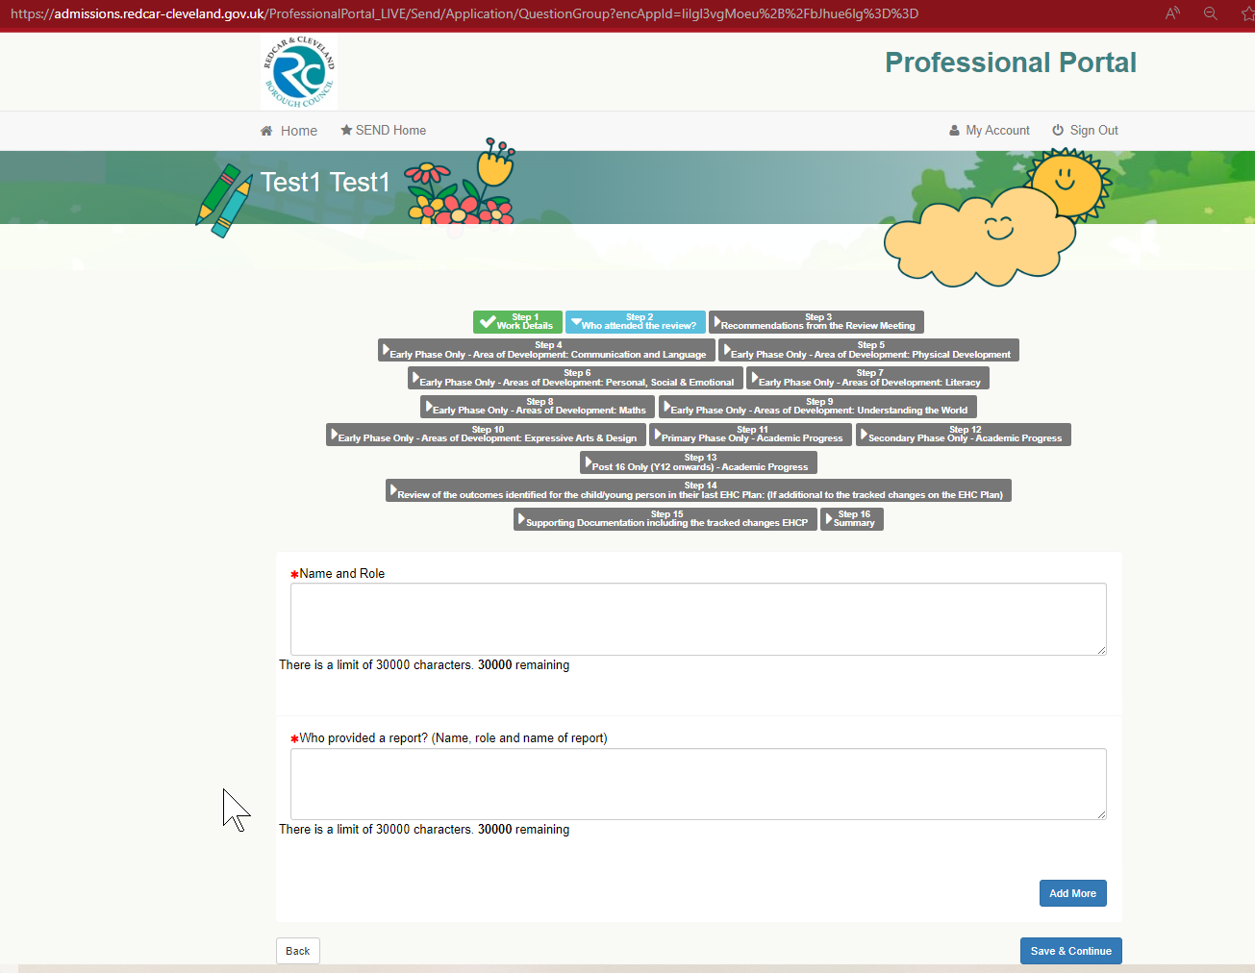
If you click ‘Start’ this will take you to the beginning of the form.
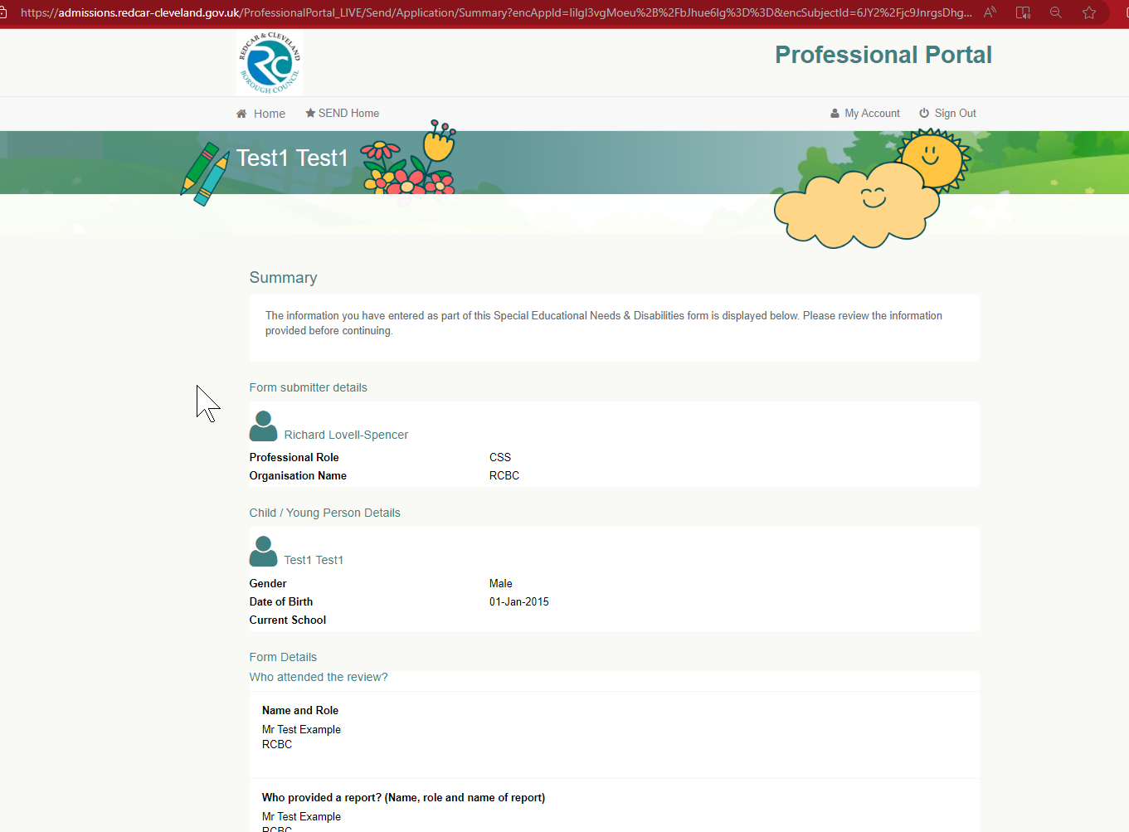
Once you are happy with the form you will need to tick both declarations and then press ‘Submit’ at bottom of the page.

If you wish to return to the form, you can do this from the SEND Home page by clicking ‘Edit’ and giving the reason for editing the document.

If you have any queries or questions, please do not hesitate to contact Ruth Atkinson on
ruth.atkinson@redcar-cleveland.gov.uk
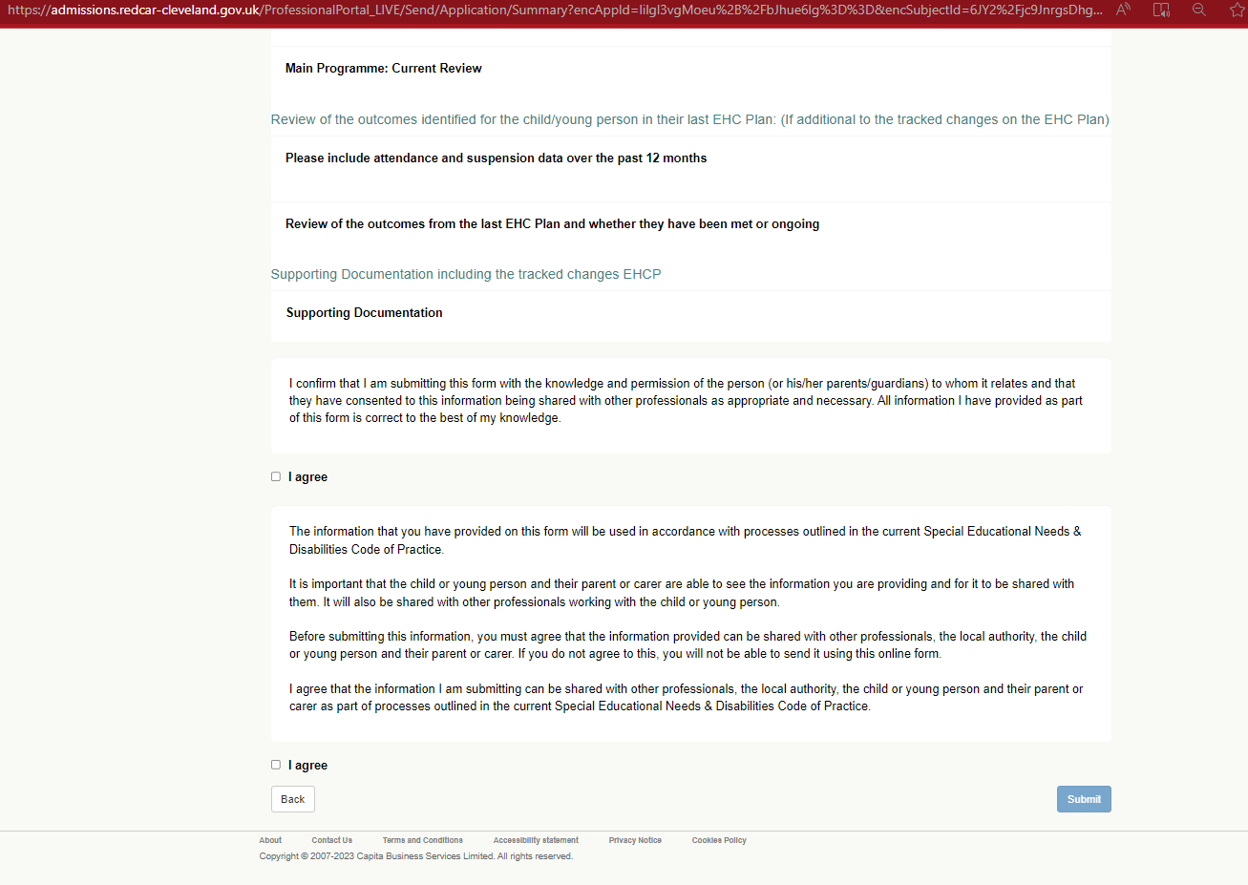
Before submitting the Portal form, you be given a summary to view the whole of your form, details, and any upload documents. This will allow you to return to a previous step if you feel you wish to edit.

