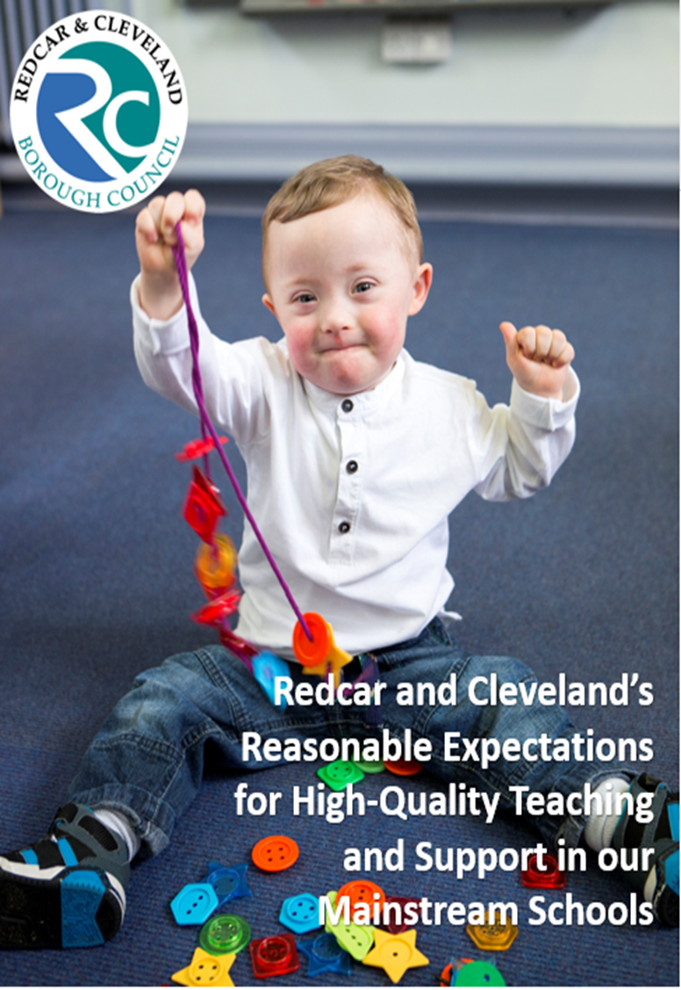

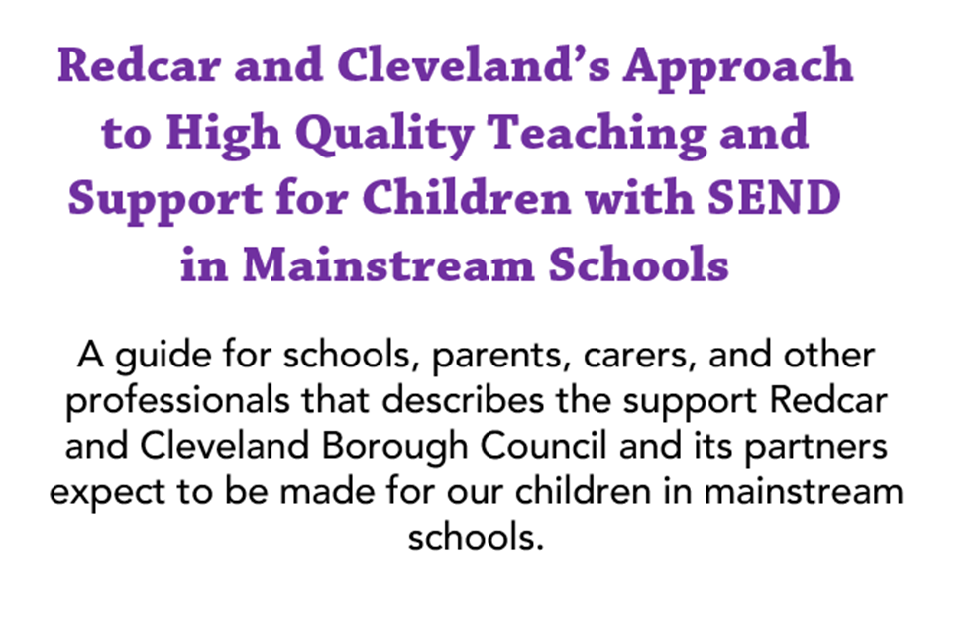


Table of Contents
Why this guidance has been produced 4
What is ordinarily available provision? 5
The meaning of special educational needs and disability 6
Identification of special educational needs and disabilities 7
Different types of educational needs: the 4 broad areas 9
High quality teaching and support– high expectations for all Redcar and Cleveland children 16
The graduated approach- a four step cycle of assess, plan, do, review 20
Assess 21
Plan 21
Do 22
Review 22
Funding for schools 23
Element 1 – Core budget 23
Element 2 – SEND support 23
Element 3 – High needs funding 24
Environment– physical and sensory 25
EQUIPMENT AND RESOURCES 27
Partnerships with parents and carers/voice of the child 29
Pastoral support 31
Staff training and expertise 33
Transitions and preparation for adulthood 35
Other useful resources 38
Local Authority Contact Information 39

Why this guidance has been produced

This guidance has been produced to support our schools in providing the best possible education that enables our children to live happy and fulfilled lives in an environment that meets their needs and promotes their independence.

The strategies and support set out in Sections 2 and 3 will contribute to realising our ambition to provide high quality education and support that enables children to achieve their very best.
It also helps to:

- support the vision of the 2022 Schools white paper and SEND review green paper to introduce and implement standards that will give every child a great education and the right support.

- promote a consistent approach by all our schools to meeting children’s needs.

- increase and encourage inclusive practice so that our children can attend local schools.

- give clarity to parents and carers about the support that should be provided for their child regardless of which school they attend.

- develop schools’ understanding of what special education provision we expect them to provide for our children from their notional SEN budget.

- meet the Department for Education’s requirement for Redcar and Cleveland Borough Council to set out what special educational provision it expects schools to make available (SEND Regulations 2014, Schedule 2). This is known as ‘ordinarily available provision’.

What is ordinarily available provision?

This is a term set out in Schedule 2 of the SEND regulations that refers to the range of activities offered for children that should be provided and delivered within the normal funding resources made available to schools from the local authority. These activities include:

- Identification of special educational needs and disabilities

- Approaches to teaching and learning

- Monitoring and evaluating progress through a cycle of assess, plan, do, review

- Staff training and expertise

- Pastoral support

- Pupil voice and involvement of parents and carers

- The environment and access to facilities/equipment

- Transitions and Preparation for Adulthood

The meaning of special educational needs and disability

The SEND Code of Practice, January 2015, Page 15 sets out the meaning for

SPECIAL EDUCATIONAL NEEDS (SEN) as:
A child or young person has SEN if they have a learning difficulty or disability which calls for special educational provision to be made for them.
A child of compulsory school age or a young person has a learning difficulty or disability if they:
- have a significantly greater difficulty in learning than the majority of others of the same age, or
- have a disability which prevents or hinders them from making use of facilities of a kind generally provided for others of the same age in mainstream schools or mainstream post-16 institutions.
A child under compulsory school age has special educational needs if they have a learning difficulty or disability and will require special educational provision upon entering school.

And DISABILITY as:
Many children and young people who have SEN may have a disability under the Equality Act 2010 That is, ‘a physical or mental impairment which has a long-term (this is defined as a year or more) and substantial adverse effect on their ability to carry out normal day-to-day activities’. This definition includes sensory impairments such as those affecting sight or hearing, and long-term health conditions such as asthma, diabetes, epilepsy, and cancer. Children and young people with such conditions do not necessarily have SEN, but a disabled child or young person may be deemed to have SEN if they require special educational provision.

Identification of special educational needs and disabilities

Our expectation is that schools have a clear approach to identifying children’s needs quickly and that the appropriate support is put in place to ensure children make the best possible progress and are included in all aspects of school life.
Parents and carers must be fully involved in any decisions about their child’s provision and support. They must be made aware that special educational provision is being made for their child.
Chapter 6 of the SEND Code of Practice 2015 states that:
Class and subject teachers, supported by the senior leadership team, should make regular assessments of progress for all pupils. These should seek to identify pupils making less than expected progress given their age and individual circumstances. This can be characterised by progress which:
- is significantly slower than that of their peers starting from the same baseline.
- fails to match or better the child’s previous rate of progress.
- fails to close the attainment gap between the child and their peers.
It can include progress in areas other than attainment – for instance where a pupil needs to make additional progress with wider development or social needs in order to make a successful transition to adult life.
For some children, SEN can be identified at an early age. However, for other children and young people difficulties become evident only as they develop. All those who work with children and young people should be alert to emerging difficulties and respond early. In particular, parents and carers know their children best and it is important that all professionals listen and understand when parents and carers express concerns about their child’s development. They should also listen to and address any concerns raised by children and young people themselves.



Different types of educational needs:
the 4 broad areas
The SEND Code of Practice places special educational needs into four broad areas. The following provides definitions for each of these areas:

Communication

Communication and Interaction includes all children who have difficulty in communicating with others, either because they have difficulty saying what they want, understanding what is being said to them, or they do not understand the social rules of communication. This includes children with speech, language and communication needs and children with an autistic spectrum condition.

Speech, Language and Communication Needs (SLCN)
The profile for every child with SLCN is different and their needs may change over time. They may have difficulty with one, some or all of the different aspects of speech, language, or social communication at different times of their lives.
Some children may be identified as having a Developmental Language Disorder (DLD). Having DLD means that a child or young person has severe, persistent difficulties understanding or using spoken language. DLD was previously known as Specific Language Impairment (SLI). DLD is diagnosed by a Speech and Language Therapist (SLT) only and is used for children over the age of 5 years. DLD is only identified when a child continues to have severe Language and Communication Needs (LCN) following targeted intervention. There is no known cause of DLD which can make it hard to explain. DLD is not caused by other conditions such as ASC, hearing loss, emotional difficulties, or limited exposure to language.

Autistic Spectrum Condition (ASC)
Having an Autistic Spectrum Condition (ASC) means that the person has a different way of understanding other people and the world around them. Children with Autism are likely to have particular difficulties with social interaction. They may also experience difficulties with language, communication, and imagination, which can impact on how they relate to others.

The Autistic Society defines Autism as ‘a lifelong developmental disability which affects how people communicate and interact with the world’.

Children with Autism may experience:
- Difficulties interpreting both verbal and non-verbal language like gestures or tone of voice.
- Difficulties 'reading' other people - recognising or understanding others' feelings and intentions - and expressing their own emotions. This can make it very hard to navigate the social world.
- Extreme anxiety, meltdowns, or shutdowns. A meltdown happens when someone becomes completely overwhelmed by their current situation and temporarily loses behavioural control. A shutdown appears less intense to the outside world but can be equally debilitating. Shutdowns are also a response to being overwhelmed but may appear more passive e.g., a child goes quiet or ‘switches off’.
- Over- or under-sensitivity to sounds, touch, tastes, smells, light, colours, temperatures, or pain. They may find certain background sounds which other children can ignore or block out, unbearably loud or distracting. This can cause anxiety or even physical pain.
- Highly focused interests or hobbies from an early age. These can change over time or be lifelong. They can become experts in their special interests and often like to share their knowledge. The need for motivators, fiddle toys and low distraction (colourful classrooms and displays can be a challenge).

Cognition and Learning

Support for learning difficulties may be required when children and young people learn at a slower pace than their peers, even with appropriate differentiation. Learning difficulties cover a wide range of needs, including:

Moderate learning difficulties (MLD)
Children with MLD will have attainments well below expected levels in all or most areas of the curriculum, despite appropriate interventions. They will have much greater difficulty than their peers in acquiring basic literacy and numeracy skills and in understanding concepts. They may also have associated speech and language delay, low self-esteem, low levels of concentration and underdeveloped social skills.

- Severe learning difficulties (SLD)
Children are likely to need support in all areas of the curriculum and associated difficulties with mobility, communication, behaviour, and personal care.
Children with severe learning difficulties have significant intellectual or cognitive impairments. This has a major effect on their ability to participate in the school curriculum without support. They may also have difficulties in mobility and coordination, communication and perception and the acquisition of self-help skills. Children with severe learning difficulties will need support in all areas of the curriculum.
- Profound and multiple learning difficulties (PMLD)
Children are likely to have severe and complex learning difficulties as well as a physical disability or sensory impairment.
Children with profound and multiple learning difficulties have complex learning needs. In addition to very severe learning difficulties, children have other significant difficulties such as physical disabilities, sensory impairment, or a severe medical condition. They will require a high level of adult support, both for their learning needs and also for their personal care. They are likely to need sensory stimulation and a curriculum broken down into very small steps. Some children communicate by gesture, eye pointing or symbols, others by very simple language and/or signing.

Specific Learning Difficulties (SpLD)
These effect one or more specific aspects of learning. This covers a range of conditions such as dyslexia, dyscalculia, and dyspraxia (known also as development coordination disorder).

Dyslexia
The British Dyslexia Association describes Dyslexia as a learning difficulty which primarily affects reading and writing skills. However, it does not only affect these skills. Those with dyslexia may have difficulty processing and remembering information they see and hear, which can affect learning and the acquisition of literacy skills. Dyslexia can also impact on other areas such as organisational skills. General signs of dyslexia in school age children can include:
- Speed of processing: slow spoken and/or written language
- Memory difficulties
- Phonological awareness
- Poor concentration
- Difficulty following instructions
- Forgetting words

Dyscalculia
Dyscalculia is a condition that affects the ability to acquire arithmetical skills. Dyscalculic learners may have difficulty understanding simple number concepts, lack an intuitive grasp of numbers, and have problems learning number facts and procedures. Even if they produce a correct answer or use a correct method, they may do so mechanically and without confidence. (The National Numeracy Strategy, DfES, 2001)

Dyspraxia
Developmental Co-ordination Disorder (DCD), also known as dyspraxia, is a condition affecting physical co-ordination. It causes a child to perform less well than expected in daily activities for their age and appear to move clumsily as they may bump into objects, drop things, and fall over a lot. Other signs include difficulties hopping, jumping, running, and catching or kicking a ball. Writing, drawing, and using scissors, getting dressed, doing up buttons and tying shoelaces. They may have difficulties staying still and swing their arms and legs a lot. (NHS website)

Social, Emotional and Mental Health

Children may experience a wide range of social and emotional difficulties which manifest themselves in many ways. These may include becoming withdrawn or isolated, concentration difficulties, fatigue, as well as displaying challenging, disruptive, or disturbing behaviour. These behaviours may reflect underlying mental health difficulties such as anxiety or depression, self- harming, substance misuse, eating disorders or physical symptoms that are medically unexplained. Other reasons why children and young people may have social, emotional, and mental health needs include experience of trauma, adverse childhood experiences, attachment difficulties or disorders such as attention deficit disorder, attention deficit hyperactive disorder. Many difficulties affecting the social, emotional, and mental health of a child or young person do not need to have a formal diagnosis. School should ensure that they are meeting the needs of the child or young person rather than requiring a diagnosis before doing so. For advice and guidance around supporting SEMH needs, please the Behaviour in School Guidance which can be found at Behaviour in schools - GOV.UK (www.gov.uk)
There is also new guidance to support children and young people who are struggling to attend school due to mental health difficulties. This guidance can be found at Support for pupils where a mental health issue is affecting attendance: effective practice examples (publishing.service.gov.uk)
It should be recognised that behaviour is a form of communication that the child is trying to tell the adult something.

Sensory and/or physical needs

Some children and young people require special educational provision because they have a disability which prevents or hinders them from making use of the educational facilities generally provided. These difficulties can be age related and may fluctuate over time.
Many children and young people with vision impairment (VI), hearing impairment (HI) or a multi-sensory impairment (MSI) will require specialist support and/or equipment to access their learning, or habilitation support.
- Visual impairment refers to a range of difficulties from partial sight through to blindness. Pupils with visual impairments cover the whole ability range. A pupil is considered to be VI if they require adaptations to their environment or specific modification or differentiation of learning materials in order to access the curriculum.
- Hearing impairment ranges from those with a mild hearing loss to those who are profoundly deaf. They cover the whole ability range. Pupils are regarded as having a hearing impairment if they require hearing aids, adaptations to their environment and/or particular teaching strategies in order to access the concepts and language of the curriculum.
- Multi-sensory impairment refers to a combination of visual and hearing difficulties. Children are sometimes referred to as deaf blind but may have some residual sight and/or hearing. Many also have additional disabilities but their complex needs mean that it may be difficult to ascertain their intellectual abilities.

Physical Disability
Some children and young people with a physical disability (PD) require additional ongoing support and equipment to access all the opportunities available to their peers.


There is a wide range of physical disabilities and pupils cover the whole ability range. Some pupils are able to access the curriculum and learn effectively without additional educational provision. They have a disability but do not have a special educational need. For others, the impact on their education may be severe. Similarly, a medical diagnosis does not necessarily mean that a child has SEN, it depends on the impact the condition has on their educational needs. There are a number of medical conditions associated with physical disability which can impact on mobility, such as cerebral palsy, spina bifida and muscular dystrophy.

It is important to understand that children may have needs that will cover a range of areas and that these needs may change over time. The purpose of identification is to gain a full understanding of both their strengths and needs. This will enable careful planning and personalisation of the curriculum and support to help the child have a positive, successful learning experience.



High quality teaching and support– high expectations for all Redcar and Cleveland children

Thriving children, fulfilling their dreams
Children and Families Service Plan Vision

Quality First Teaching is an approach that was introduced in the Department of Children, Schools and Families policy document called Personalised Learning published in 2008.
Quality First Teaching focuses on high expectations for all children. It is based on the importance of building positive relationships between the teacher and the child, enabling the curriculum to be personalised and differentiated to meet their needs.
The National Curriculum inclusion statement states that teachers should set high expectations for every pupil, whatever their prior attainment. Teachers should use appropriate assessment to set targets which are deliberately ambitious. Potential areas of difficulty should be identified and addressed at the outset. Lessons should be planned to address potential areas of difficulty and to remove barriers to pupil achievement. In many cases, such planning will mean that children with SEN and disabilities will be able to study the full national curriculum. (SEND Code of Practice 2 015, Chapter 6.12).²

“Special educational provision is underpinned by high quality teaching and is compromised by anything less.” (SEND Code of Practice 2015, Chapter 1.24)²
We know that this approach to teaching and learning provides effective inclusion of all children, develops a positive experience of school life, and enables every child to achieve their best.

We expect all our schools to implement quality first teaching approaches as a first step in early identification and action to meet the needs of Redcar and Cleveland children.

We have set out below some of the approaches we expect to be used, recognising that the class teacher/subject teacher in consultation with the parents/carers, the child, other professionals, the SENDCO and school leaders are best placed to determine which work best in their setting for children at individual, subject, class, and school levels.
- Implement a range of planned strategies that promote high quality teaching for all children that engage, support, and provide challenge. The Education Endowment Foundation’s evidence review – ‘High quality teaching for pupils with SEND’ suggests the following are used flexibly and responsively:-
- Scaffolding – a method of structured support used to help children learn and develop a new skill or concept. It enables children to gain confidence as they learn something new, carry out tasks and solve problems.
- Explicit Instruction – clear, detailed teacher explanations followed by teacher demonstration, good examples and guided practice moving to independent work.
- Technology – can support through the use of instructional aides to learning which many children find engaging and motivating, increase the speed of assessment and feedback and there are many specialist applications that support additional needs.
- Flexible grouping – Allocate children to groups flexibly based on the individual needs that they currently share. These groups can be formed for an explicit purpose and then disbanded when that purpose is met. These are useful to enable children to work together and collaborate on tasks.
- Cognition, Metacognition and Chunking – Memory techniques and methods to solve problems, strategies to teach children to plan, monitor and evaluate their learning and breaking the tasks/learning into manageable chunks with visual cues to make the information easier to process.
- Build positive relationships between the teacher, support staff and children.

- Design classrooms that are well resourced, organised and enable all children to fully participate in lessons.

- Use a range of learning styles that energise and engage children.

- Consider the use of language ensuring it is matched to the needs and circumstances of the learner.

- Promote, model, reinforce and reward positive behaviour. Praise should be specific and named.

- Engage parents/carers in two-way conversations to support children’s learning and to develop effective home/school communication channels.

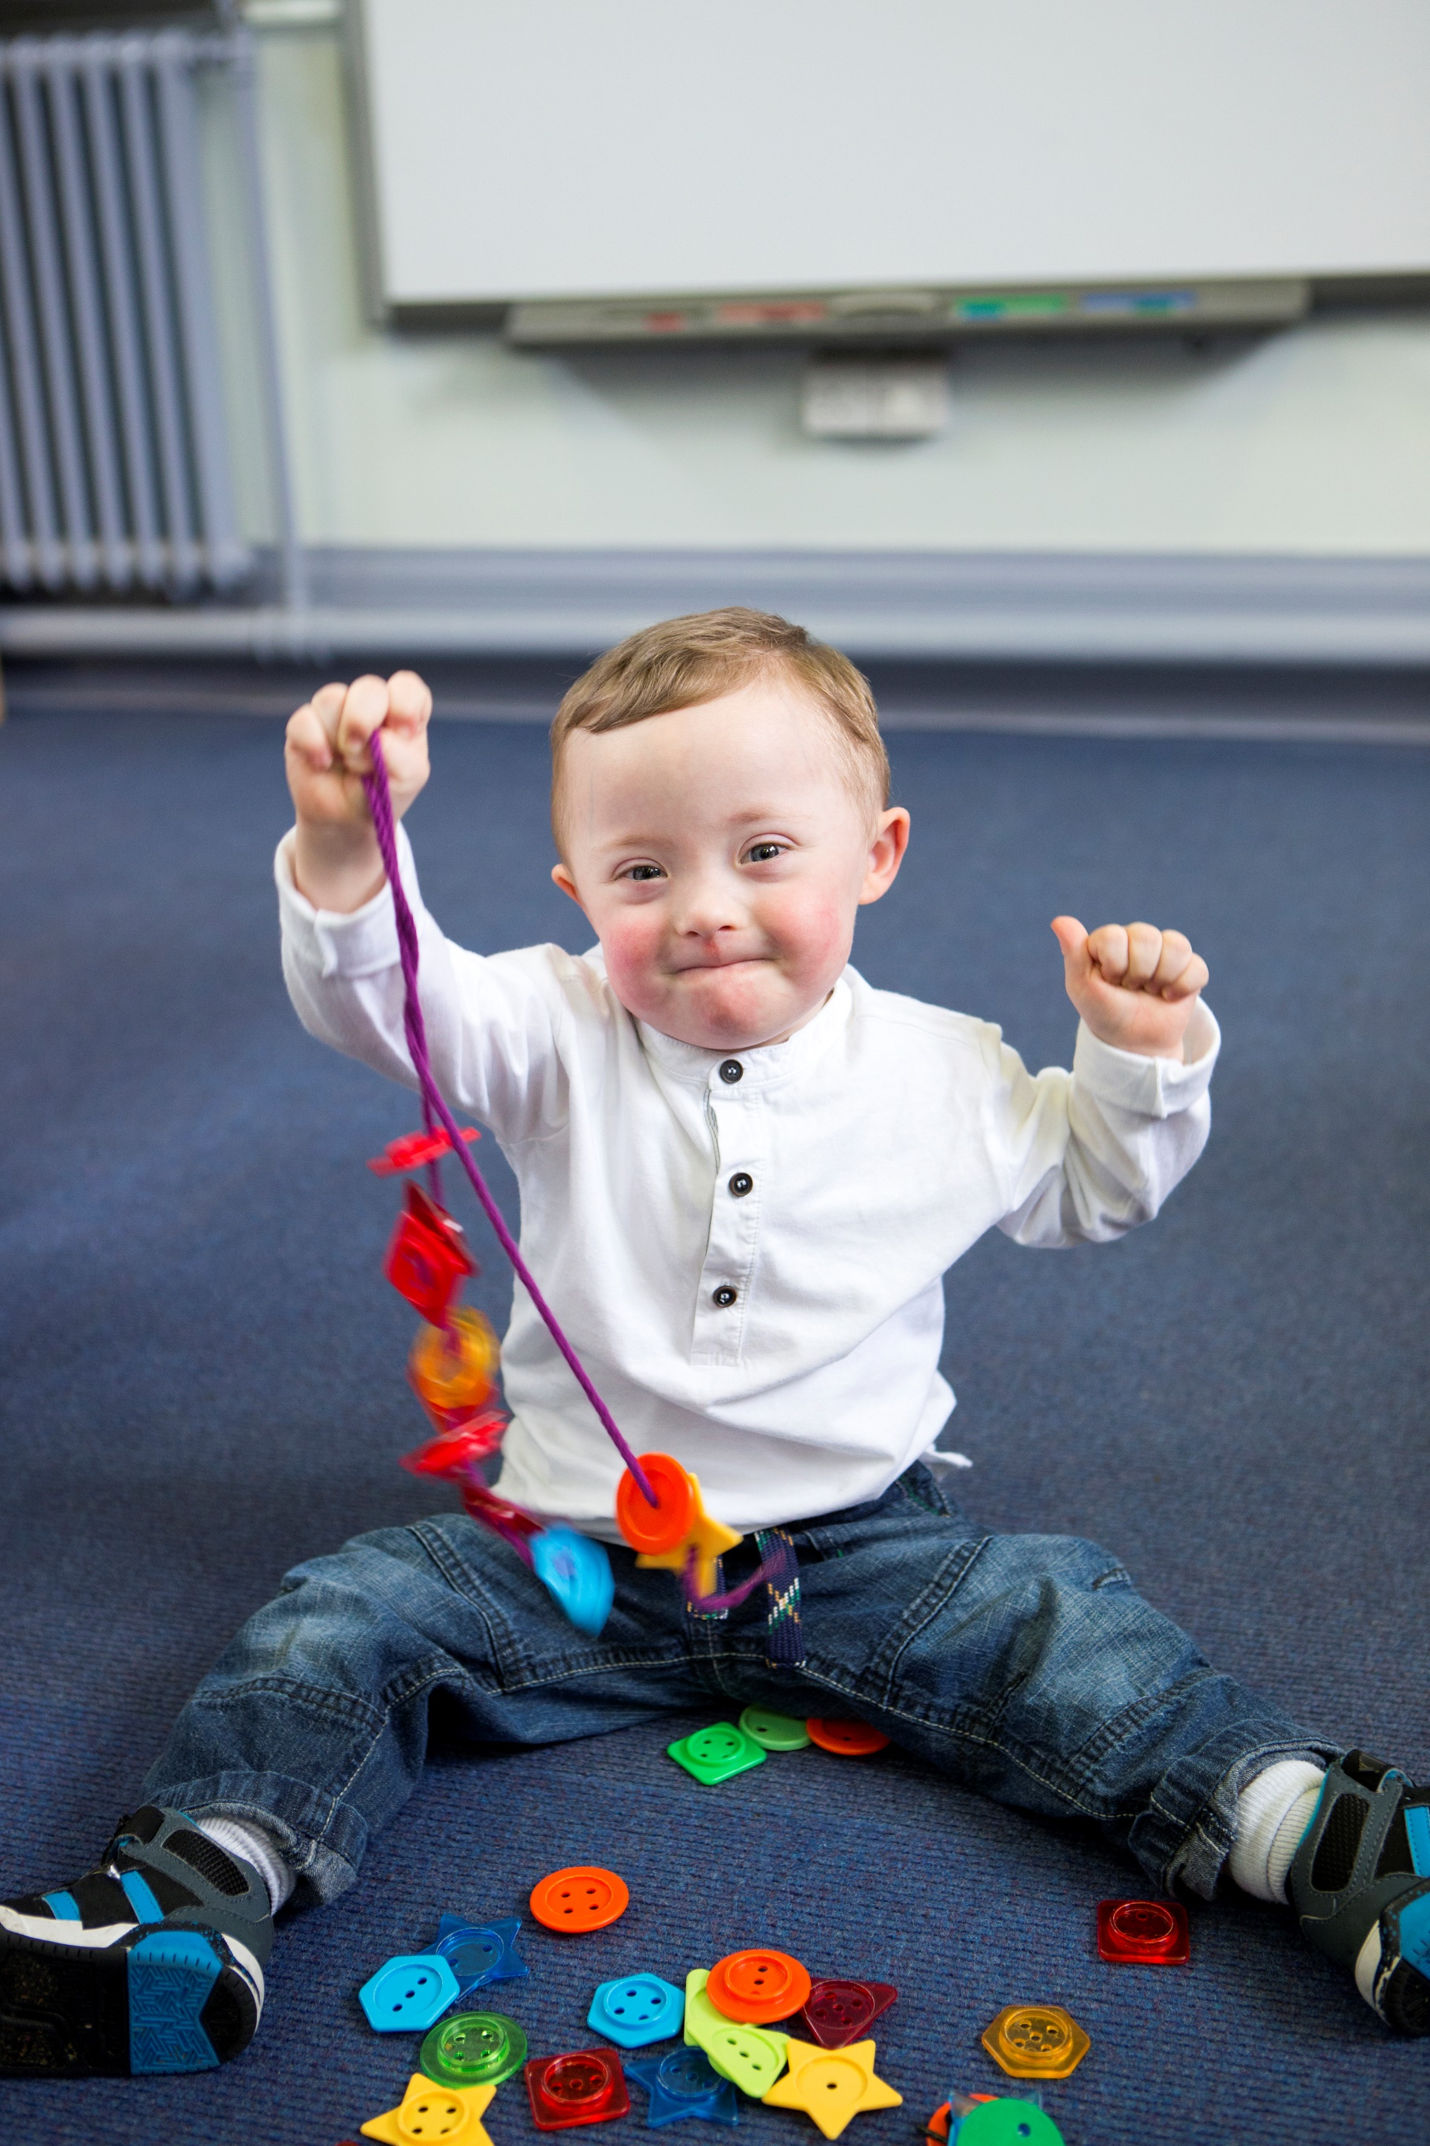
- Effective deployment of teaching assistants to ensure high quality structured support that allows children to develop independent learning skills and manage their own learning. All targeted interventions should be linked to the whole class teaching.

The graduated approach- a four step cycle of assess, plan, do, review

The SEND Code of Practice, January 2015² defines the Graduated Approach as:

“A model of action and intervention in early education settings, schools, and colleges to help children and young people who have special educational needs. The approach recognises that there is a continuum of special educational needs and that, where necessary, increasing specialist expertise should be brought to bear on the difficulties that a child or young person may be experiencing”.

We expect Redcar and Cleveland schools to implement the graduated approach where it has been identified that the needs of a child cannot be met through quality first teaching strategies and local care and health services.
The graduated approach involves a continuous four step cycle of Assess, Plan, Do, Review that is regularly reviewed to draw on more personalised approaches, specialist expertise and tailored interventions to meet the specific needs of an individual child.
The teacher retains responsibility and accountability for the child’s development and progress. The child and their parents/carers must be at the centre of this four-part cycle.
Further information on this four-step cycle is available in the NASEN 2014 publication ‘SEN support and the graduated approach: Inclusive practice together with a range of further resources on the SEND gateway.


Assess
Review
Child
and family
Plan
Do

Assess
A clear analysis of the child’s needs should be carried out by the class/subject teacher, support staff, SENDCO and other professionals who may already be supporting the child.

This assessment should be regularly reviewed to ensure that support and interventions are matched to needs. Where the child is not making the appropriate progress, further advice may be sought from a range of professionals with the full engagement of the child’s parents/carers.

Plan
The class/subject teacher and the SENDCO should work with the child and their parents/carers to discuss and agree the:

- adjustments, interventions, and support to be put in place.
- expected improvements in progress, development, or behaviour.
- clear dates for review.

All teachers and support staff who work with the child should be made aware of their needs, the outcomes sought, the support provided and any teaching strategies or approaches that are required. Consistency of approach is key to success. This should also be recorded on the school’s information system.

The support and intervention provided should be selected to meet the outcomes identified for the child, based on reliable evidence of effectiveness, and should be provided by staff with sufficient skills and knowledge.

Do
The class/subject teacher should remain responsible for working with the child on a daily basis even where the interventions involve group or one-to-one teaching away from the classroom.

Teachers should work closely with any teaching assistants or specialist staff involved, to plan and assess the impact of support and interventions and how they can be linked to classroom teaching.

The SENDCO should support the class/subject teacher in the further assessment of the child’s particular strengths and weaknesses, in problem solving and advising on the effective implementation of support.

Review
The quality and effectiveness of the support and interventions together with
their impact on the child’s progress should be reviewed in line with the agreed date. This evaluation should include feedback from the child and the views of parents/carers.

The class/subject teacher, working with the SENDCO, should revise the support in light of the pupil’s progress and development, deciding on any changes to the support in consultation with the child and their parents/carers.

Parents/carers should have clear information about the impact of the support and interventions provided, enabling them to be involved in planning next steps and using strategies at home to support the work in school.
Redcar and Cleveland have developed a SENDCo Handbook to support SENDCos and schools. Information on the graduated approach can be found here on page 60: People's Information Network | SENDCO Handbook Autumn Term 2022 (peoplesinfonet.org.uk)

Funding for schools
Our expectation is that through high quality teaching and the implementation of a graduated approach, the needs of the majority of our children can be met from a school’s core and notional budgets. We know that this is not the case for all and some children with significant, complex needs may require more funding, provided by Redcar and Cleveland Council, to secure specialised support set out in an Education, Health, and Care Plan.

There are three sources of funding available to schools to support children with special educational needs, described as Elements 1, 2 and 3.

Element 1 Core Education  Funding | Element 2 SEND Support | Element 3 High Needs  Funding
Funding for the education of all  children | Funding for children who require SEND  support | Funding for children with Education, Health, and Care Plans and in some specific cases, ‘top up’ funding to support those without EHCPs

Element 1 – Core budget
All schools are provided with what is known as core education funding. This is the individual funding that is provided to each school to provide the standard offer of teaching and learning for all children on the school roll.

Element 2 – SEND support
Schools have an amount of money in their school budget called the notional SEN budget. It is called a notional budget as it is an amount of money agreed between the local authority and schools, based on a formula, and not by the number of children in the school with special educational needs. The decision on how to spend this budget to support individual children, groups or classes is made by each individual school.
Schools are expected to meet the special educational needs of the majority of children from this budget. Government guidance says schools should provide up to the first £6,000 of additional or different support for those children and young people who need it, including those with an Education, Health, and Care Plan. This does not mean that the school will spend £6000 on every child with SEND. This is referred to as the ‘national threshold’ and this amount is set by the Department for Education.

Element 3 – High needs funding
This is the amount of money that is made available to the school to fund the individual, specialist provision that is required to meet the specific needs of the child through an Education, Health, and Care Plan where the costs of SEND support is over £6,000. For each child that has an Education, Health and Care Plan the school must spend the first £6,000 of support from its own budget and any further costs are paid to the school by the local authority. This is also known as ‘top up’ funding.



Environment– physical and sensory
We want our children to be fully included in school life so that they can have the same experiences as other children.

Expectation of  schools | How you can support
Plan the physical environment of the school to enable all children to access and use education, facilities, and services | Produce, revise, and publish annually on the school website:  An Accessibility Plan as specified in the Equality Act 2010 Guidance for Schools³ aimed at increasing the extent to which children can access and participate in the curriculum.  The SEND Information report as specified in Paragraphs 6.78 – 6.83 of the SEND Code of Practice, January 2015.²  Gather the views of parents/carers and children to inform advance planning for physical and sensory adaptations that may be required.  Ensure furniture and equipment is selected, adjusted, and positioned appropriately.  Provide organised classrooms to give children easy access to their own specialist equipment.  Consider the size and layout of areas for storage of materials and physical aids such as wheelchairs and walking frames.  Provide clear signage with visual cues that enables children to move safely around the school.  Plan extra-curricular activities and educational visits to fully include all children.  Provide access to and support the use of assistive technology.  Train staff and secure support if needed from other agencies to meet the medical needs of children.  Ensure children can access outdoor facilities. Where children cannot access outdoor facilities ensure that alternative arrangements are made.
All staff are aware and understand the sensory needs and issues that may impact on children. | Identify sensory needs and use to inform classroom seating arrangements, visibility of whiteboards and displays, impact of natural and artificial lighting, noise.  Include /brain breaks within lessons to re-energise children.  Make sure that children who wear glasses and/or hearing aids wear them and are seated in the optimum position.  Implement strategies to manage noise levels and provide supportive resources such as ear defenders.  Design displays that are meaningful and visually accessible to reduce sensory overload.  Be adaptable to the wearing of school uniforms recognising sensory issues with shoes and irritability with clothing.  Consider the use of weighted vests or blankets, fidget toys, stress balls, chewing and sucking aids.

EQUIPMENT AND RESOURCES
All schools must make reasonable adjustments, including the provisions of auxiliary aids and services for disabled children (Equality Act, 2010).³

Expectation  of schools | How you can support
Provide tailored equipment and resources to enable children to access the curriculum | Enable easy access to resources to promote independence.  Provide resources that meet children’s sensory needs such as weighted resources, therapeutic resources, pencil grips, writing slopes, ear defenders.  Produce good quality documents in a font size that is easy to read as advised by the QTVI. This work should be presented on A4 as it is more accessible than A3 and cream paper is often easier to access.  Ensure that children can use the assigned resources effectively and that these resources are labelled using text and images.  Ensure left- and right-handed children can use equipment comfortably.  Provide adapted PE equipment as appropriate.  Use resources that support learning for a range of children such as assistive technologies and multi-media.  Jointly evaluate the effectiveness of any resources with child, parent/carer.
Information technology is used to improve children’s learning, knowledge, and retention | Use IT to:  Integrate IT into lessons to improve learning.  Enhance the way new ideas, knowledge and skills are introduced, learned, and remembered.  Enrich modelling and explanations.  Increase the benefits of practice to improve fluency/retention of information.  Provide alternative methods of recording.
Keep abreast of the latest innovations in technological applications and equipment | Research new technologies through social media, blogs, and other on-line platforms.  Seek advice/visit other educational settings.  Subscribe to IT educational newsletters.  Attend conferences and exhibitions.

Partnerships with parents and carers/voice of the child
Research shows that if parents and carers are actively involved in their children’s learning and activities at school, they will be more likely to thrive both in terms of academic performance and in their general wellbeing.
Engaging with parents and carers | Childrens’ mental health and wellbeing in schools | Anna Freud Centre

Expectation of schools | How you can support
A range of methods are used to effectively engage all parents/carers and children in decision making. | Ensure the school information report is updated at least annually, ensuring it meets the SEND Code of Practice 2015 requirements set out in Paragraphs 6.78 – 6.79.² Enter into genuine co-production with parents/carers/children before making any changes.  Raise awareness with parents/carers and children of the methods in school to share information and the staff they can talk to about their concerns.  Be aware of the needs of parents/carers and ensure that appropriate mechanisms for engagement are in place. For example, if a parent has a hearing loss and uses British sign language (BSL), ensure a BSL interpreter, not a family member, is provided for all meetings and parent’s evenings.  If a parent has visually difficulties, arrangements must be made to enable them to access text that is sent home. Parents/carers can advise as to how best this can be achieved. Consideration should also be given as to how these parents/carers can support their child’s reading at home.  Support direct and indirect communications with parents/carers through a range of media such as email, text, written correspondence, home school diary.  Provide clear information to parents/carers/children about their SEND status, the interventions and support that they are receiving and enable them to be involved in planning next steps.  Support parents/carers to reinforce agreed strategies at home and adopt strategies that work at home in school.  Adopt an open and friendly approach with parents/carers ensuring that they are treated as equals in discussion.  Signpost parents/carers and children to external networks where they can access support and advice both locally and nationally such as the local offer, SENDIASS, Parent/Carer Forum.  Use a range of formal and informal events/opportunities to seek views in relation to SEND provision in the school.

Pastoral support
Promoting the health and wellbeing of pupils and students within schools and colleges has the potential to improve their educational outcomes and their health and wellbeing outcomes. The link between pupil health and wellbeing and attainment

Expectation  of schools | How you can support
The setting recognises, and responds to, the need for pastoral support for learners with SEND, bearing in mind the individual’s social and emotional needs and other relevant, contextual circumstances. | Develop a curriculum that helps children understand and manage their emotions and builds resilience through PSHE, assemblies and whole school programmes.  Create a calm and purposeful climate for learning where children feel they belong, and their contributions are valued.  Identify a safe space/s in school that children know they can access.  Train staff to support children’s wellbeing and raise awareness of the vulnerabilities of children in the school.  Embed the use of positive language throughout the school that demonstrates unconditional, positive regard for all children.  Provide a range of opportunities for children to build social relationships within the school day through classroom based and school-based activities.  Promote children’s awareness and sensitivity towards different groups through whole school and class activities.
Learners feel safe and valued. They know that they can  approach staff and that their opinions and concerns are valued. | Inform children which staff they can talk to if they have concerns or worries.  Build confident, open trusting relationships with children.  Encourage children to think about how they feel and let them know that you are there to listen.  Challenge negative attitudes and perceptions towards individuals and groups.  Provide opportunities for children to share their experiences, wishes and views of school and act on their feedback.

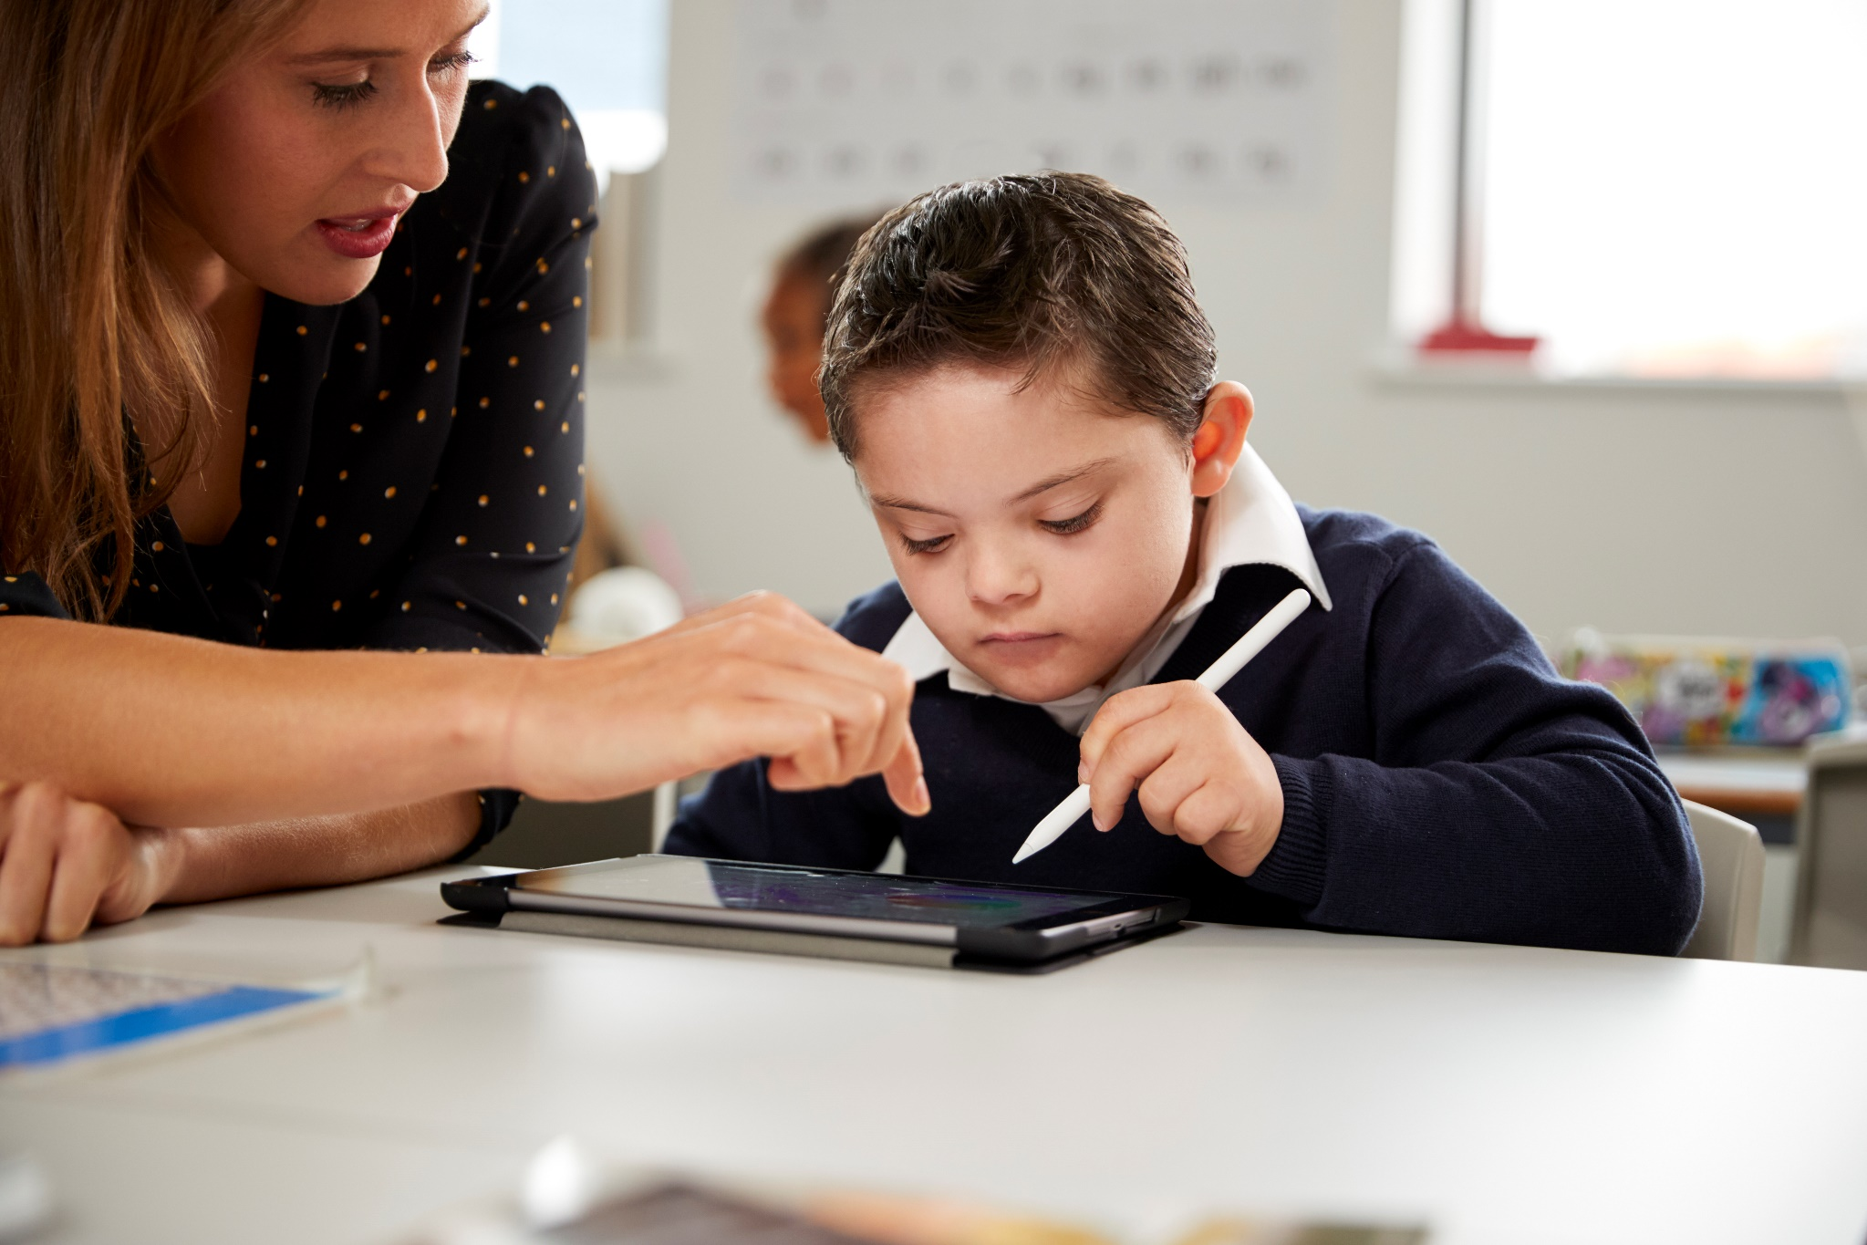

Staff training and expertise
‘The quality of teaching for pupils with SEN, and the progress made by pupils, should be a core part of the school’s performance management arrangements and its approach to professional development for all teaching and support staff….’ SEND Code of Practice, January 2015.²

Expectation  of schools | How you can support
There is a plan for on-going continual professional development (CPD) for all school staff,  designed to meet the needs of all children in the school. | Develop an annual plan for CPD incorporated into the School Improvement Plan/School Development Plan. This plan should be developed, reviewed, and evaluated by Senior Leadership and take account of feedback from staff, children, and parents/carers.  Include arrangements for CPD in the SEND information report when describing the expertise and training of staff to support children with SEND.  Provide staff with ongoing professional development to secure expertise at different levels, Awareness, Enhanced, Specialist (as stated in SEND Code of Practice, January 2015, para: 4:32)²  Embed best practice within school and share with wider partnerships.  Provide sufficient time for staff to reflect on, discuss and evaluate their learning.
Staff collaborate and have effective links with other relevant outside agencies and specialists. | Signpost staff to internal and external sources for support or advice.  Ask for advice and support from the SENDCOs at Redcar and Cleveland’s Resourced Provisions, including observations of young people being considered for high needs places.  Encourage staff to access training and support provided through local partners and share strategies across the school. There are termly SENDCo Network meetings where information is shared regarding new processes within SEND and from outside services in the local area such as CAMHS, STARS, SALT.  Use and share advice received from other professionals to inform teaching and learning and improve outcomes.  There are several teams within the Education Service that can offer advice and guidance to support with SEND needs such as the SEND team, Specialist Teaching Service, Inclusion Service and the Virtual School. Within the Inclusion Team there are officer to support with inclusion, elective home education and safeguarding.  Schools can refer to the Resource and Support Panel which is held approximately every three weeks. At this panel, schools can request high needs funding, support from the Educational Psychology Service using a Family Centred Multi-Agency Model, Specialist Teaching Service, Home and Hospital, Strive, and outreach support from our Additional Resourced Provisions.

Transitions and preparation for adulthood
Change is a normal part of life and can provide opportunities for children to develop their resilience.
Transitions - Mentally Healthy Schools, Anna Freud Centre

Expectation  of schools | How you can support
Transition is effectively planned for on entry and during school life. | Develop a whole school transition plan to ensure consistency of approach and transparency for parents/carers and children.  Identify and plan support for those who are most likely to find transition difficult.  Connect with previous/new school or college to ensure information is shared and additional support is available on entry/exit.  Implement a familiarisation process that includes links with feeder schools/nurseries, taster days, invitations to school events/open days.  Involve parents/carers in supporting transition by keeping them informed and signposting to appropriate resources.  Use a transition plan that allows children to share their strengths and preferences.  Plan the use of unstructured times through the provision of access to library, ICT, activity clubs.  Develop a peer mentoring system.
Classroom transitions are effectively planned. | Build trust and make children feel safe with reassuring language, address each child by name, positive notes on their work.

Use creative tools to support children who may struggle such as social stories, visual timetables.

Set clear and consistent boundaries so that children know what is expected of them.

Use visual tools such as timers and Now and Next strategies to show starting, duration and finishing times for tasks.

Provide opportunities for periods of respite using withdrawal to smaller groups. This might include self-directed/individual time-out.
Transition from school to further education/training / employment is well managed | Develop a transition curriculum that enables children to express and resolve their concerns/anxieties, builds resilience and independence, include strategies for managing change, problem solving, travel and organisational skills.  Provide opportunities to build relationships beyond the school community through volunteering or work experience.  Create partnerships with local businesses to provide opportunities for meaningful contact with employers through employability programmes, experience of work and work experience.  Provide high quality careers information, advice, and guidance both face to face and on-line.  Ensure young people with a learning disability or autism are made aware of supported internships as a progression route into employment / an apprenticeship.  Provide careers education aligned to the Gatsby Benchmarks.  Facilitate contact with a wide range of college and training providers, including information on apprenticeships and links to Higher Education in line with the Baker Clause.

Other useful resources

Detailed below are some of the resources and websites that we found useful in compiling this guidance.

Clever Classrooms, 2015, Peter Barrett, Yufan Zhang, Fay Davies, Lucinda Barrett Summary report

Council for Disabled children

Graduated Approach Toolkit: Blackpool Council

Reasonable adjustments for disabled pupils

Supporting pupils with medical conditions at school

Equality Act - Technical guidance for schools

Preparing for adulthood

Teacher Handbook: SEND | Send Gateway

Using Digital Technology to Improve Learning | EEF

Local Authority Contact Information

Charlotte Ellis | Preparation for Adulthood co-ordinator | Charlotte.ellis@redcar-cleveland.gov.uk
Angela Henderson | Education Development Advisor – Inclusion | Angela.henderson@redcar-cleveland.gov.uk
Jo Johnson | Head of the Virtual School | Jo.johnson@redcar-cleveland.gov.uk
Rachel Leonard | Principal Educational Psychologist | Rachel.leonard@redcar-cleveland.gov.uk
Maxine Lewis | Statutory SEND Manager | Maxine.lewis@redcar-cleveland.gov.uk
Clare Mahoney | Assistant Director for Education and Skills | Clare.mahoney@redcar-cleveland.gov.uk
Amanda Olvanhill | Head of Employability | Amanda.olvanhill@redcar-cleveland.gov.uk
Jane Ratcliffe-Dowling | Lead for Achievement | Jane.ratcliffe@redcar-cleveland.gov.uk
Grant Smith | Lead for Inclusion | Grant.smith@redcar-cleveland.gov.uk
Michelle Smith | Senior Attendance and Welfare Officer | Michelle.smith4@redcar-cleveland.gov.uk
Jane Todd | Early Years Area SENDCo | Jane.todd@redcar-cleveland.gov.uk
Monica Wheater | Education Development Advisor – SEND | Monica.wheater@redcar-cleveland.gov.uk

SEND Regulations 53, 2014 (Schedule 2).SEND Regulations Schedule 2
SEND Regulations 53, 2014 (Schedule 2).SEND Regulations Schedule 2
SEND Code of Practice, January 2015, Department of Education, Department of Health.
Equality Act 2010 – Guidance for schools
SEND Code of Practice, January 2015, Department of Education, Department of Health.
National Autistic Society
British Dyslexia Association
The National Numeracy Strategy, DfES 2001
Overview - Dyspraxia in Children
Personalised Learning, DCSF, 2008
Special Educational Needs in Mainstream Schools | EEF (educationendowmentfoundation.org.uk)
Making best use of teaching assistants, 12 October 2015, EEF. Making Best Use of Teaching Assistants | EEF
SEN Support and the graduated approach: Inclusive practice | Nasen
Making best use of teaching assistants, 12 October 2015, EEF. Making Best Use of Teaching Assistants | EEF
Implementing the Gatsby benchmarks (goodcareerguidance.org.uk)

