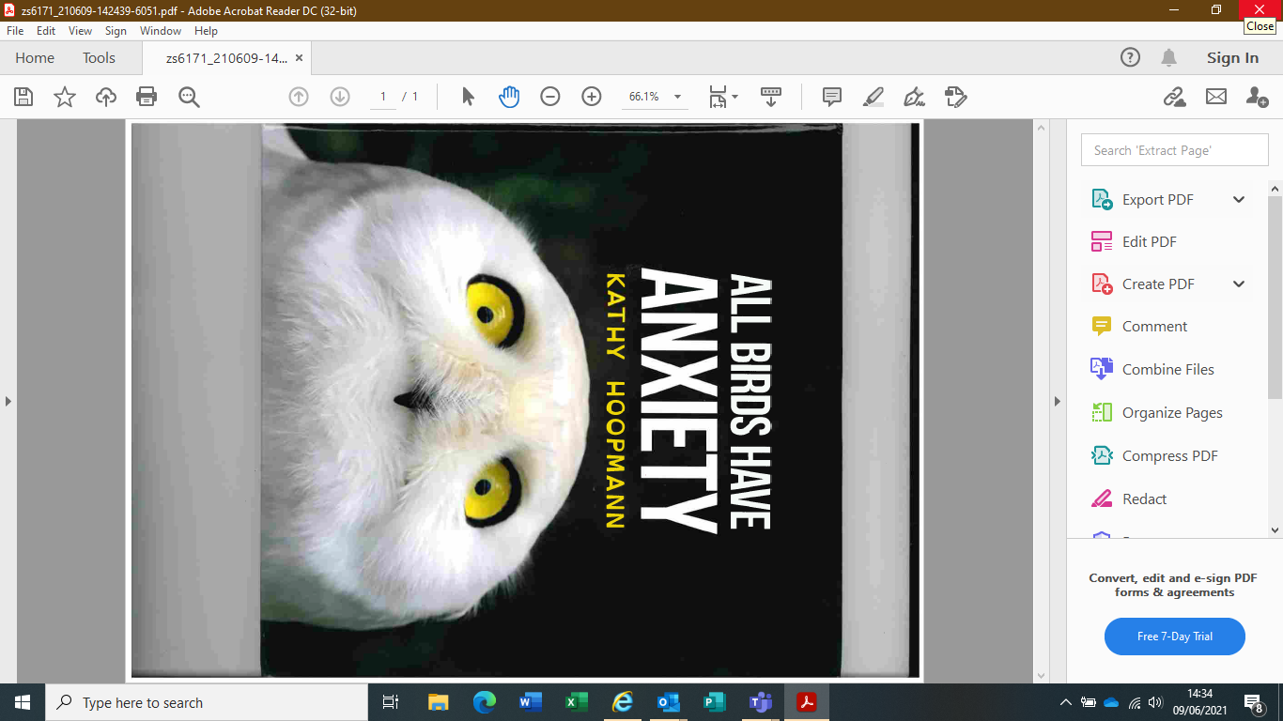

**EBSA Folder – Recommended Books**

**Resource:**

Written by best-selling author of All Cats have Asperger Syndrome, All Dogs have ADHD

**Supports:**

A book to enable adults to discuss anxiety with children and together develop coping strategies

**Learning outcomes:**

The book offers an amusing depiction of bird behaviour validating experiences of anxiety

**Age approximately:**

9 upwards

**Resource:**

Written by a Senior Educational Psychologist to equip young people with autism to live a calm and healthy life.

**Supports:**

Young people, parents/carers, and professionals

**Learning outcomes:**

The book offers an imaginative range of tricks and techniques to help young people understand and overcome the symptoms of anxiety

**Age approximately:**

8 to 14 years old

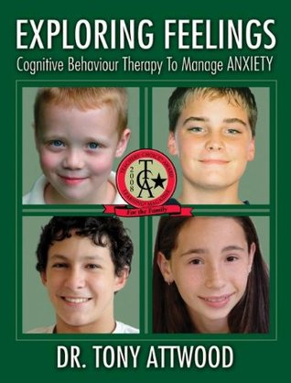

**Resource:**

Written by Dr Tony Atwood - author of several books on autism and Asperger’s Syndrome

**Supports:** Young people, parents/carers, and professionals

**Learning outcomes:**

A structured CBT-based programme designed to manage anxiety. It includes activities and worksheets, focussing on: feeling happy and relaxed; exploring changes to physiology, thinking, behaviour and speech; developing and using an emotional toolbox; creating Social Stories[trademark symbol | Trademark symbol, Company symbol, Trademark](https://www.google.co.uk/url?sa=i&url=https%3A%2F%2Fwww.pinterest.com%2Fpin%2F555702041527172116%2F&psig=AOvVaw3EtD2yXIPUjSrl3qj8lRoG&ust=1623760878236000&source=images&cd=vfe&ved=0CAIQjRxqFwoTCNjcueSSl_ECFQAAAAAdAAAAABAE); and sharing strategies

**Age approximately:** 9 to 12 years old

**Resource:**

Clinically proven self-help guide for parents/carers

**Supports:**

Teaches parents/carers how to use CBT techniques with their children to overcome fears, worries and phobias.

**Resource:**

Guide to writing Social Stories created by Carol Gray. They are short descriptions of a particular situation, event or activity, which include specific information about what to expect in that situation and why.

**Supports:**

Provides parents/carers and teachers with a step-by-step guide to writing their own social stories, alongside examples of 150 most requested social stories written by Carol Gray

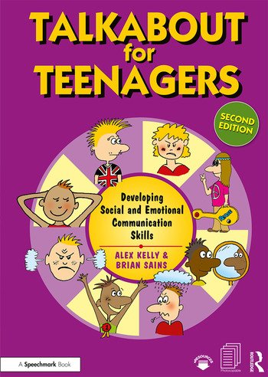

**Resource:**

Written by Alex Kelly and Brian Sains

**Supports:**

Young people, parents/carers, and professionals

**Learning outcomes:**

A complete workbook to assess and develop young people’s social skills. The resource is aimed at children who have difficulties with self-esteem; social skills; friendships; and assertiveness. The format and structure of the sessions are clear and easy to follow.

**Age approximately:**

Age 11 to 19 years old

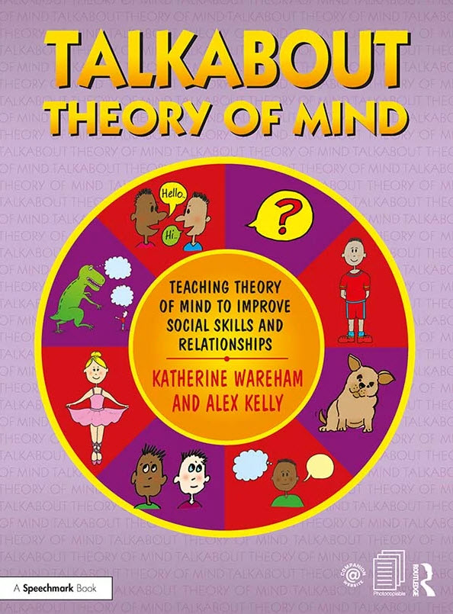

**Resource:**

Written by Katherine Wareham and Alex Kelly

**Supports:**

Young people, parents/carers, and professionals

**Learning outcomes:**

A practical workbook full of worksheets, activities, and resources to support theory of mind covering: thoughts, feelings and actions, knowledge, beliefs and respect.

**Age approximately:**

Age 11 upwards

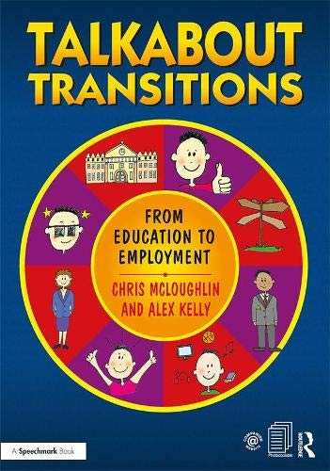

**Resource:**

Written by Chris McLoughlin and Alex Kelly

**Supports:**

Young people, parents/carers, and professionals

**Learning outcomes:**

A practical workbook full of worksheets and activities to support young people as they transition from education to employment including: school leaver opportunities, making applications; the interview process; and employment skills

**Age approximately:**

Age 16 upwards

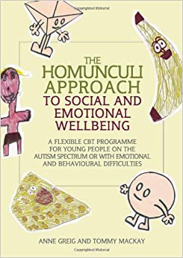

**Resource:**

Written by Anne Grieg and Tommy Mackay

**Supports:**

Young people, parents/carers, and professionals

**Learning outcomes:**

A fun, flexible CBT programme for young people with autism or emotional/behavioural difficulties.

Students create their own Homunculi agents with problem-solving missions and special gadgets. It is very effective with students who enjoy drawing/creative/imaginative activities.

**Age approximately:**

Age 7 upwards

**Resource:**

Workbook covering the core elements of CBT written by Consultant Clinical Psychologist

**Supports:**

A range of flexible materials and activities to support children to develop alternative cognition and behaviour skills

**Learning outcomes:**

Various resources covering balanced thinking, controlling thoughts, and changing behaviour

**Age approximately:**

Children and young people

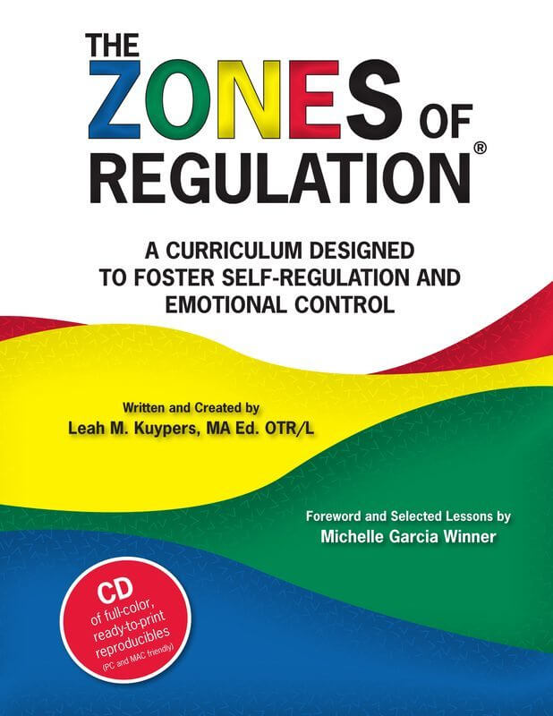

**Resource:**

Written by Leah M Kuypers with input from Michelle Garcia Winner

**Supports:**

Young people, parents/carers, and professionals

**Learning outcomes:**

A structured curriculum designed to foster self-regulation and emotional control. User friendly lessons and manual of resources included.

**Age approximately:**

Primary age upwards