My Views
Name: |  | DOB:
Address: |  | Contact No:
School / College / Training Provider: |  | Date:
My Special Educational Needs:
(Section B of EHCP)

I am currently working towards these qualifications:
Examples include: vocational course, AS/A/Levels, GCSE’s,
Functional Skills, Personal Development (D of E, Asdan Award, AQA Qualification)

Things I like to do:
(Likes/Hobbies/Strengths)

Things I dislike:
(Dislikes/Improvements)

How I currently travel to school/college?

How I would like to travel:
(on my own, on a bus with friends, walk on my own)

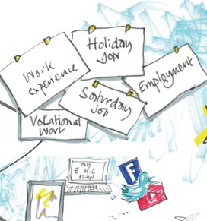 |   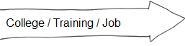  My aim:  Next step for me:  Future steps for me:  The support I will need and who can help me:
 | 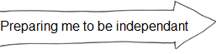  My aim:  Next step for me:  Future steps for me:  The support I will need and who can help me:
 | 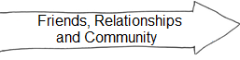  My aim:  Next step for me:  Future steps for me:  The support I will need and who can help me:
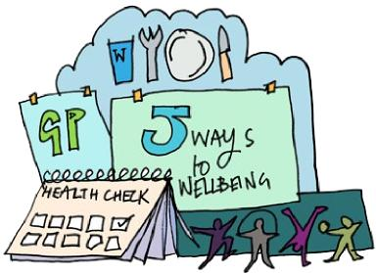 | 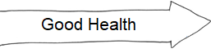  My aim:  Next step for me:  Future steps for me:  The support I will need and who can help me:

People who are important to me and will help me prepare for adulthood:
Name | Service | Contact Details

Where to get further information from:

Redcar & Cleveland Local Offer - http://www.peoplesinfonet.org.uk

Contact details:

Special Educational Needs Service
Inspire 2 Learn
Normanby Road
South Bank
TS6 9AE

Telephone: 01642 304503
Website: www.redcar-cleveland.gov.uk
Email: SEN@redcar-cleveland.gov.uk

