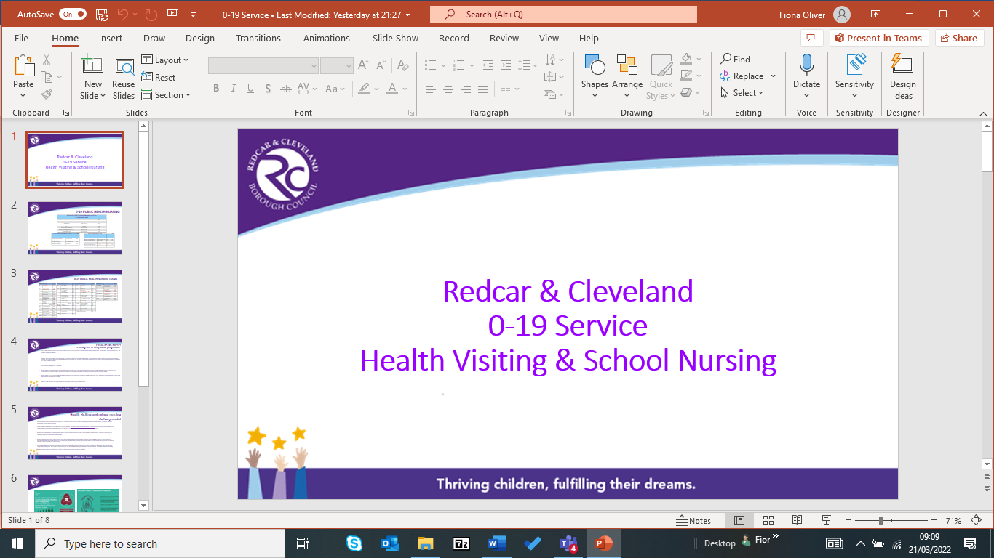

Guide to refer into 5-19.
5-19 - School Nursing is part of the 0-19 Public Health Nursing Team,
within Early Help & Safeguarding-Children’s Services.
Redcar & Cleveland Borough Council.

Criteria for School Nursing Interventions:
Continence: | Day-time wetting  Night-time wetting  Soiling  Toilet Training | All ages
Nutrition: | Healthy Eating/Eat Well Plate  Assessment of Growth  Fussy Eater  Meal-time conflict/issues | All ages
Behaviour: | Behaviour Management  Low Level behaviour support | All ages
Emotional Wellbeing: | Low Level Worries/Anxieties  Low Level Fears | From age 6/7 years onwards
Sexual Health: | C- Card Condom Provision  Chlamydia Testing  Pregnancy Testing  Discuss STI’s | Secondary School age
Risk -Taking Behaviour: | Low Level Staying Safe  -referral to drug/alcohol  services | Secondary School age
Healthy Relationships: | Low Level Understanding Healthy Relationships | Secondary School age
Sleeping: | Sleep problems  - Establishing sleep routines  - Night Terrors | All ages
Health Promotion  Stop Smoking:  Dental Health:  Puberty:  Hygiene:  Headlice: |  | All ages

