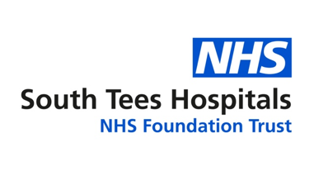
Paediatric Occupational Therapy (OT) Service

The PINS (Partnership for Inclusion of Neurodiversity in Schools) project is a UK national program by the Department for Education (DfE) and NHS England to help mainstream schools better support neurodiverse children, bringing together local authorities, health professionals, and parents/ carers to develop innovative, whole-school strategies for inclusion, focusing on training, resources, and cultural change for better health and education outcomes.
In 2025, 20 Primary schools in Redcar & Cleveland accessed a variety of resources and training as part of this project. The South Tees Paediatric Occupational Therapy team completed environmental audits in these schools where we had the opportunity to look at how sensory inclusive school environments are. We used a simple audit tool (see attached). We also have a short staff training video (QR code attached) to encourage sensory smart schools. We would like this resource to be available to all Primary and Secondary schools in South Tees (Middlesbrough, Redcar & Cleveland).
Audit tool:

Sensory Smart Schools (QR code to access video)

Our referral criteria:
Our referral form:

If you have any questions or would like to speak to any of our OT team members please email: ste-tr.westacklamcentre@nhs.net for attention ‘OT team’

