Sensory Inclusive Environments
Audit Tool

Class: Date completed: Completed by:

Physical Environment and Learning Context
Young people are:
- able to participate in meaningful activities and supported as necessary to ensure this continues.
- offered experiences which lead to meaningful choices which are clearly communicated.
- supported in acceptable physical environments

Strategies for meeting capable environments standards | One example of how we do this well  (to be completed by class teacher) | Any actions required?
Visual support systems are used, e.g., task lists, now and next boards, individual learning targets in pupil’s work area, photos/symbols/signs are used alongside written words to support teaching at whole-class and 1:1 level to clarify:
- timetable
- learning objectives
- success criteria
- date in full format
- key vocabulary and information
- the sequence of steps within an activity
- safety rules
- names of equipment and where it is stored, etc.
- check in for example using the Zones of Regulation.
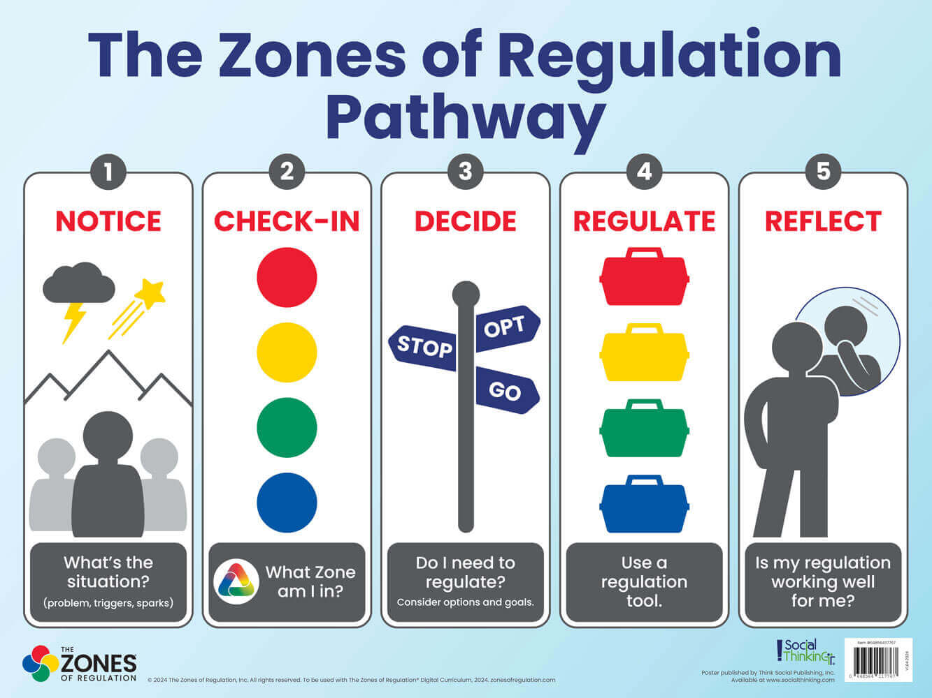

Visual timetable on display for the whole class and referred to for each lesson.
Individual visual timetables provided for individual young people where needed.
Classroom rules presented visually in the classroom.
Drawers and storage that pupils access are labelled to promote independence.
Learning and social areas clearly defined and labelled with words or pictures.
Resources for free time stored in designated area with labels e.g., board games, cards, crafts etc.
Seating is appropriate for movement and comfort.
- Are feet grounded on the floor?
- Appropriate desk and chair height.
- Consider layout of tables and seating plan for children.
- Consider having a height adjustable table in each class that can be used as a standing desk.

Consider an independent workstation area set up so that if pupils need to work alone in a lower stimulus area they can.
Routines and transitions (between activities or environments) managed effectively and supported with the use of a visual timetable so young people know what to expect next.
Methods of recording:
Alternative arrangements are made for pupils who find writing to be physically painful or difficult.
- Willingness of the school to allow some work or homework to be typed.
- Possible use of technology for written work
- Allow extra time for written work (not at break / lunch)
- Encourage the development of touch typing (typing clubs)
- Ipads can be used to take screenshots from the board, can enlarge text and use background colours when children would otherwise require coloured overlays

Sensory environment
Consider the sensory environment in the classroom, corridors, and dinner hall.
Young people are:
- supported to try new experiences, develop skills, and increase their independence.
- supported in dignified ways to care for and look after themselves and their health.
Strategies for meeting capable environments standards | One example of how we do this well | Any actions required?
Visual
General environment: The classroom is kept tidy and free from ‘clutter’ to minimise visual distractions.
This includes tidy table-top/desks, clear walkways between desks and around the room, and appropriate cupboards and shelves for storage.
Walls around teaching areas (e.g., whiteboards) have minimal distractions.
Minimal posters and displays.

Display boards and posters to be located at the back of the room behind the pupils’ line of vision where possible, OR outside of the classroom on designated boards in the corridors or communal spaces.

Display backgrounds should be a light, low stimulus colour.
Where the walls are display boards, they should be backed in a one low stimulus colour.

Lighting: Does the classroom make use of all available natural light, e.g., teaching with artificial lights off where possible?

Does the lighting vary:
- depending on time of day?
- Seasonally?
What lighting is being used in the classroom?
Are there any comments re: lighting, e.g., bright/dim? Flickering?

Noise
Noise levels are managed effectively to limit distractions with use of visuals if needed.
Is there any regular or consistent, observable background noise, however subtle?

Is there a designated quiet area in the classroom where noise is minimised for ‘down time’? Or a designated space outside of the class?

Are students able to access this area when feeling overwhelmed?

Are young people made aware of a loud bell/fire alarm (planned)/noise?
Are strategies put in place e.g., visual supports, sensory aids (ear defenders)?

Temperature
Is the room temperature appropriate for learning? i.e., not too hot, or cold?
Does the room temperature vary:
- depending on time of day?
- seasonally?
- depending on any equipment being used in lessons?
Smells
Smells within the classroom are kept to a minimum: e.g., the smell of glue, paint, clay, cleaning fluids.
Staff are aware that the strong/specific smells, e.g., perfumes/deodorants/body odour/cigarette smoke/chemicals/food cooking etc. may be distressing and make adaptations as required for individuals (grounding smells such as hand cream/ gel, perfume on a tie etc.)

Keeping rooms well ventilated

Smells from outside the classroom are monitored and reduced, where possible, e.g.:
Toilets
The smell of cooking from the main kitchen

Movement/ ‘brain breaks’
Have regular movement breaks built into the day for example, breaks, lunch, and in between focussed tasks.

Consideration of settling / grounding activity following transitions / unstructured times.

Brain break area where a decompression activity can be completed for example colouring in, reading, listen to music.

Individualised approach for children that may require additional breaks for example, give jobs, hand out books etc.

Students allowed to leave classroom early to avoid busy transition times e.g., assembly, lunch, and home time.

Movement aids (e.g., wobble cushion, fidget tools, resistance band to chair legs) are available to support young people who seek additional movement in seating or finds focused tasks challenging.

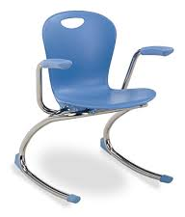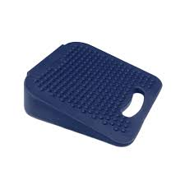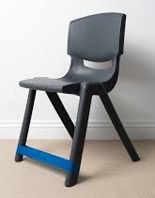

‘Reset’ rooms/ spaces:
A reset room in a school is a designated calming space with comfortable furnishings, low lighting, and sensory tools such as stress balls, playdough, fidget toys, blankets, or bean bags to help students self-regulate and manage emotions. The room should be calm and quiet, with activities like drawing/ Lego/ puzzles, and may also include ways to release energy, like a skipping rope or static exercise bike (with adult supervision). It's important to involve students in setting up the room and to ensure the tools and activities are effective for their individual needs.

Purpose:
- Emotional Regulation- provides a safe space for students to process feelings, calm down, and return to the classroom in a better emotional state.
- Self-management skills- by using the room and its tools, students learn valuable lessons in self-management and emotional regulation.
- Not a punishment- the room is not a disciplinary tool but an accessible resource for any student or staff member needing support with anxiety, anger, focus, or motivation.

Feel free to contact the South Tees paediatric occupational therapy team on 01642-944506 or email ste-tr.westacklamcentre@nhs.net with any questions/ queries.

