

Transition Pack

My name:

My new secondary school:
Freebrough Academy

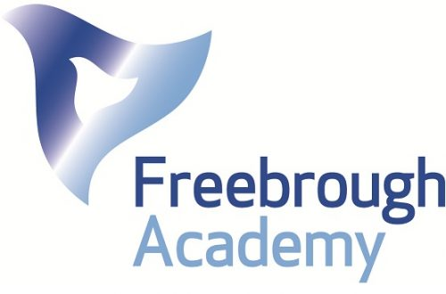

To get to know your new school and find key information you can go on your school website.
Website address – fra.northerneducationtrust.org

What my new school looks like
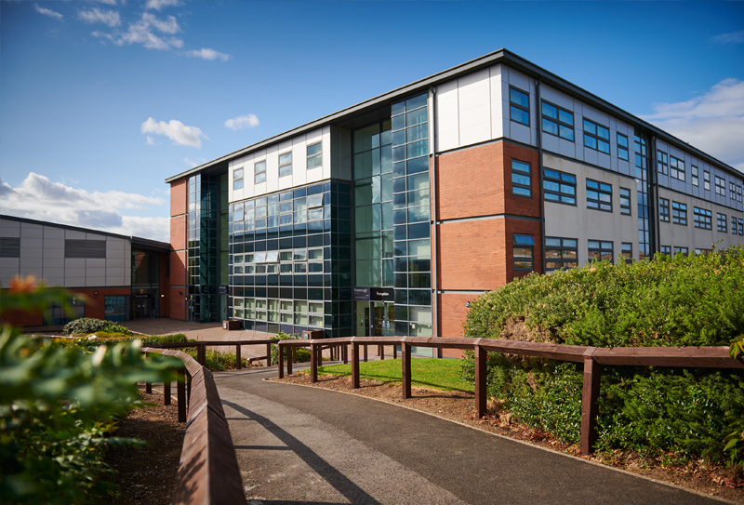

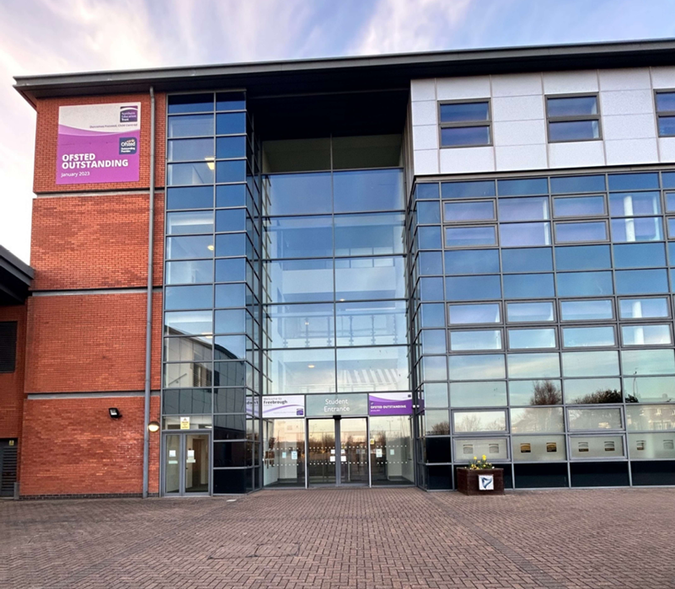
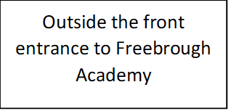
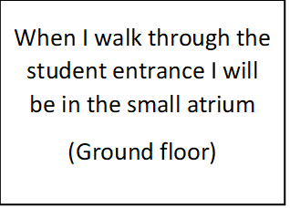
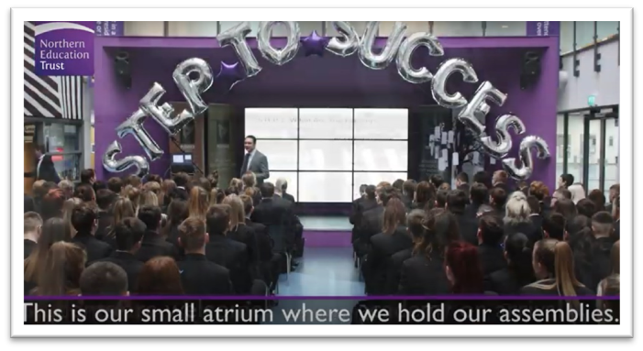
Student Entrance
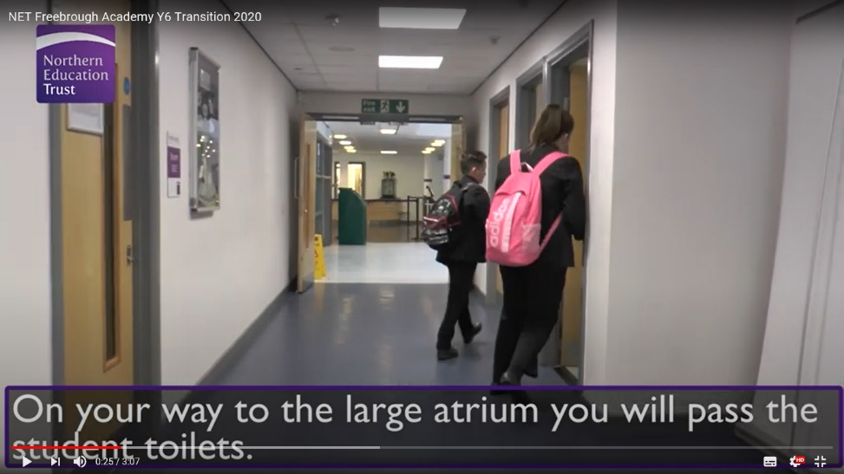
When I walk to the large atrium I will pass the student toilets
(Ground floor)
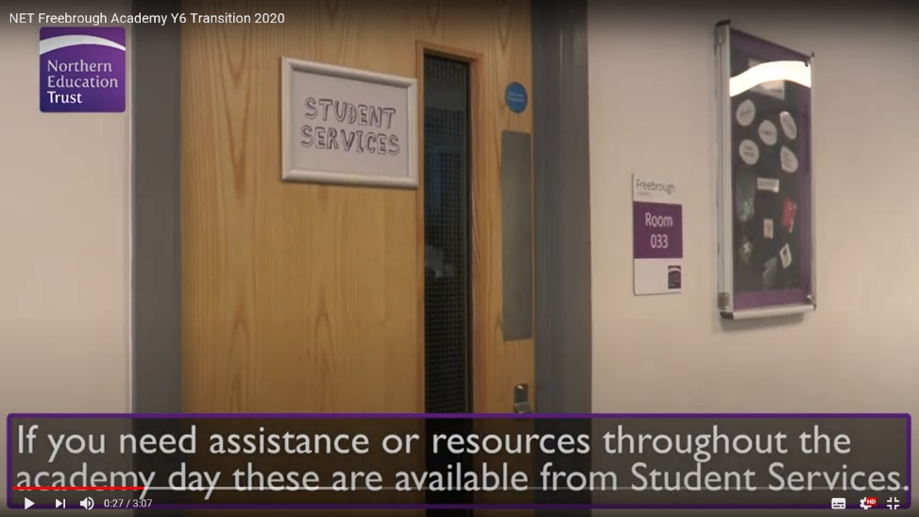
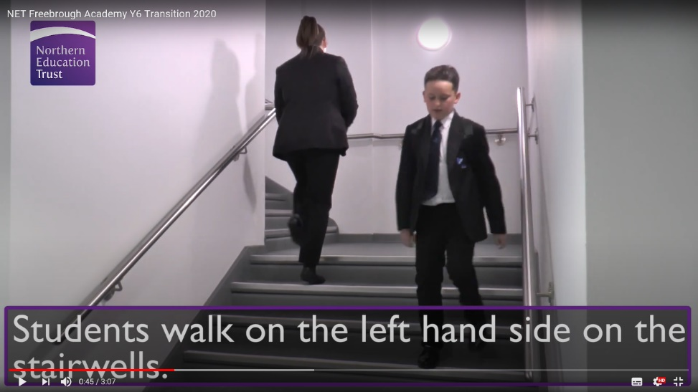
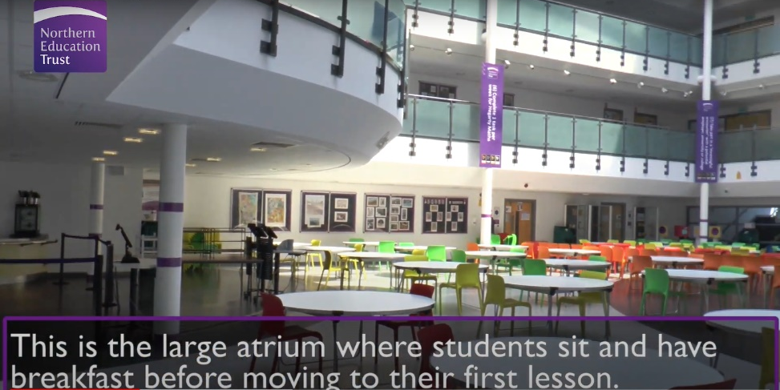
Stairs to the first floor
Students walk on the left-hand side
At the end of the corridor is the large atrium dining area
(Ground floor)
The student services room is opposite the student toilets
(Ground floor)

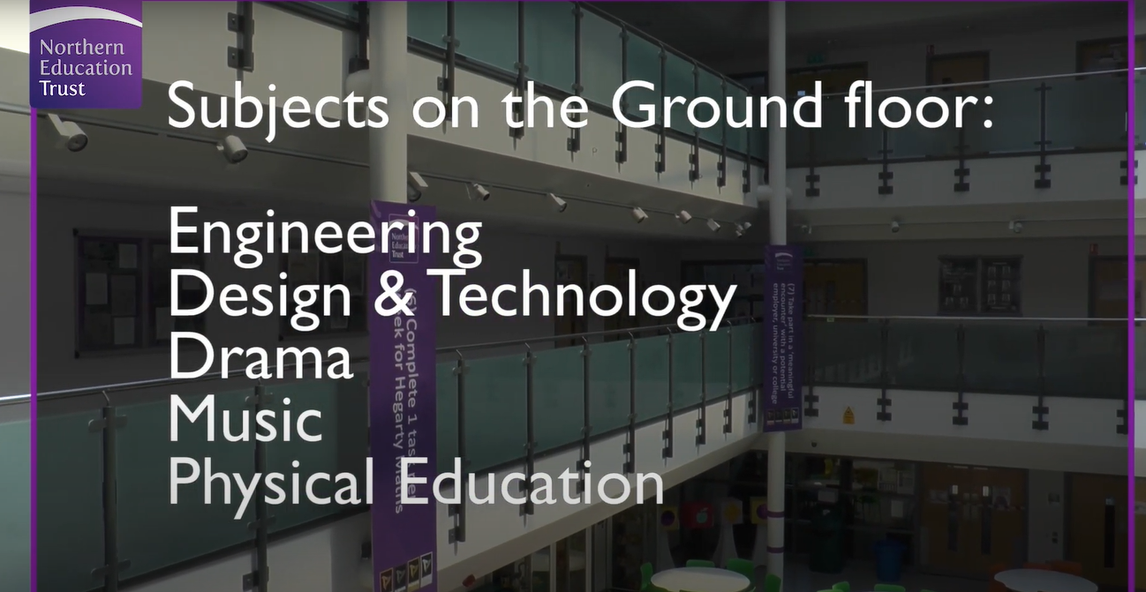
Subject classrooms on the ground floor
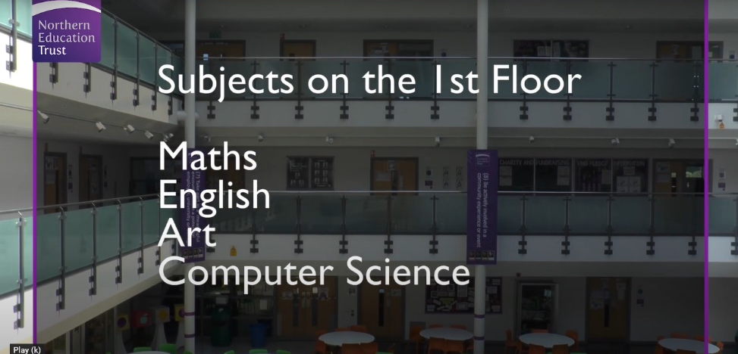
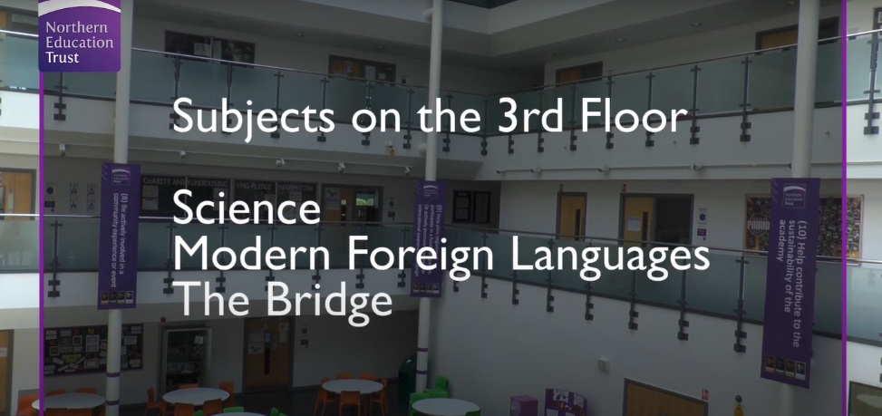
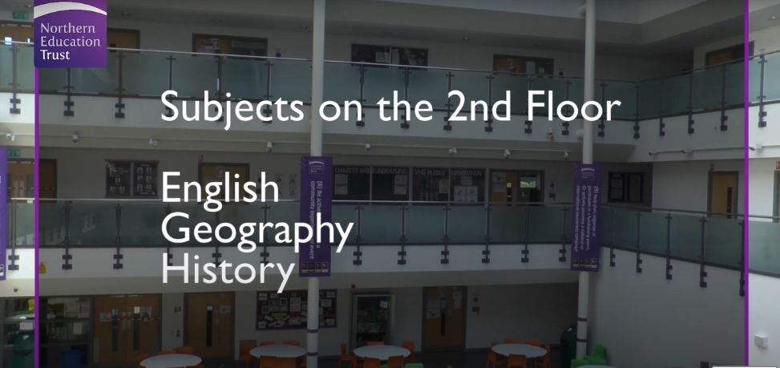
Subject classrooms on the second floor
Subject classrooms on the third floor
Subject classrooms on the first floor
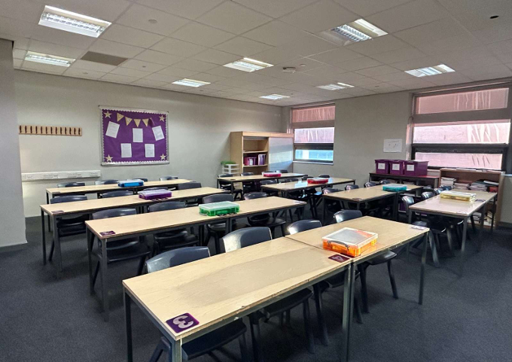
Classroom

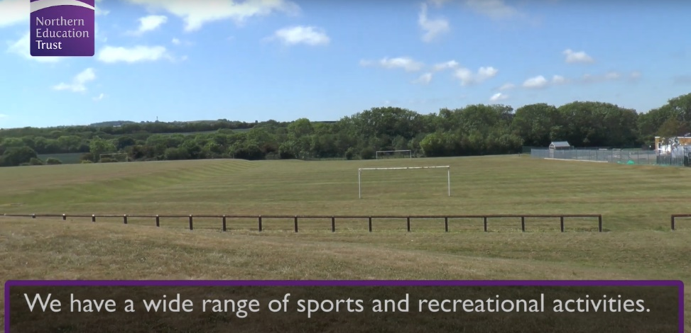
Outside area for sport and PE activities

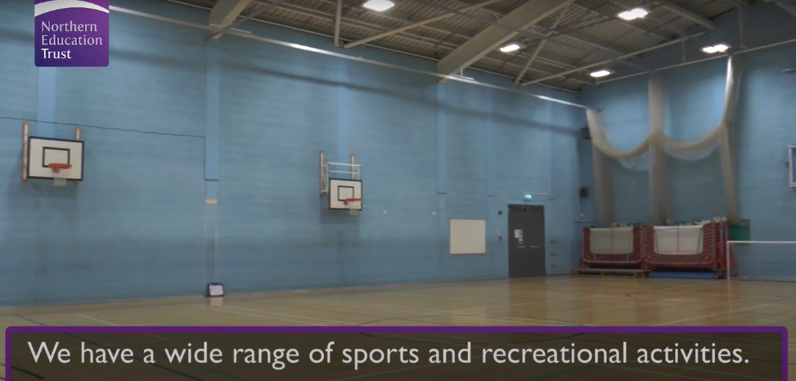
Indoor sports hall

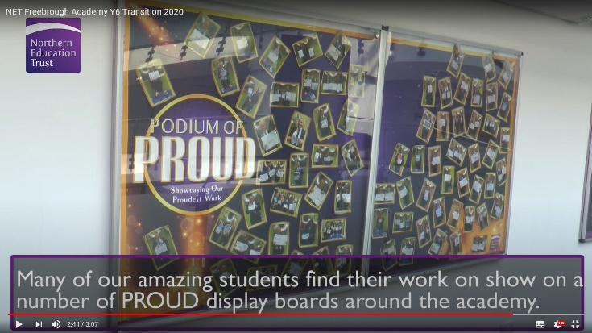

Finding my way around
Its normal to be a little worried about getting lost. Lots of students might get a bit lost as they get to know their new school. It’s a new adventure! If you aren’t sure how to get somewhere, you can find a teacher or ask another student which way to go.
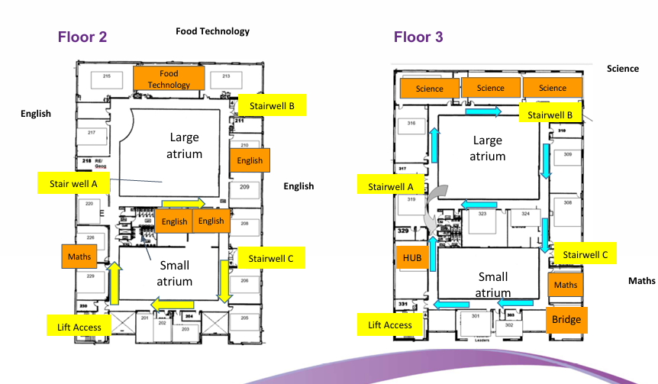
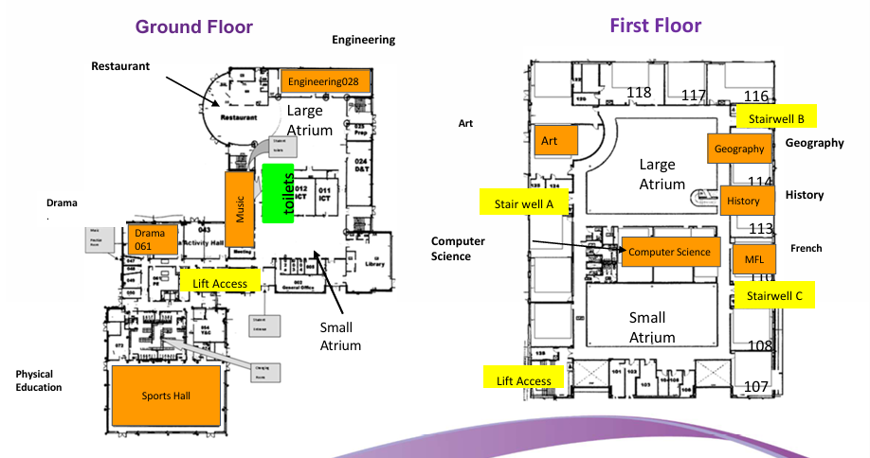
Here is a map of my new school:

Finding my way around

Choose different colours and colour in:

Place in School | Colour on map
The door I will use to come in
Toilets
Dinner Hall
Main Office
Library
Sports Hall
Form room
Add anything else that is important to you……..

Timetable
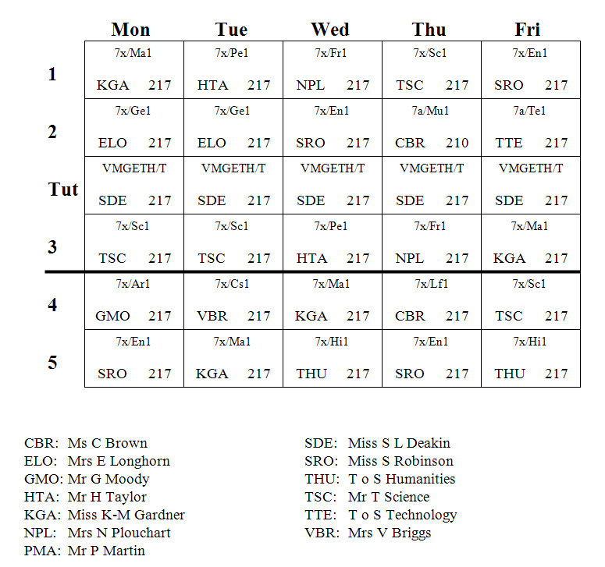
Here is an example of what my timetable will look like:
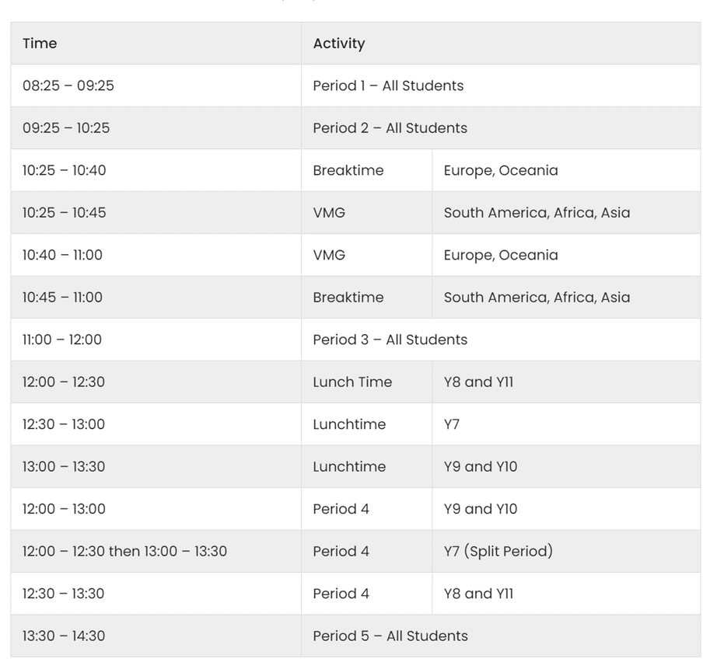
Science period 3 Tuesday
English period 1 Friday
Lunch
School Uniform
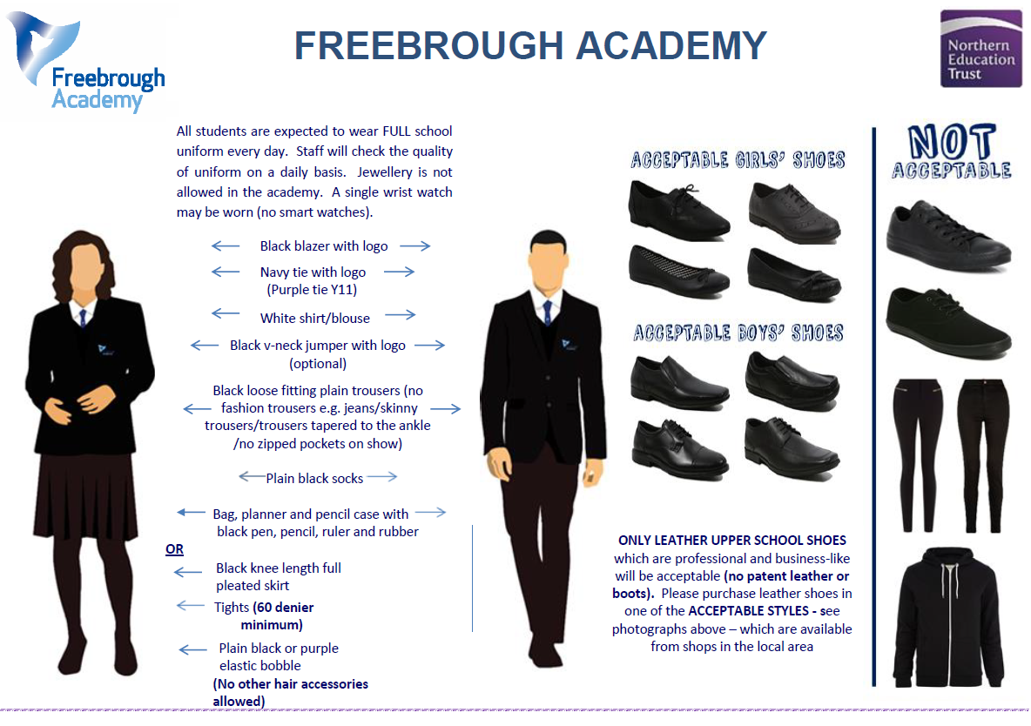
This is what my school uniform will be when I got to secondary school:
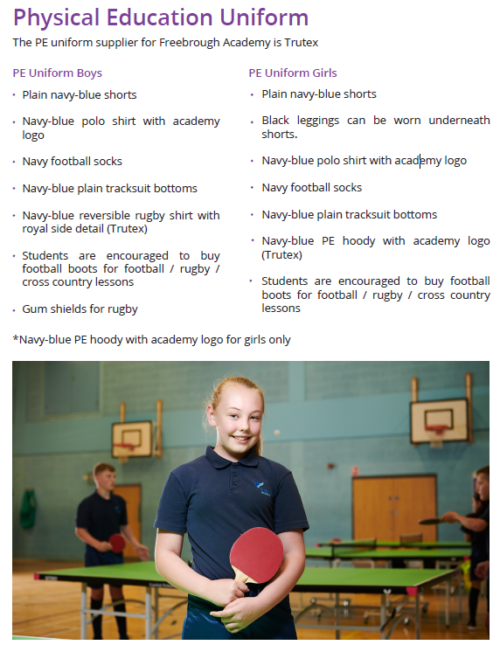
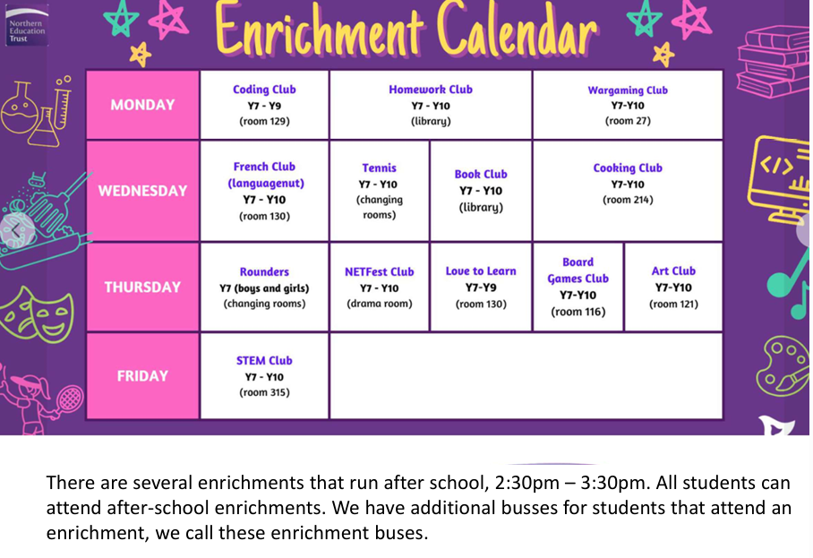
Key People
Here are the names and photos of key staff members that will be important to me at secondary school:
Name | Who are they? | Where can you find them?
Notes

