

Transition Pack

My name:

My new secondary school:


To get to know your new school you can go on your school website.
Website address – huntcliff.co.uk
You can even watch a video tour of the school – www.youtube.com/watch?v=N0F14Cw5o2k
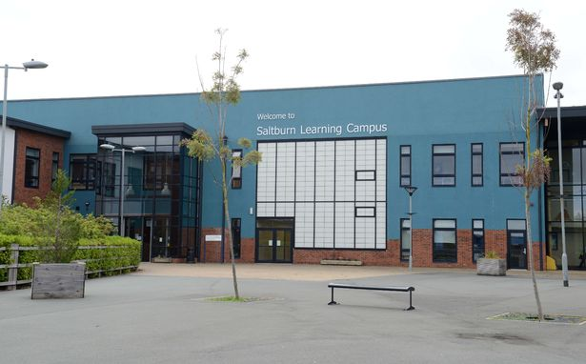
What my new school looks like
Arrive at 8:20-8:30am
If you arrive late you will have to enter through main reception. If you are on time, the atrium doors will be open and staff will welcome you through them.

Uniform and equipment I will need
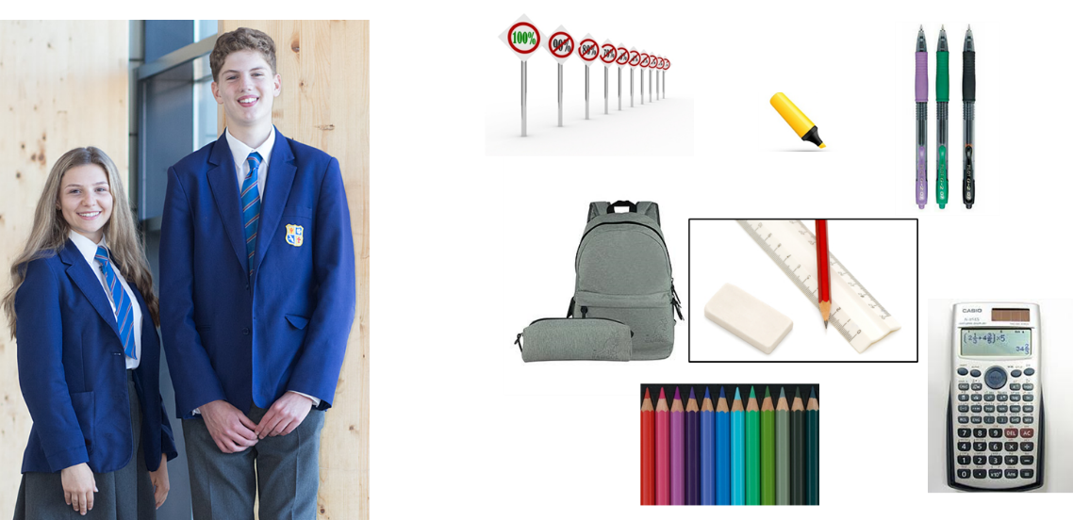
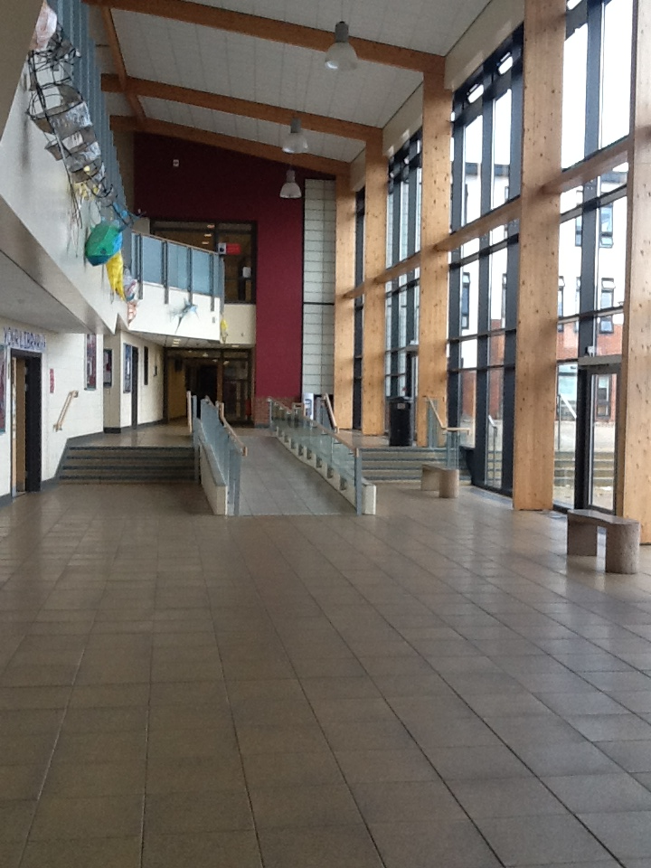
Atrium
Where students can eat their packed lunch at lunch time.

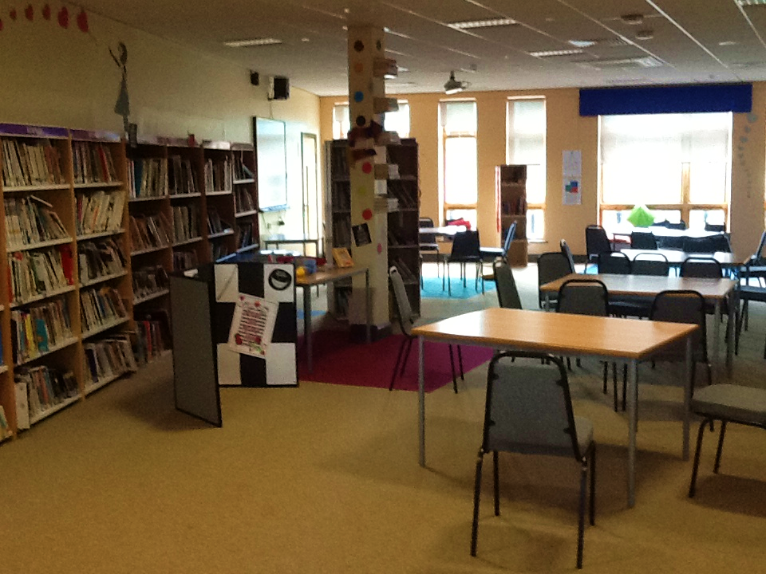

Library
A quiet space to study

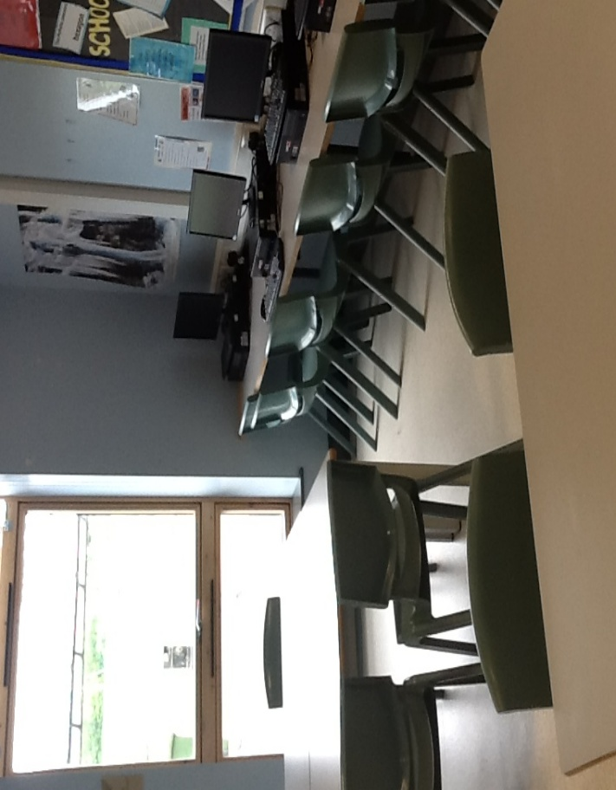
Inclusion Room

You can ask to come here if you feel overwhelmed or need a quiet space at break or lunch,

Everyone has a locker allocated to them in transition week.

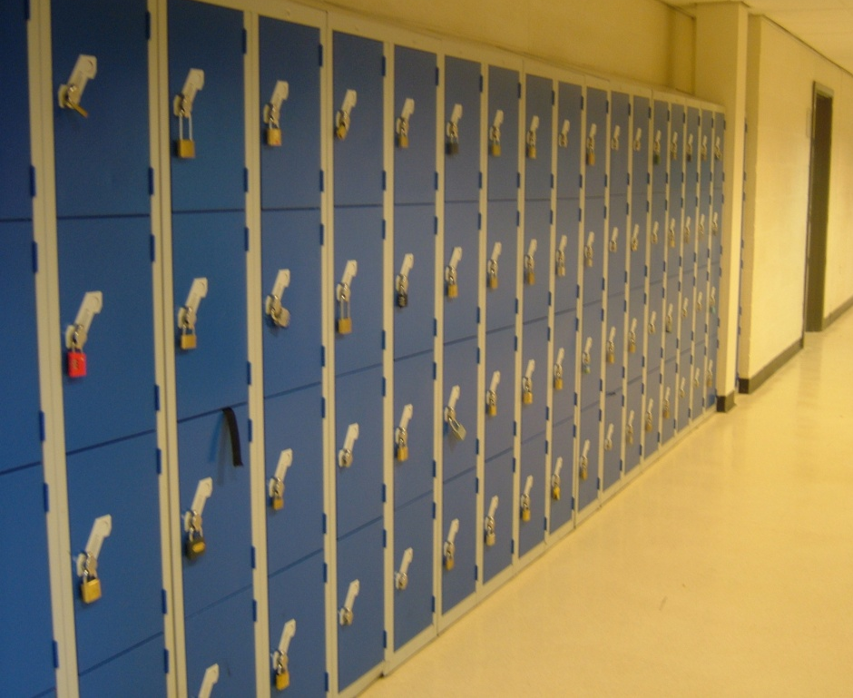

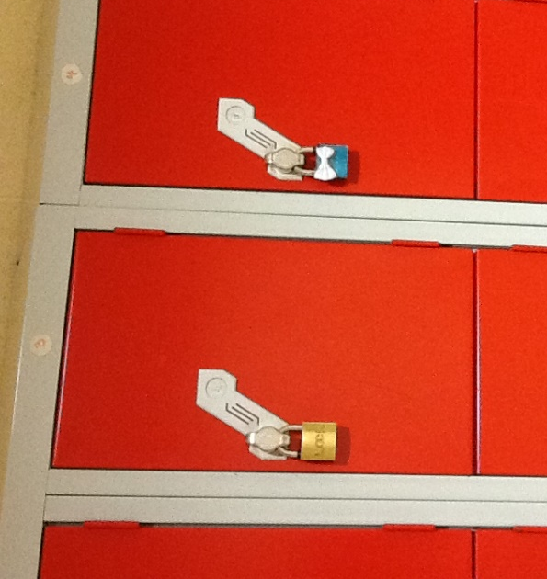
You need to bring in your own padlock for your locker.

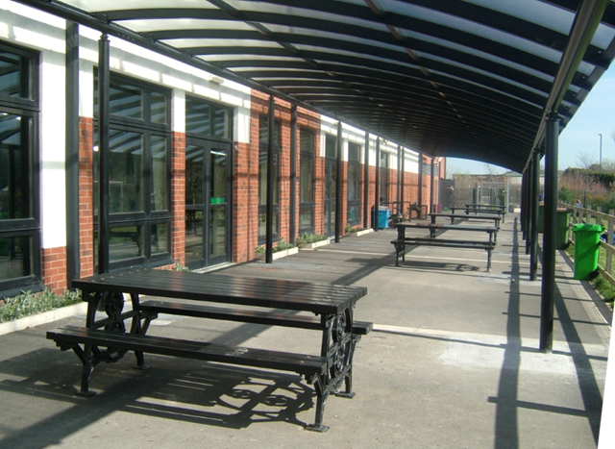
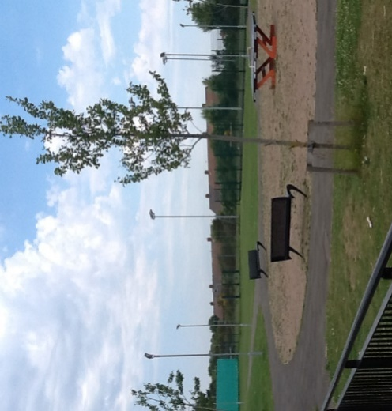

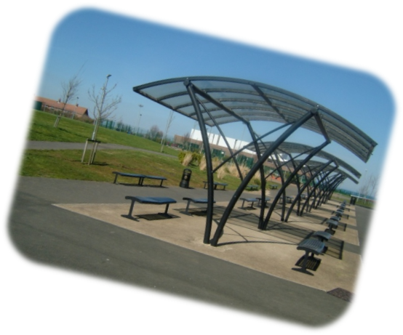
Outside Areas
Year 7 have their own part of the field and their own break area.

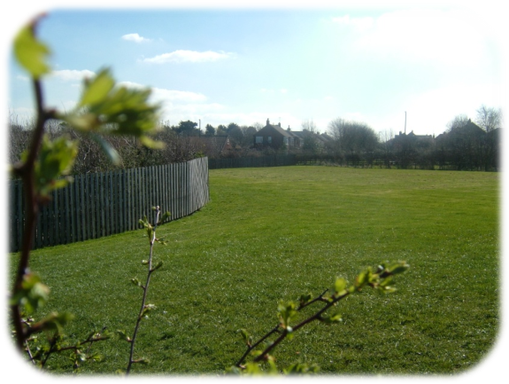

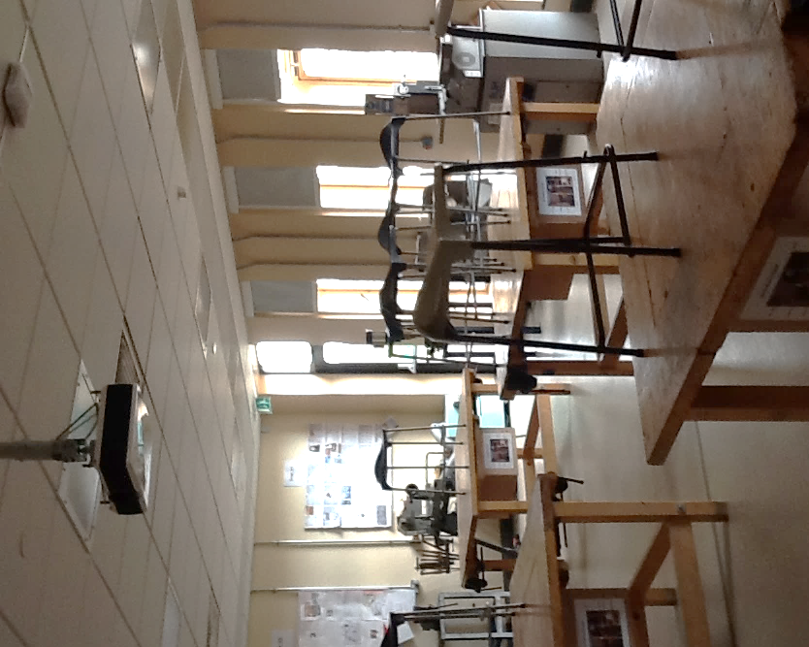
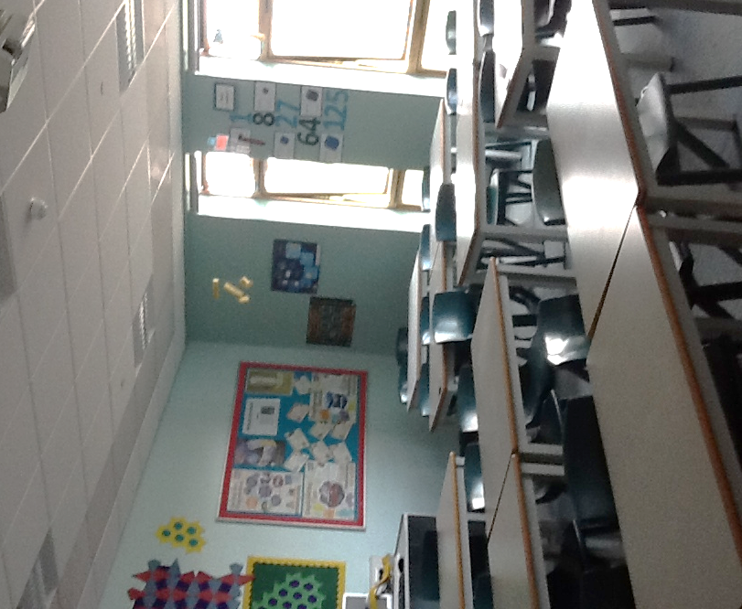
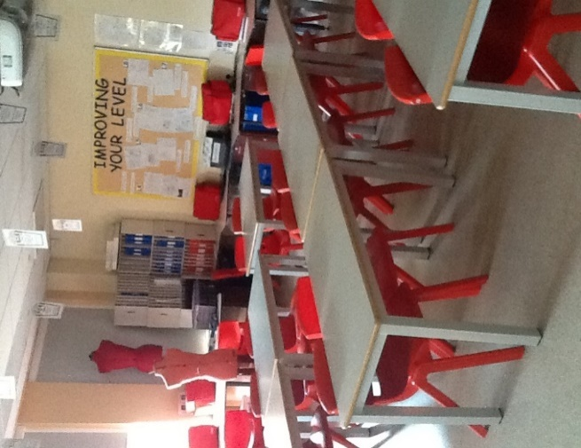
Resistant Materials Classroom
Maths Classroom
Technology Classroom for Graphics, Photography and Art

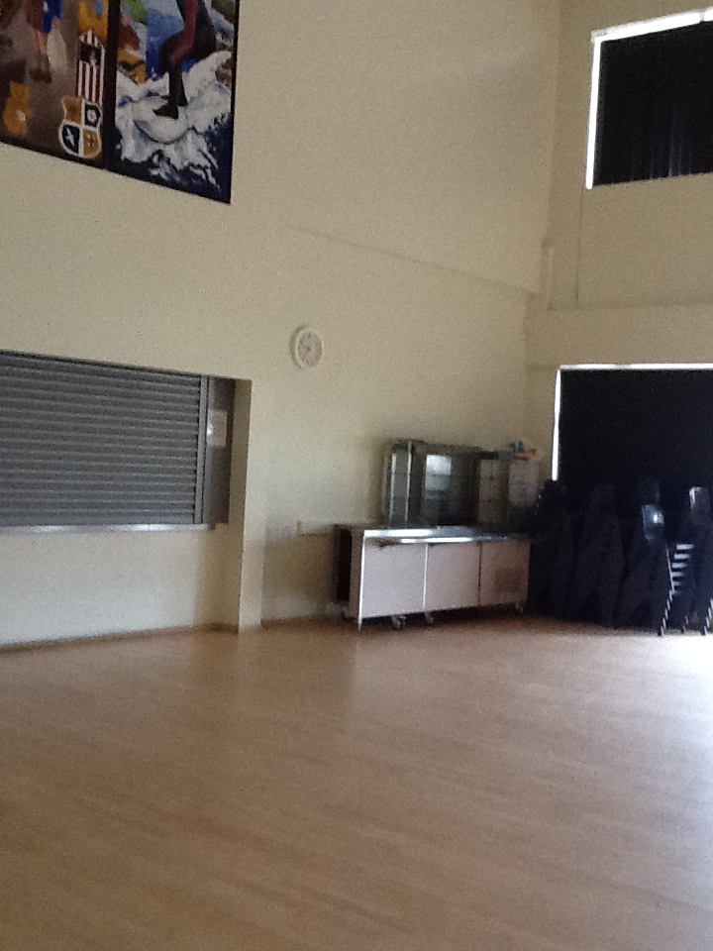
Lunch Hall

Directions to Class are around the school but you will also have a buddy to help you in the first few weeks.

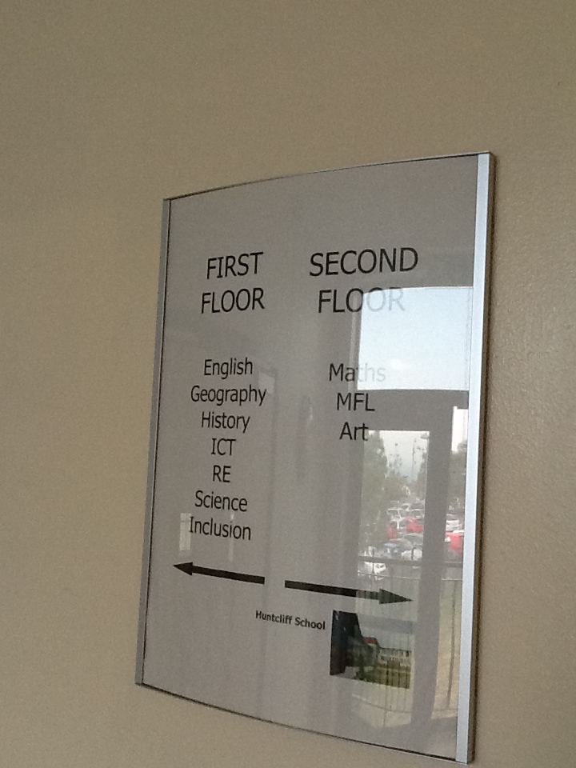

Homework Club is on every night after school every Tuesday-Friday.

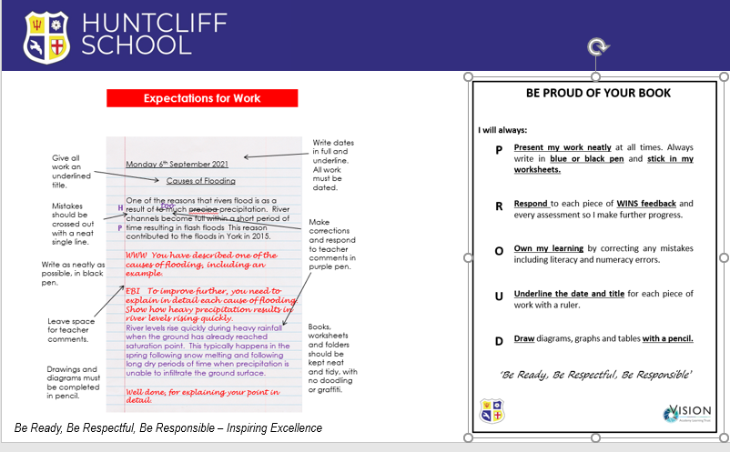

Each year group is separate at social times, this is where the different year groups can be. KS3 pupils are able to purchase a snack at break times from the canteen.
 | Social Time | Wet Break
Y7 | Picnic area | Picnic area
Y8 | Amphitheatre | Atrium
Y9 | Shelters outside of English | Hall
Y10 | Tennis courts | Sports Hall
Y11 | MUGA | Sports Hall
 | Pupils will be able to access the Library/Inclusion with a pass.

Finding my way around
School Expectations
Its normal to be a little worried about getting lost. Lots of students might get a bit lost as they get to know their new school. It’s a new adventure! If you aren’t sure how to get somewhere, you can find a teacher or ask another student which way to go.

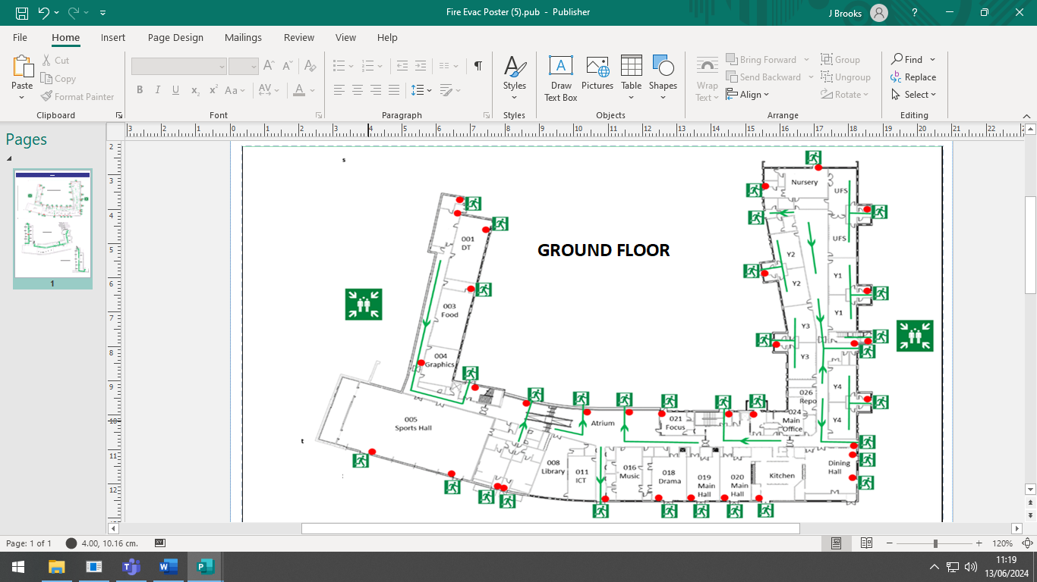
Here is a map of my new school:
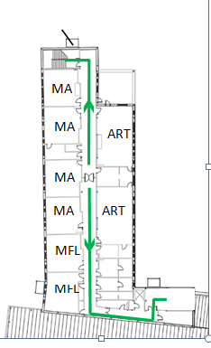
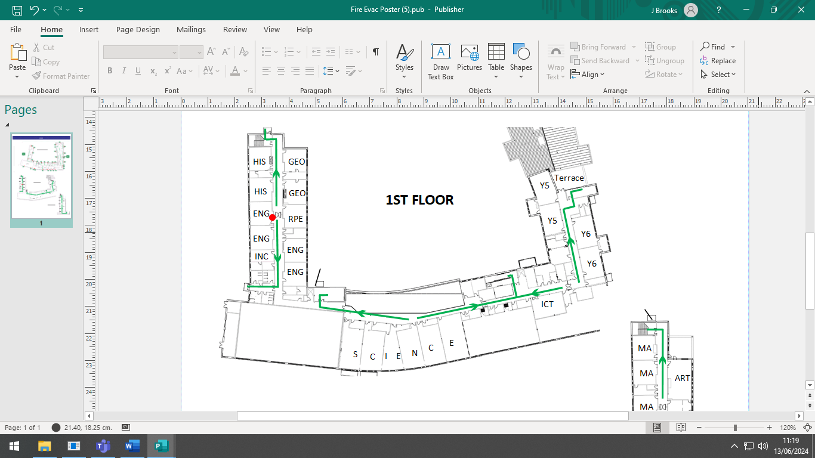
2nd FLOOR
Finding my way around

Choose different colours and colour in:

Place in School | Colour on map
The atrium
The main office
The library
The picnic area
The sports hall
The English and Humanities corridor
The Maths and MFL corridor
Add anything else that is important to you.

Timetable
Here is an example of what my timetable will look like:
DAY | Monday | Tuesday | Wednesday | Thursday | Friday
Registration  8:30 – 8:50am | Form with Mr G  In 205 | Form with Mr G In 205 | Form with Mr G In 205 | Form with Mr G In 205 | Form with Mr G In 205
Period 1  8:50 – 9:50am | Maths 206 | Art 211 | History 108 | English 114 | Science 123
Period 2  9:50-10:50am | PE in sports hall | English 114 | Music 009 | Science 123 | Art 211
Break
10:50-11:10am
Period 3  11:10-12:10pm | Technology in 004 | Geography 112 | Maths 206 | Spanish 201 | PE in sport hall
Period 4  12:10-1:10pm | Technology in 004 | Science 123 | English 114 | Technology 001 | Maths 206
Lunchtime
1:10-1:45pm
Period 5  1:45-2:45pm | English in 114 | Maths 206 | Science 123 | RPE 112 | Drama

Class Charts
You will be given instructions, in September, about how to find and log on to class charts. Here you will find all of the information you need about your school week. Timetables, behaviour points, detentions, messages home and more can be found here and will help keep you organised.
Rewards can also be found here – you get lots of rewards here at Huntcliff, and you can even buy items (school equipment, passes to skip the lunch queue etc) using your commendations!
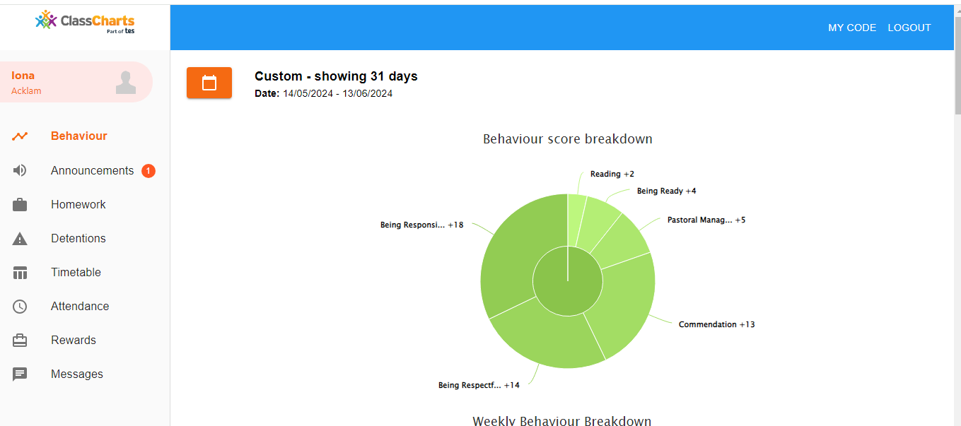
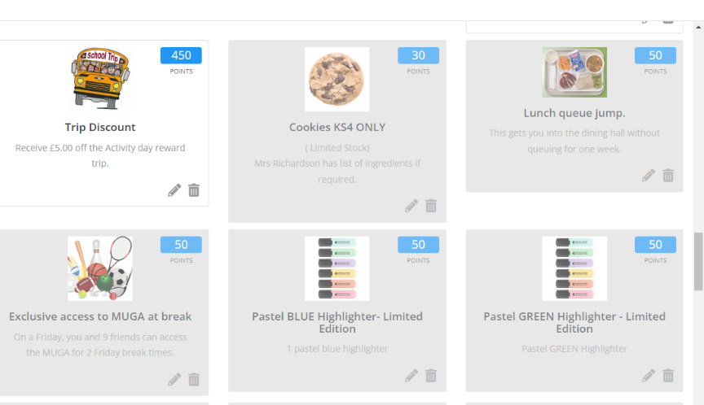
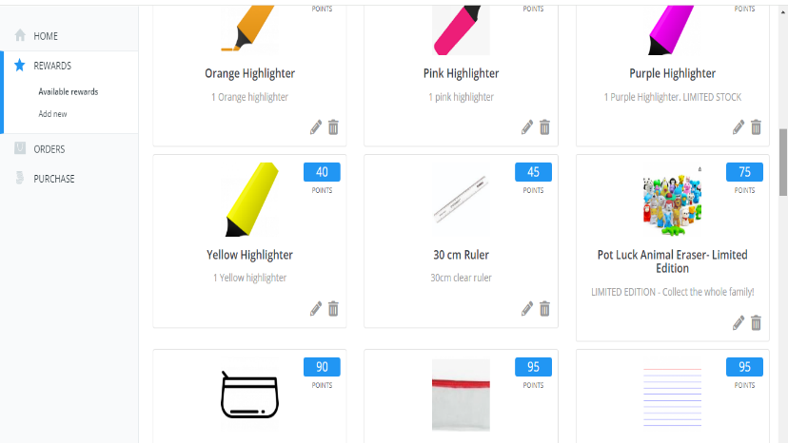

School Uniform
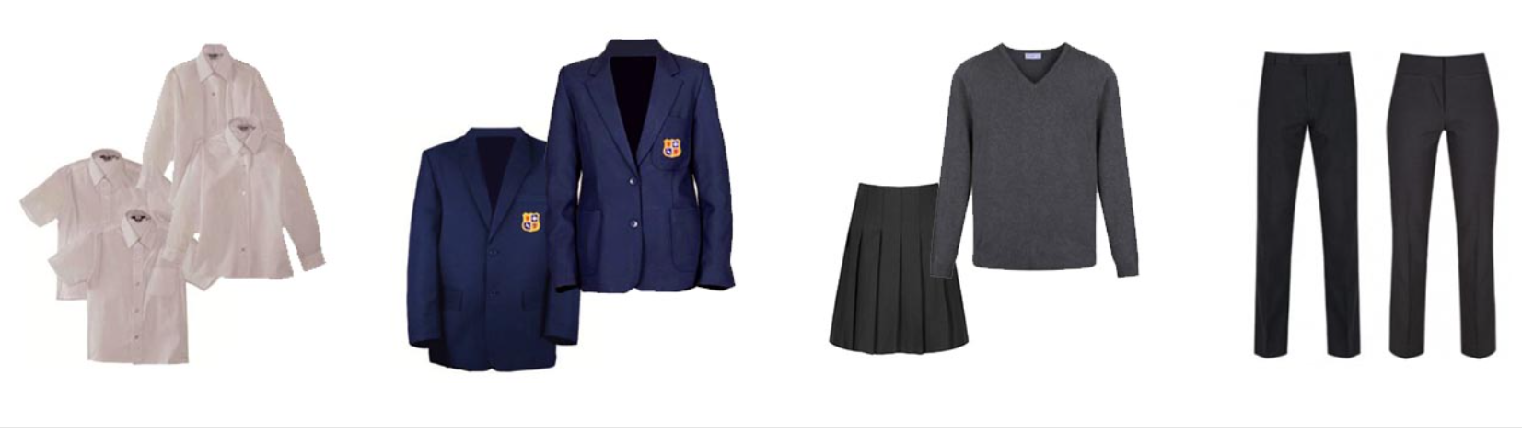
This is what my school uniform will be when I got to secondary school:

BASIC EXPECTATIONS FOR SCHOOL UNIFORM
- A blazer worn at all times while moving around the school. Students will be able to remove it with permission from staff once working in classrooms.
- The school tie worn at all times, and must reach the waistband of trousers/skirt when tied with a sensible narrow knot. Large loose knots not permitted. Ties should be worn directly over the top button of the shirt. Clip-on ties are available for those who have physical difficulty in fastening a tie.
- Plain white conventional school shirt must be worn by all students; free of branding, tucked in at the waist and have all buttons fastened.
- Trousers are dark grey; straight or boot cut and fall away from the knee (must not be skin tight); have a flair at the ankle of at least 3cm. Trousers must not be fashion items such as jeans, jean style, linen, skinny fit, leggings etc or include branding, accessories, brightly coloured zips. If a belt is worn it must be plain black or grey.
- Skirts are dark grey and pleated; must be worn as knee length (i.e. not above the knee cap when standing); must not be fashion items including branding, accessories, zips, etc. If tights are worn, they can be black, grey or nude but must be no more than 60 denier and plain, without any patterning. Tights must cover the foot, and as such not be leggings. If no tights are worn, then plain, white ankle socks must be worn (below the calf).
- Jumpers are optional. If worn they must be plain, dark grey, v-neck and knitted (not sweatshirt) and be free from branding and accessories.
- Shoes should be flat, plain and completely black. No trainers/trainer style, including plimsolls, canvas shoes and skate style shoes. As a guide they should be able to be polished.
PE UNIFORM
- A navy blue sports polo top with the school logo and navy shorts
- In cooler weather, navy tracksuit bottoms and navy sweatshirt/hoody with the school logo may be worn.
- Suitable trainers must be worn. Canvas shoes such as skate shoes and plimsolls are not suitable.

Key People
Here are the names of key staff members that will be important to me at secondary school:
Name | Who are they? | Where can you find them?
Miss Wilkinson | Head of School | At the front doors every day, welcoming students into school.
Miss O’Shaughnessy | Deputy Head and Safeguarding Lead | In her office on the Science corridor.
Mr Nicholson | Assistant Headteacher: Inclusion & SENCO | In his office on the Science corridor.
Miss Brooks | Assistant Headteacher: Well-being and attendance | In her office on the Humanities corridor.
Notes
Your form tutor will also be important to you and they will meet you at the door to form every morning.
You will also have buddies for the first two weeks at school, to help you remember your way around and to ask questions of.
We are really looking forward to meeting you.

Welcome to Huntcliff.

