

Transition Pack

My name:

My new secondary school:


To get to know your new school you can go on your school website.
Website address – www.laurencejackson.org

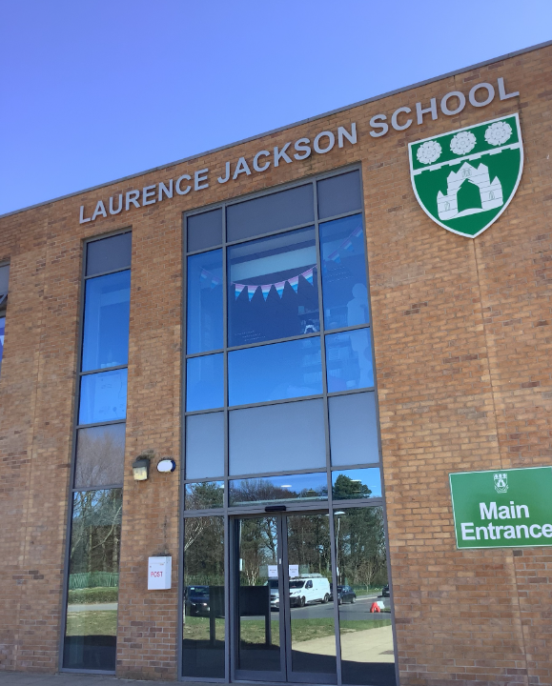
What my new school looks like
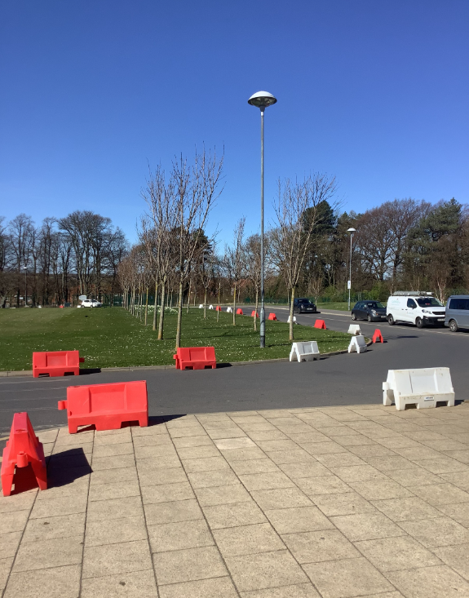

This is what our entrance looks like when you come onto the school site

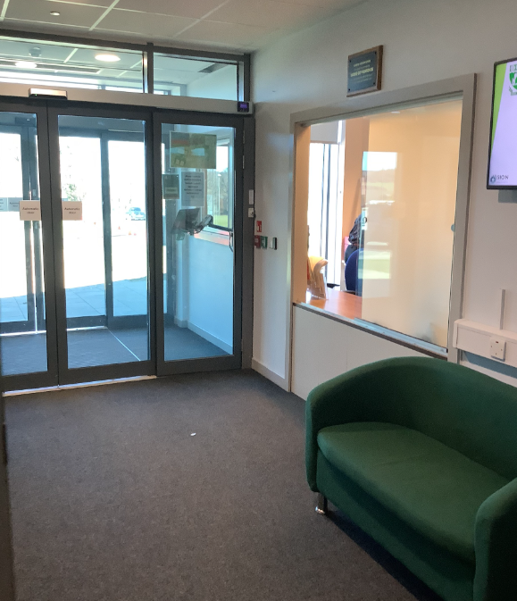
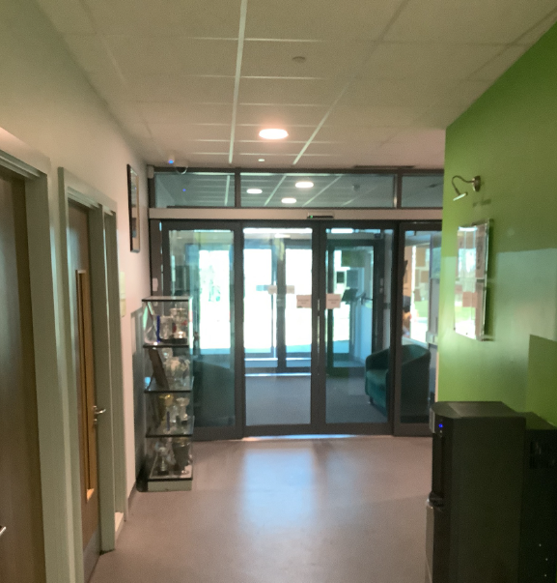
Main reception area
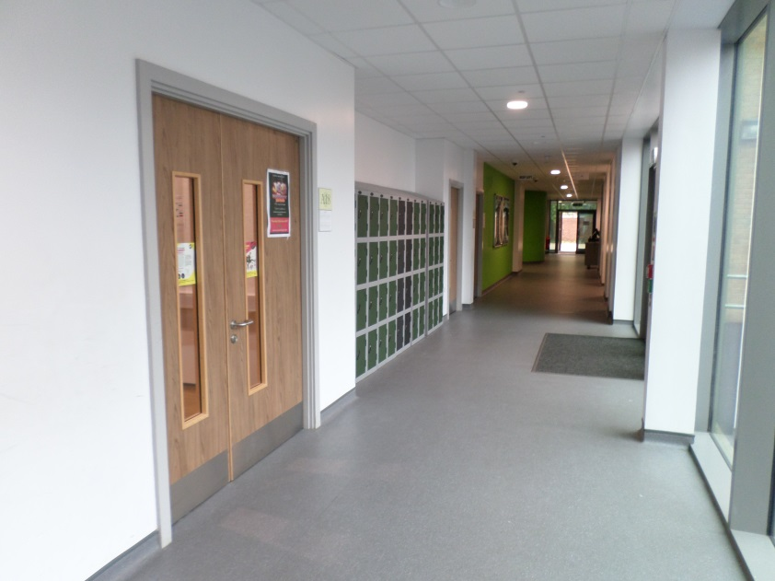
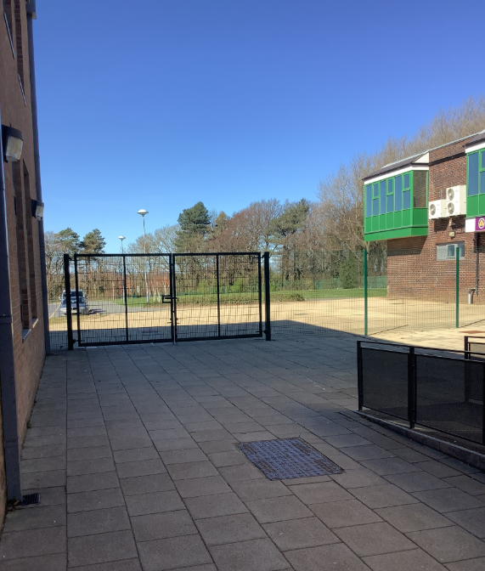
This is the main corridor, it connects all of the wings (corridors with classrooms on) to the main building. If you ever get lost, go back to the main corridor to help you find your way again!

The entrance gates I use when I arrive and leave school
This is called the Student Entrance

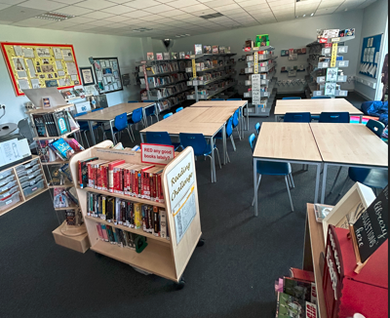

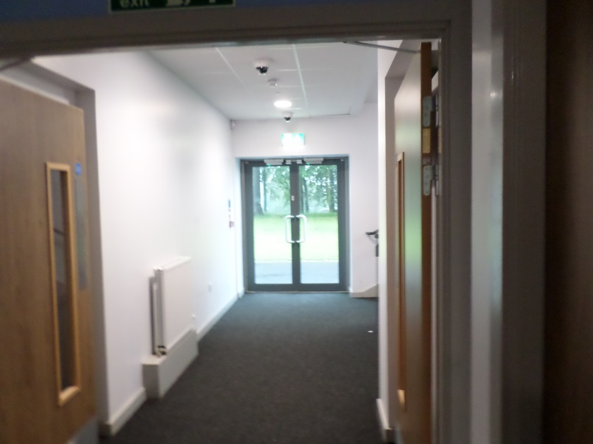
Doors I use to go out at breaktime.
There are 3 main wings – each one has doors at the end.
The Library
Lots of Year 7s like to use this space at lunchtime

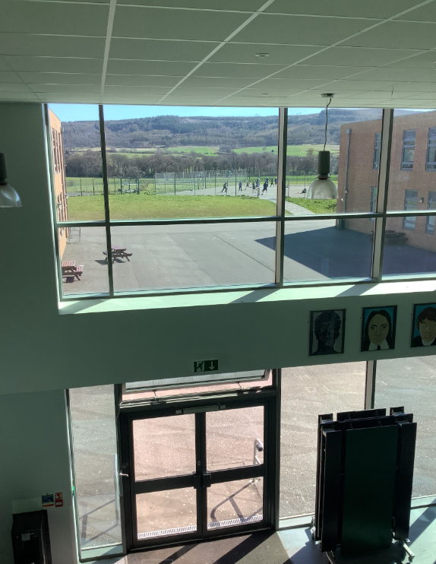
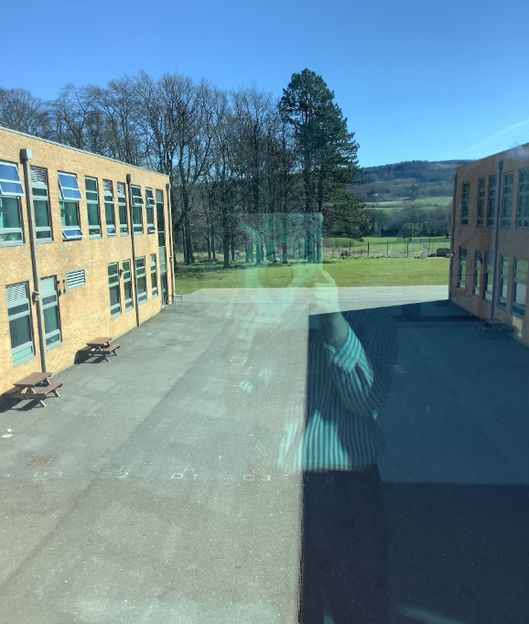

At breaktime all students use the yard area.
You also go here at lunchtime, after you have eaten your lunch.

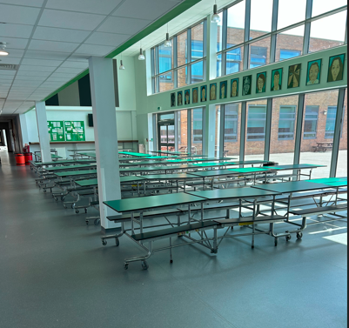

This is where you will eat your lunch.
You can have a school meal or a packed lunch in this area.

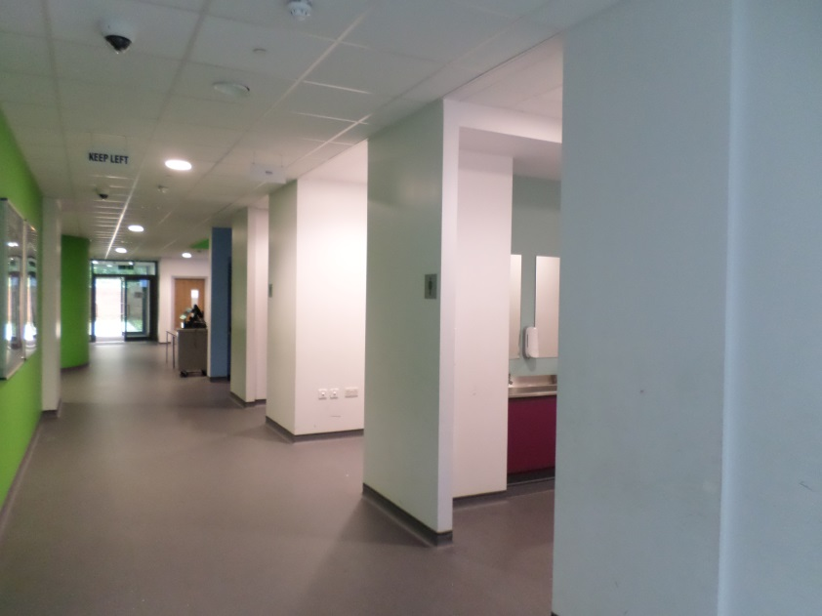
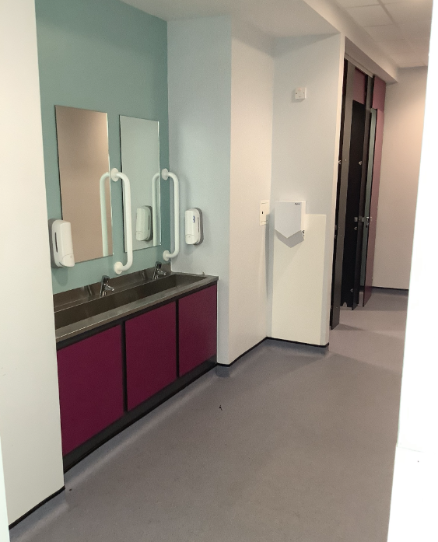
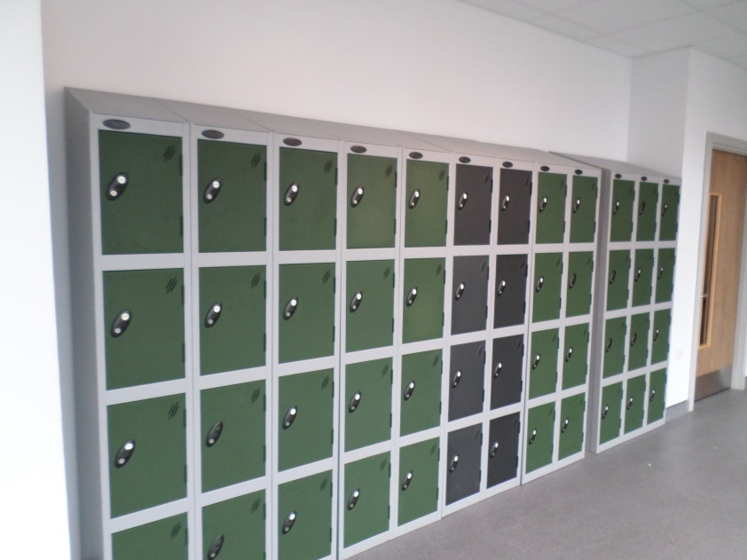
Lockers where you can store your PE kit.
Student Toilets.
There are toilets at the end of wings 1 and 2, upstairs and downstairs.

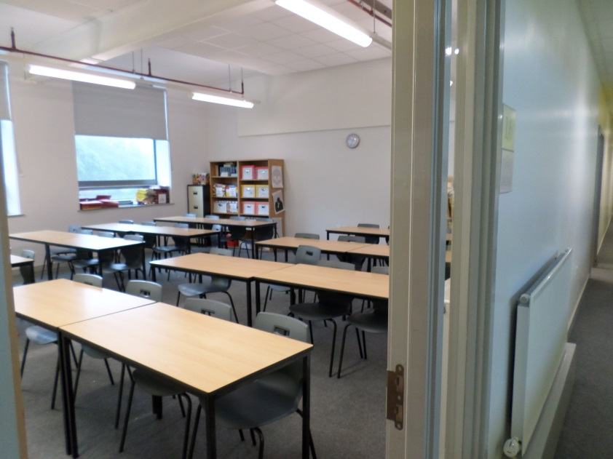

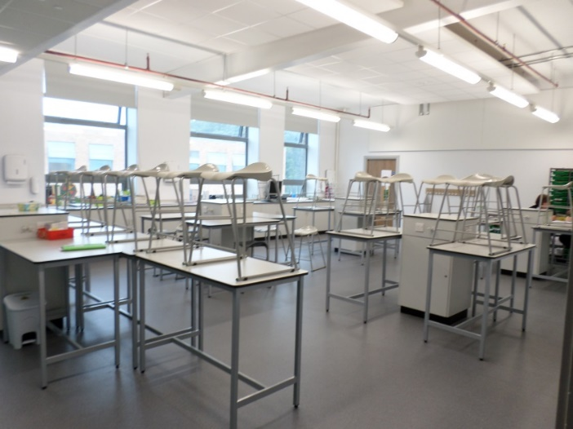
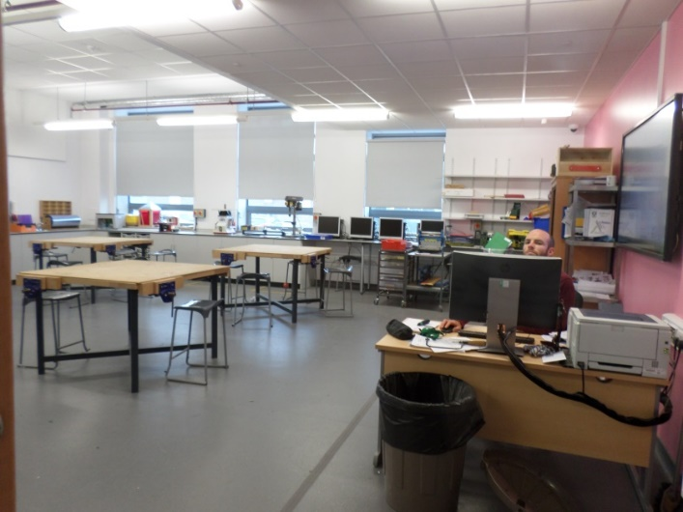
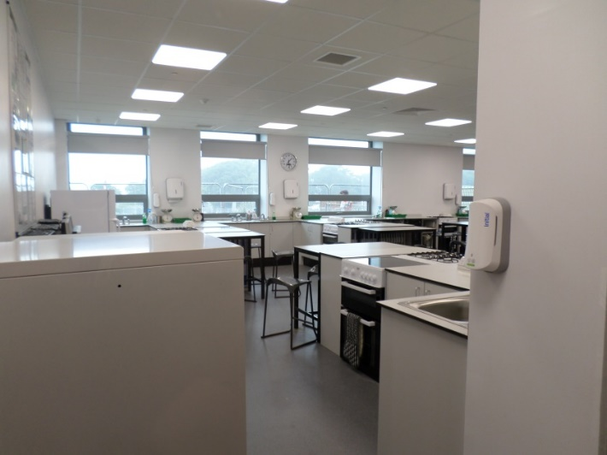
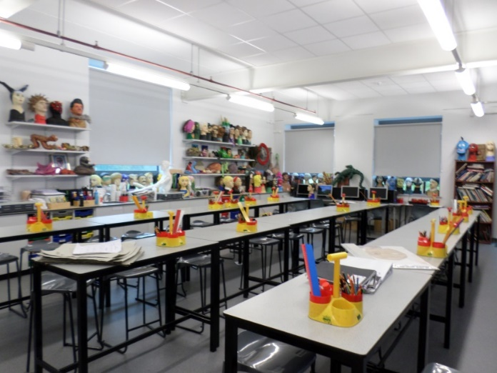
Science classroom
Technology classroom
Food Technology classroom
Art classroom
Most classrooms look like this.

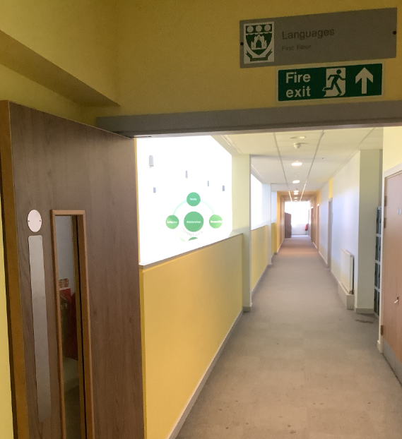

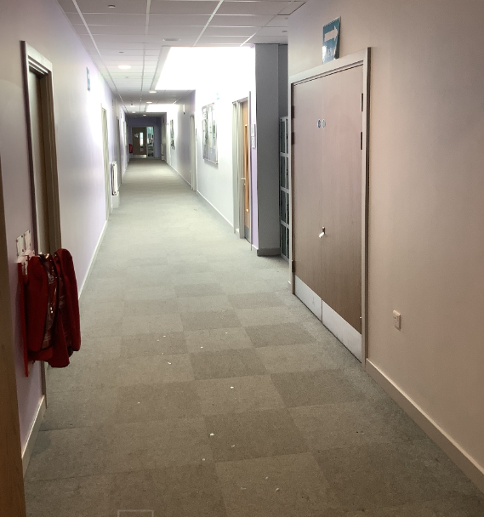
Purple corridor – upstairs in Wing 1
Maths classrooms

Yellow corridor – upstairs in Wing 1
English and Languages classrooms

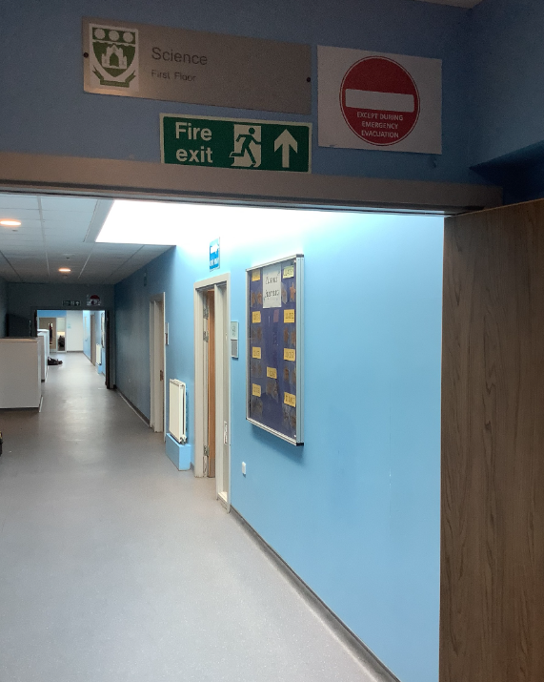

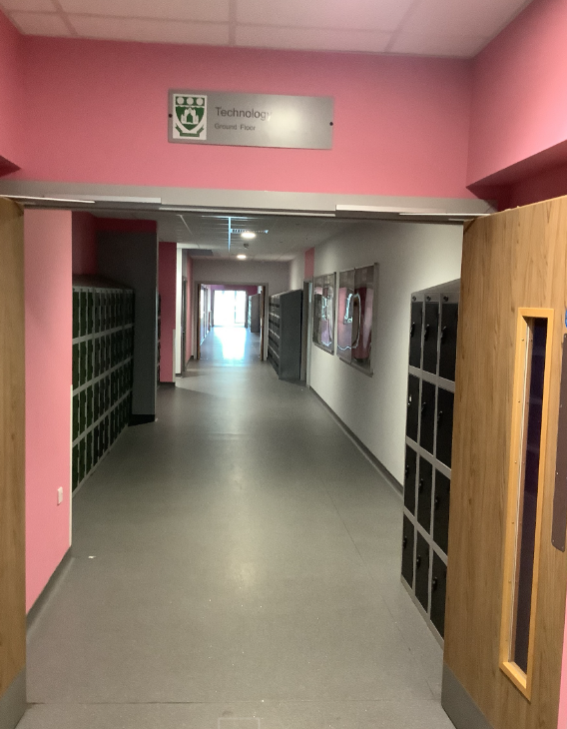
Pink corridor – Ground Floor in Wing 3
Music and Technology classrooms

Blue corridor – upstairs in Wing 1
Science classrooms

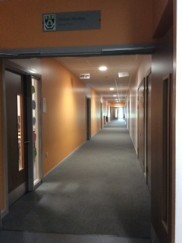
Orange corridor – Ground Floor in Wing 2
Geography. History and RE classrooms

Finding my way around
Its normal to be a little worried about getting lost. Lots of students might get a bit lost as they get to know their new school. It’s a new adventure! If you aren’t sure how to get somewhere, you can find a teacher or ask another student which way to go.
Here is a map of my new school:
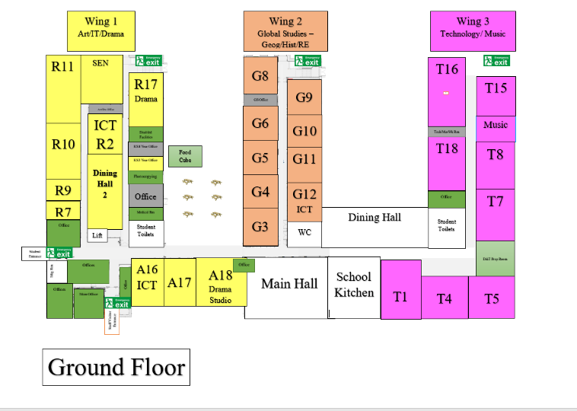

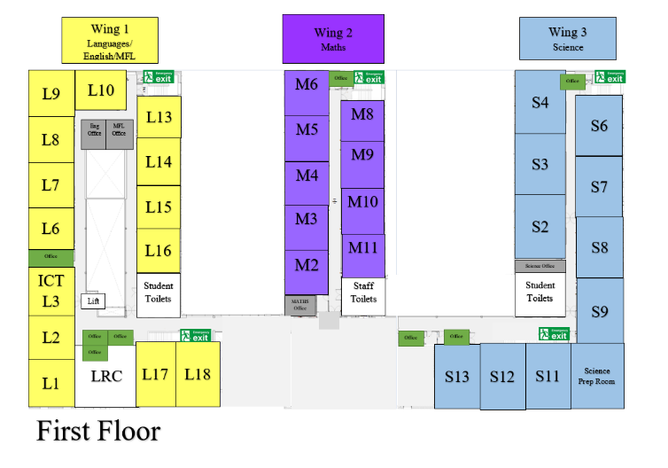
Finding my way around

Choose different colours and colour in:

Place in School | Colour on map
The door I will use to come in
Toilets
Dinner Hall
Main Office
Library
Sports Hall
Form room
Add anything else that is important to you……..

Timetable
My school day -
Time | Details
8:10 | Student entrance opens
8:20 | Students should be on their yard
8:25 | Line Up in Form Groups on the Yard
8:30 | Form Time
8:50 | Lesson 1
9:50 | Break
10:10 | Lesson 2
11:10 | Lesson 3
12:10 | Lunch
12:50 | Lesson 4
13:50 | Lesson 5
14:50 | End of the day  Clubs and Activities start

My timetable will show me what classes I have, when and where I need to be. Like this -

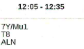
The room is T8.
The lesson is Music.

This is the teacher. Teachers’ names are shortened.

My full timetable will look like this. There will be a week A and week B timetable.
Week A:
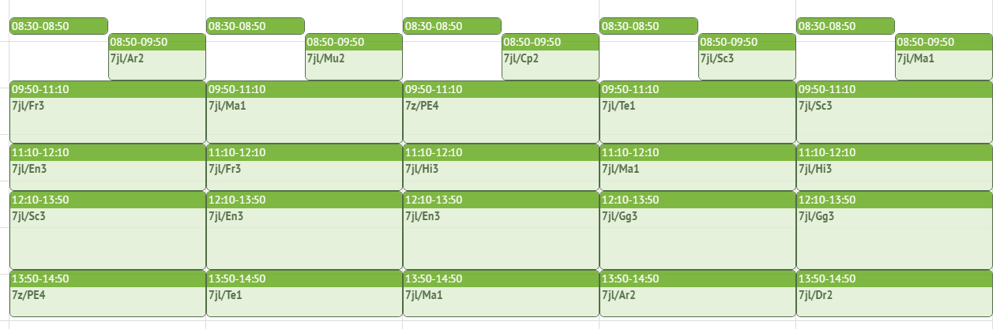
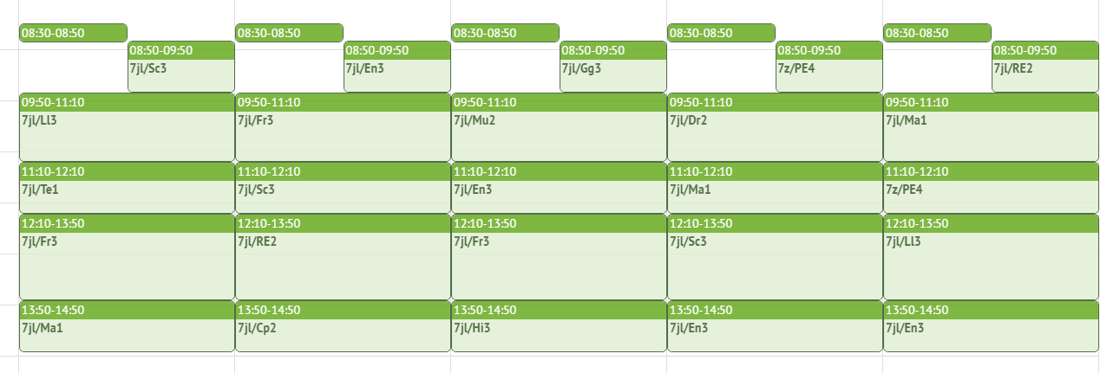
Week B:
School Uniform
This is what my school uniform will look like:
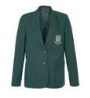
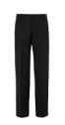



This is the PE kit:

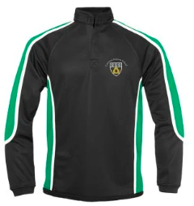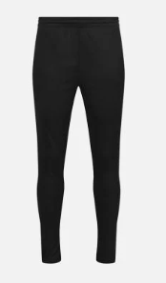
Key People
Here are the names and photos of key staff members that will be important to me at secondary school:
Name | Who are they? | Where can you find them?
Mrs Juckes   | Headteacher | You will see Mrs. Juckes around the school.  Mrs. Juckes makes sure that there are lots of people in school who can help you and make sure that you feel safe and happy in school.
Mrs Alderson   | Assistant Headteacher and SENCo | Mrs. Alderson’s office is in Wing 1, she works closely with the staff in Student Support.  Mrs. Alderson is also on duty in the Year 7 area throughout the week.

Notes

