

Transition Pack

My name:


My new secondary school:
Sacred Heart Catholic Secondary

To get to know your new school you can go on your school website.
Website address – sacredheart.npcat.org.uk
The homepage of the website shows some video clips of the different areas, subjects, and departments around the school.
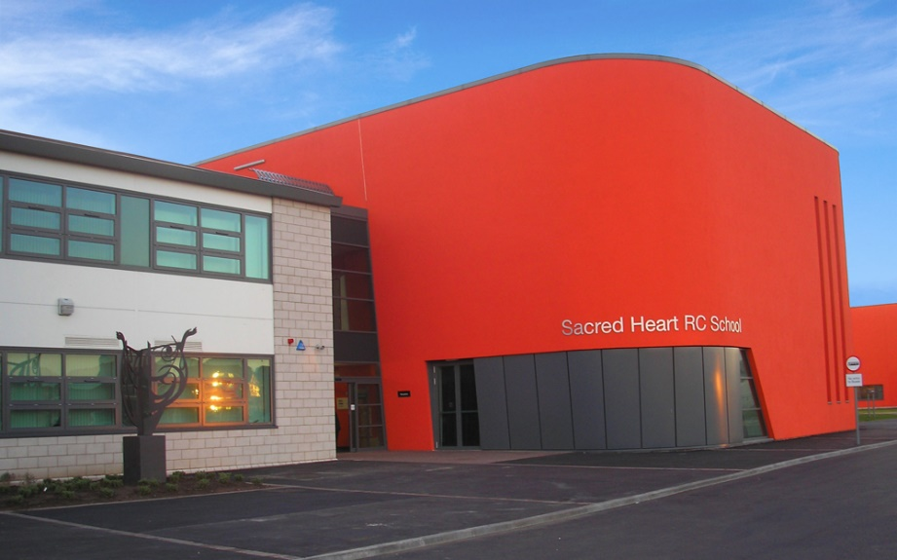
What my new school looks like
Student Entrance
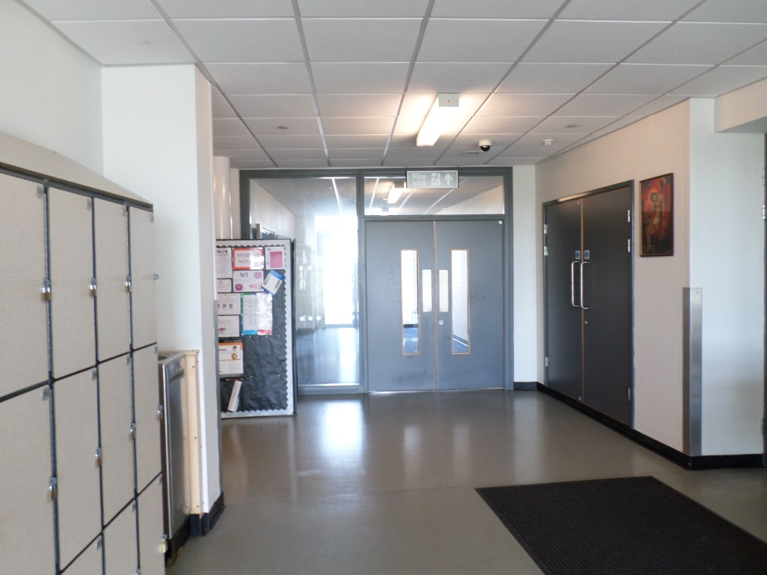
Lockers
Water Fountain
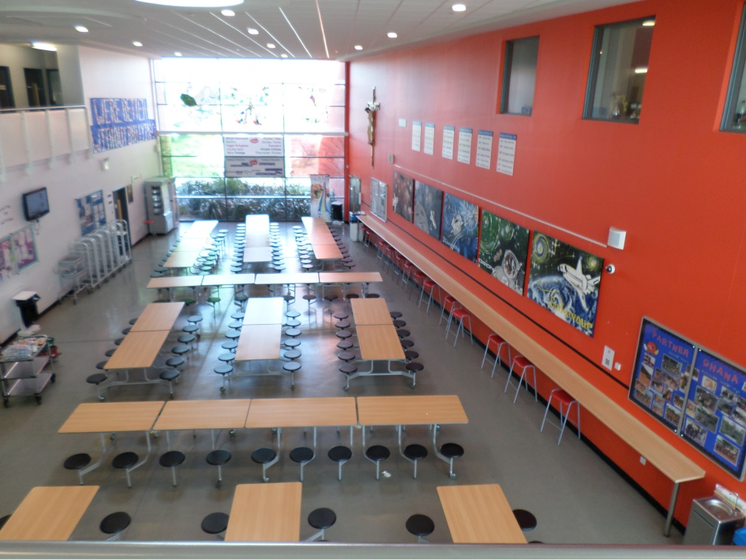

Dining Hall

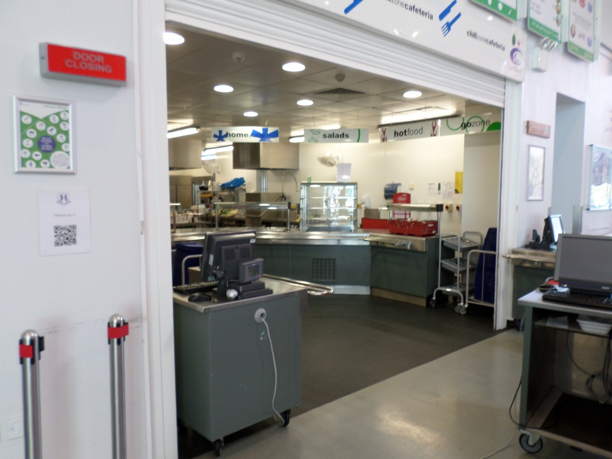

Canteen

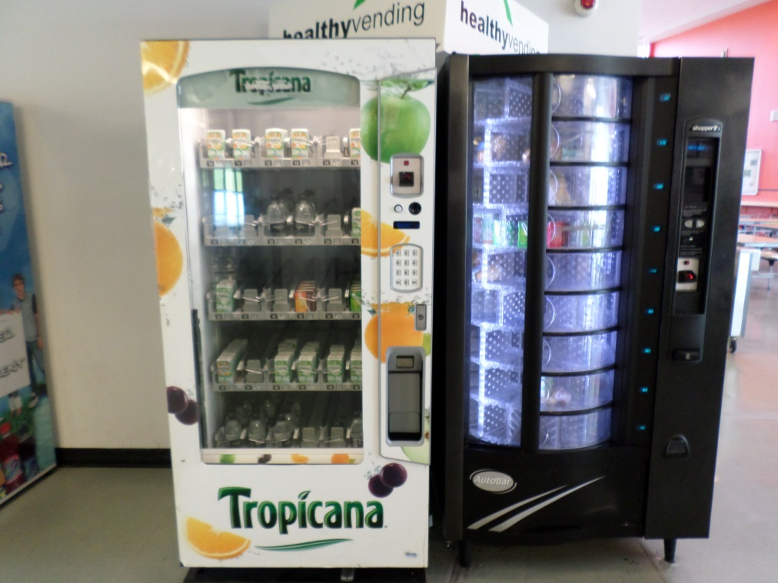

Vending machines

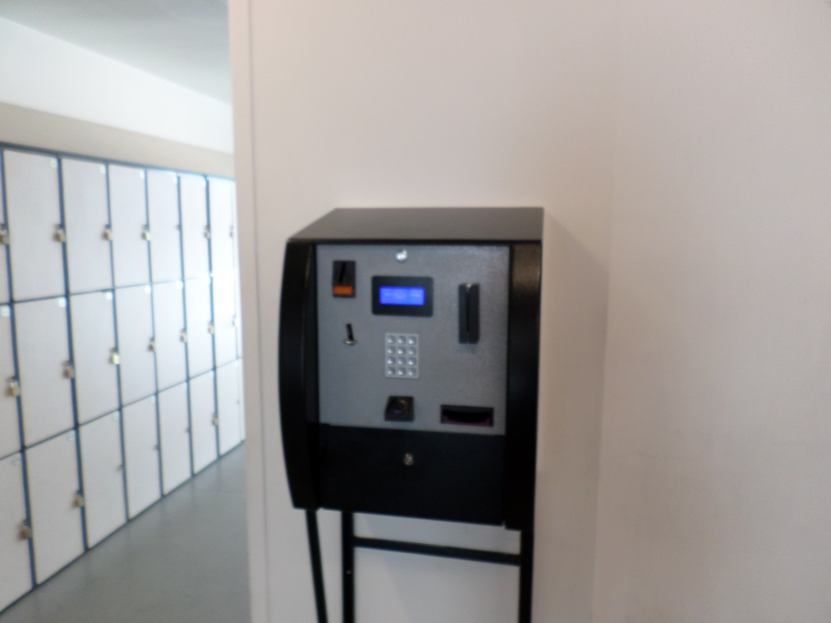

Cashless biometric payment system
Use your fingerprint to buy your lunch!

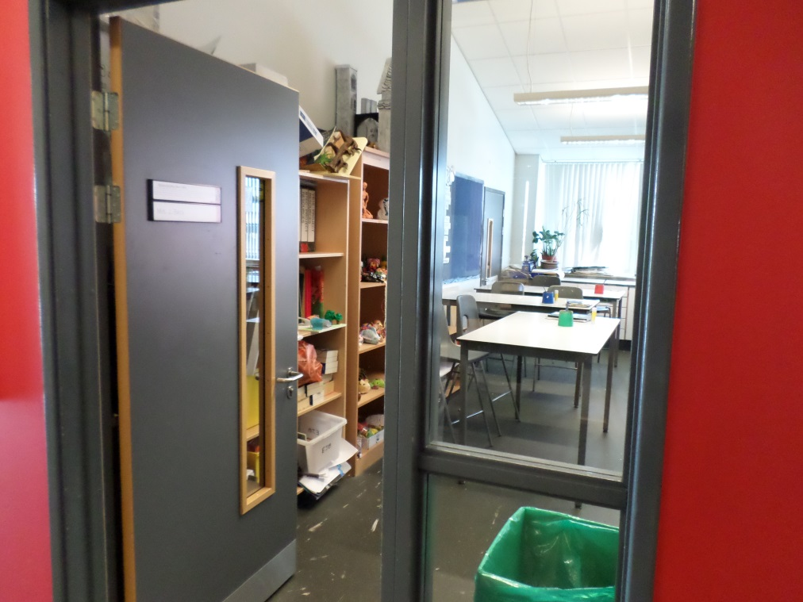

Art classroom

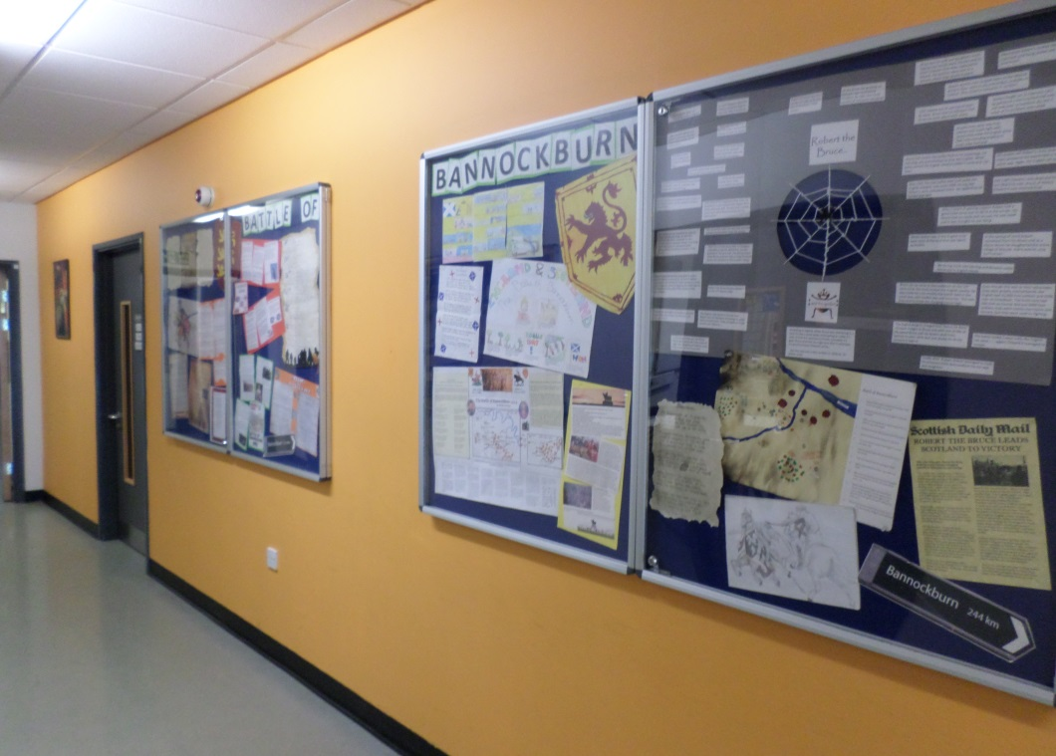

Humanities Corridor
(History Geography, RE)

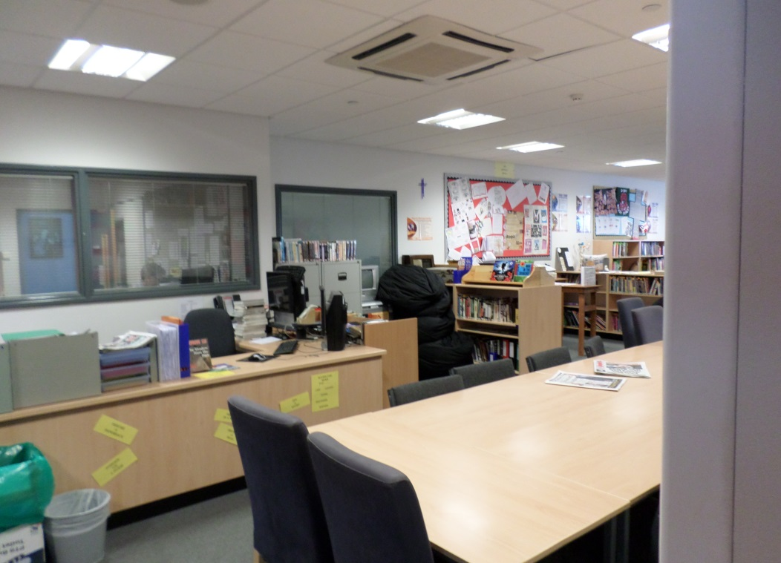

The library

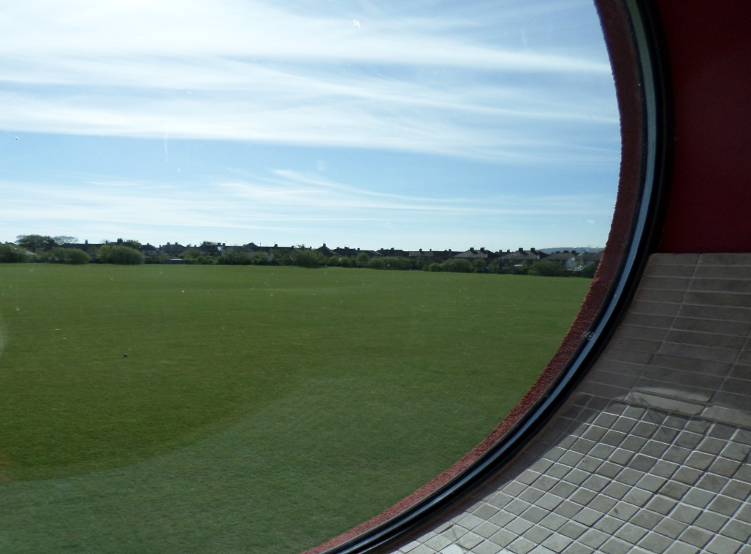

Sports field

Finding my way around
Its normal to be a little worried about getting lost. Lots of students might get a bit lost as they get to know their new school. It’s a new adventure! If you aren’t sure how to get somewhere, you can find a teacher or ask another student which way to go.
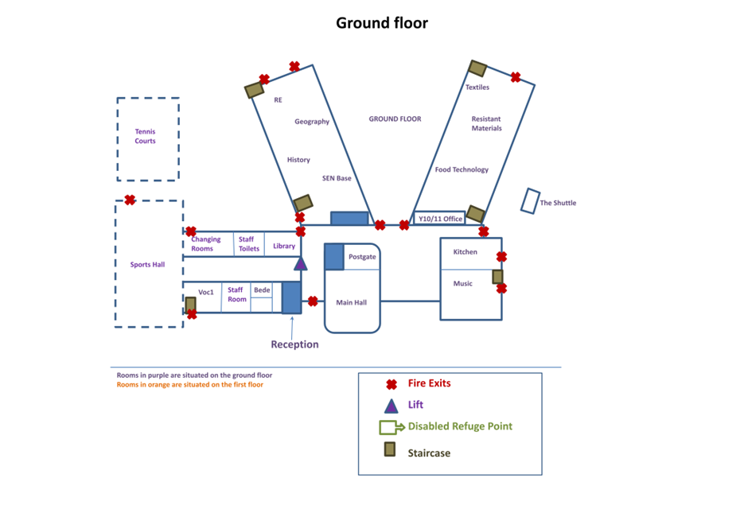
Here is a map of my new school:
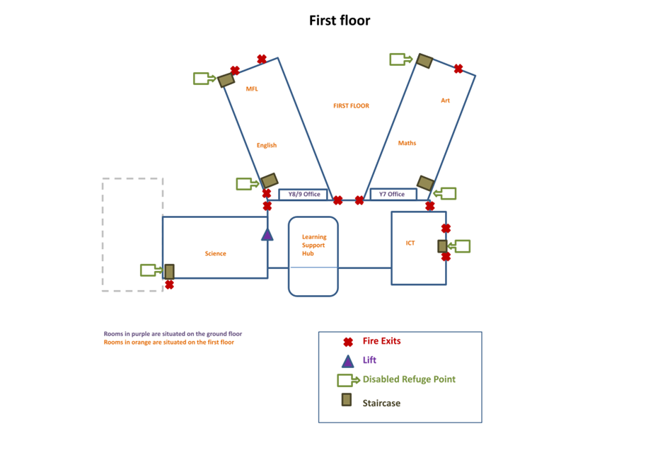
Finding my way around

Choose different colours and colour in:

Place in School | Colour on map
The door I will use to come in
Toilets
Dinner Hall
Main Office
Library
Sports Hall
Form room
Add anything else that is important to you……..

Timetable
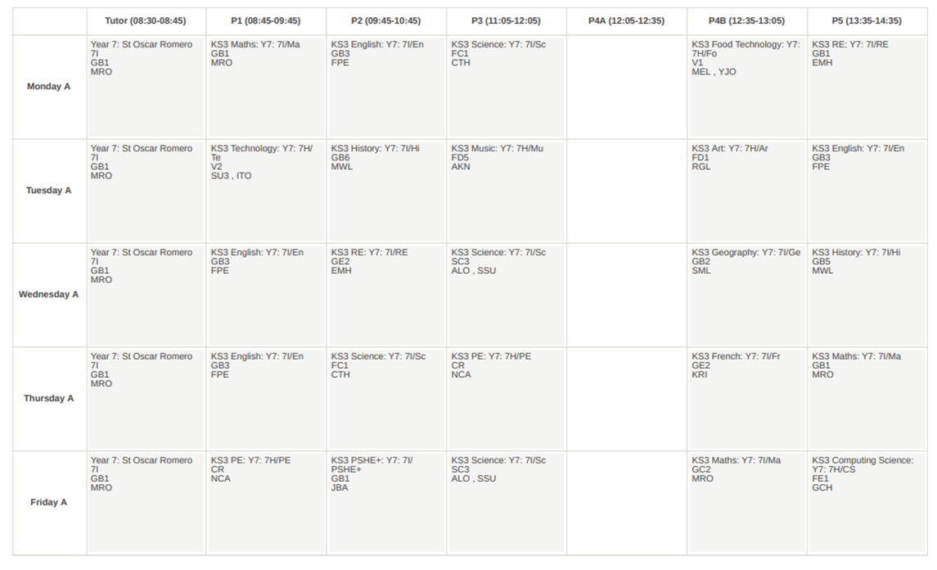
Here is an example of what my timetable will look like:

The School Day - Year 7
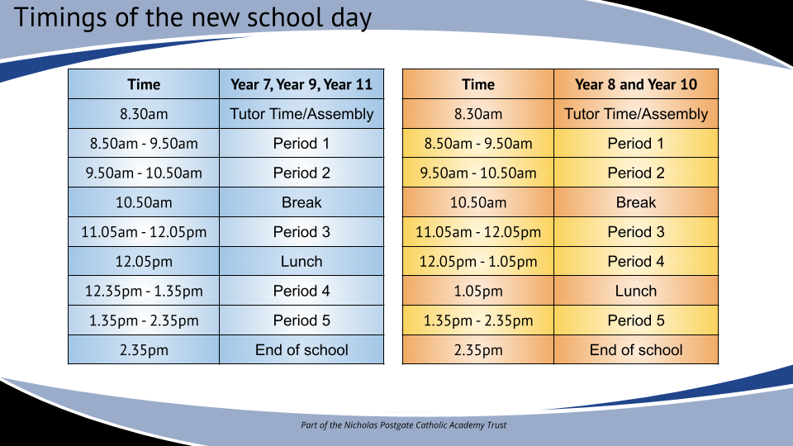
This is a timetable of our school day, you will have a range of different lessons, but the times of the day do not change.
School Uniform
This is what my school uniform will be when I got to secondary school:
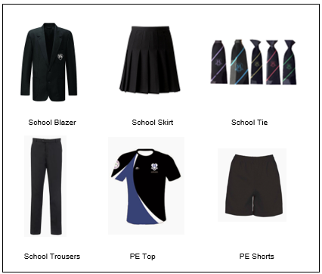
Do’s and Don’ts:
- Skirts must be worn at knee length
- Any trouser that is a jersey style fabric for example, a legging or any denim is strictly not allowed. Trousers that are slim fit are acceptable as long as they are a trouser and not a jersey style legging or denim.
- Cords or canvas type trousers are not permitted
- Shirts must be worn tucked in
- No sweatshirts or cardigans
- Plain black polishable shoes. No fashion shoes, boots, trainers or other sports shoes
- No make-up or false eyelashes
- No false nails or acrylic nails or nail varnish
- Earrings and nose piercings. We do not allow piercings including temporary clear ones or a plaster covering the piercing. All must be removed.
- No jewellery at all***
- Only natural coloured hair dye is permitted
- All pupils must bring a school bag everyday to carry sports kit and classroom equipment. This is an expectation.

Hair - Rules at Sacred Heart

Mid to long length hair

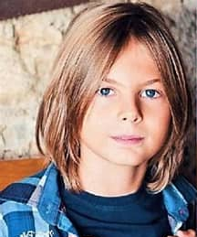
- Must be tied back away from the face during certain lessons which includes:

PE
Design and Technology
Science

This is for Health and Safety reasons e.g., when using a Bunson burner in science the hair may get caught by the flame and set alight by the burner.
In Design and Technology the hair may get caught in equipment like the sander. In PE the hair may get caught in equipment like the trampoline springs.
This could cause a serious accident for the pupil.

School staff have a duty of care to keep all pupils safe in school and we need to ask all students with mid to long hair to tie it back - this applies to boys and girls.

Staff will be very happy if students follow the rule in these lessons.
Staff are trying to keep all students safe.
I will try to follow the rule on tying my hair back in PE, Design and Technology and Science lessons
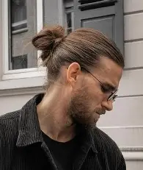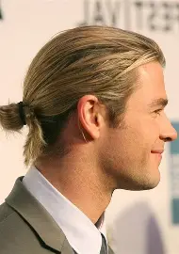

Key People
Here are the names and photos of key staff members that will be important to me at secondary school:
Name | Who are they? | Where can you find them?
Notes

