

TRANSITION PACK

Student Name
Current Primary School

Contents

Contents 2
All about you 3
Our School 4
Catholic Life 5
Behaviour and Expectations 6
The School Day -Year 7 7
Timetable 8
Our School Uniform 9
Equipment you need to bring with you everyday 10
Key people 11
How do you feel? 12
Some things to help you with your worries 13
Travelling to Secondary School 15
Developing Friendships 16
A Trusted Person 17
Quiz 18

All about you
We would love to find out a bit more about you.

I am looking forward to starting secondary school because…

The things I most enjoy about primary school are…

Outside of school, my hobbies and interests are…

The things I am nervous about secondary school are…

My friends in school are…

Some things you need to know about me are…

Our School

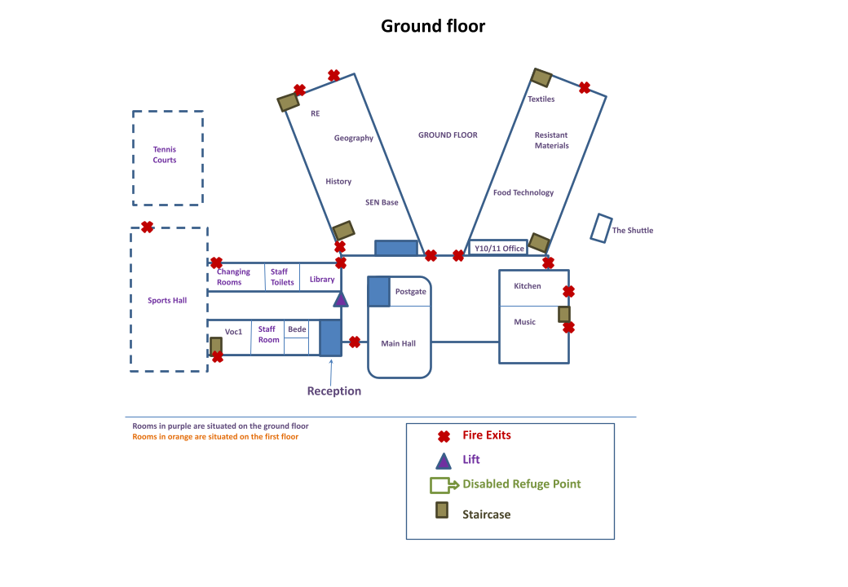

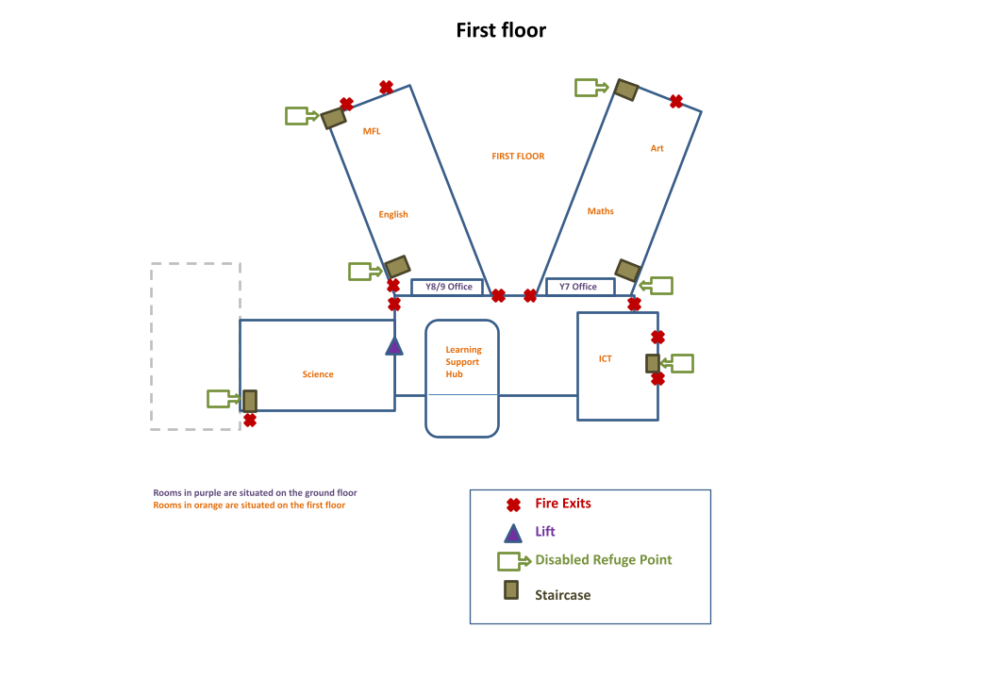

Catholic Life

Our School Prayer

All: Christ has no body but ours,
No hands, no feet on earth but ours.
Ours are the eyes with which he looks
With compassion on this world.
Ours are the feet, with which he walks to do good.
Ours are the hands, with which he blesses all the world.
Ours are the hands, ours are the feet,
Ours are the eyes, we are his body.

Collective worship

At Sacred Heart our prayer life is at the heart of what we do. Each day our tutor time begins with the opportunity to bring our prayers to God as a form class.

Each week we take part in a "Celebration of the Word" where we reflect and pray on the theme for the week. Once a fortnight members of your tutor group will be invited to plan and lead a time of prayer in your tutor group. Don't worry we help you plan it, but you can decide what the tutor does during this time. Each of these starts with a piece of scripture linked to the theme for the week, you are invited to reflect and respond to this and finally as the time of prayer closes you will be given a mission to go out and do in our lives.

Prayer is about helping us to live out our faith in the choices we make both in school and out of school.

Every day we finish the day with a review of the day and closing prayer.

Behaviour and Expectations

A1 - First formal negative behaviour

You will be told you have an A1 and your name will be written on the board at this point.

A2 - Second negative behaviour

You will be told you have now moved to A2 and your teacher will try to talk to you.

A3 - Third negative behaviour

You will be reminded that it is your choice to break the rules and the rules you are breaking. You will be offered solutions on how you can alter your behaviour such as :

● Set time markers for completing work, “You are here now and when I come back you should be here”, mark with the time.

● Moving seats – if this is possible.

● Offer different activities.

● Ask them to take a minute to think about their behaviour.

A4 - Fourth negative behaviour or immediate A4 for Health & Safety reasons

At this point you must leave the room to the Reflect Room. You will be given an Approach sheet filled in (yellow A4 slip). You must be at the reflect Room within 5 minutes of being sent. You stay in this room and must not cause disruption or disturbance to a class if a lesson is underway. Failure to meet these instructions will mean an issue of an A5 from the Reflect Room teacher.

A5 - Fifth negative behaviour or immediate A5 for:

● Health and Safety

● Violence or threatening behaviour towards others

● Walking away from a member of staff refusing to hand over items, which

are not allowed in school

● Swearing

● Smoking

● Not attending a A4/A4 OTHER detention

● Refusal to follow a reasonable request

● Other behaviours at the Headteacher’s discretion

● Fifth misbehaviour (in reflection) means that you are sent to the CSC Room for the rest of the lesson.

Rewards policy
His master said to him, ‘Well done, good and faithful servant. You have been faithful over a little; I will set you over much. Enter into the joy of your master.’ Matthew 25:21
Principles and aims -
The rewards policy aims to create an environment where children feel supported, motivated and inspired to embrace their faith, excel academically and become compassionate and responsible individuals in society.
House system
The house system fosters a sense of belonging and identity creating a smaller community within the school, allowing the students to develop a strong sense of belonging and pride. By assigning students to specific houses, they work together to achieve common goals. This sense of identity and affiliation enhances school spirit and strengthens the overall school community.
Each student and staff member (with the exception of the headteacher) will be attached to a house from year 7 and stay within that house throughout their journey at Sacred Heart. Each house will be attached to a form group and inspired by our Catholic ethos, all of our houses are named after Patron Saints – whom the students will learn about. The houses will have their own motto which represents the guiding principles and values that the house system upholds.

The houses
  House - Romero  Virtue - Stewardship  Colour - Green  Patron St Oscar Romero  Motto - Dum spiro spero (While I breathe, I hope) | House - Bakhita  Virtue - Compassion  Colour - Red  Patron St Josephine Bakhita  Motto - beata vita gratia ducitur (A blessed life is  led by Grace)
  House Lisieux  Virtue - Attainment  Colour - Purple  Patron St Therese of Lisieux  Motto Proximos ama sicut te ipsum (Love your  neighbour as you love yourself) | House - John Paul II  Virtue - Diligence  Colour - Orange  Patron St John Paul II  Motto - Sapientia et diligentia (Wisdom and diligence)
House - Kolbe  Virtue - Resilience  Colour - Blue  Patron St Maximillian Kolbe  Motto - Ambula in vestigiis Dei (Walk in the  footsteps of God) | House - Soubirous  Virtue - Effort  Colour - Yellow  Patron St Bernadette of Soubirous  Motto - Humilitas est vera magnitudo (Humility is  true greatness)
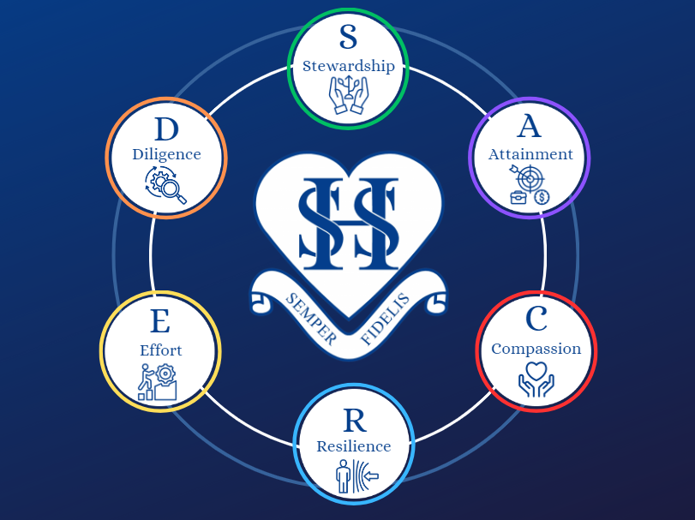
The system will be based around awarding house points to individual students. These house points will be recorded on Arbor and students will be rewarded for the accumulation of house points over the five school years. This system is designed to give every student the opportunity to be rewarded and all staff will have the ability to award house points. The system is designed to be comprehensive, encompassing all strands of school life. The following diagram outlines the values the students will be rewarded house points for:

House Competitions
Each half term there will be a range of curriculum, sporting and staff competitions that
are open to all, whereby the students and staff can achieve house points.

The rewards
House points will lead to the following awards:
Award | No. of house points |  | Weekly awards | Rewards
Commendation | 25 |  | 10 house points per week with no A4’s and A5’s | A raffle ticket entered into a half term prize draw.
Bronze | 50 |  | 100% attendance in a week | 2 house points awarded.
Silver | 75 |  | Highest form group attendance in each year. | 1 house point awarded per form member.
Gold | 100 |  | Headteachers award | A gift bag presented by the headteacher.
Platinum | 125 |  | Curriculum star of the week | A certificate awarded to the student and posted on social media for individuals who have been recognised by staff
Emerald | 150 |  | Sacred Heart home | Staff members call home to at least one student who has displayed the core values.
Sapphire | 175 |  | Half termly awards
Ruby | 200 |  | Highest form group attendance in each year. | A prize for every member of the form.
Diamond | 250 |  | Accumulation of raffle tickets for house points with no A4’s and A5’s | A prize draw for each year group with the choice of three mystery boxes to choose from
Headteachers | 300 |  | Winning house based on the number of house points | Winning house treat for all year groups in that house
Hegarty | 450 |  | Termly Awards
Sacred Heart | 550 |  | Whole school celebration assemblies | Christmas, Easter and Thanksgiving assemblies are a time to celebrate all of our God given Talents.
Nicholas Postgate | 600 |  | End of year
 |  |  | Students who have a positive attitude to learning (received no A4’s / A5’s in each half term) will receive a raffle ticket to be entered into an end of year prize draw. With a total of 5 possible tickets. | A grand prize draw to win a luxury item / gift.
 |  |  | A celebration of our God given talents in an evening spent with parents / guardians | Junior awards evening.
 |  |  | Sports / Enrichment day | House points are awarded to end of year totals.

For each individual award the students will receive a certificate which will be presented to them in their year group weekly assembly. Weekly house point totals will be displayed in form rooms, announced in assemblies and over the school tannoy system. Once they pass the platinum award they will receive a pin badge to wear on their lapel, these will be traded in for the next badge once they reach this award.

Student leadership
Students at Sacred heart will have the opportunity to apply for the role of house (Yr 10) and vice captain (Yr 9) working alongside our head students and prefects. The role of house / vice captain will empower students, provide support and mentorship, amplify student voice, and ensure the continuity and legacy of the house system.

The School Day -Year 7
This is a timetable of our school day, you will have a range of different lessons, but the times of the day do not change.
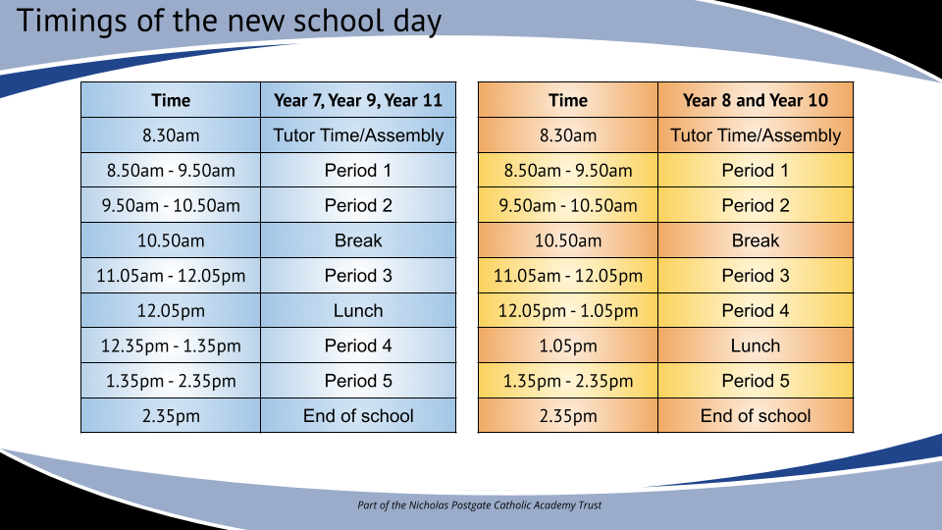

Timetable
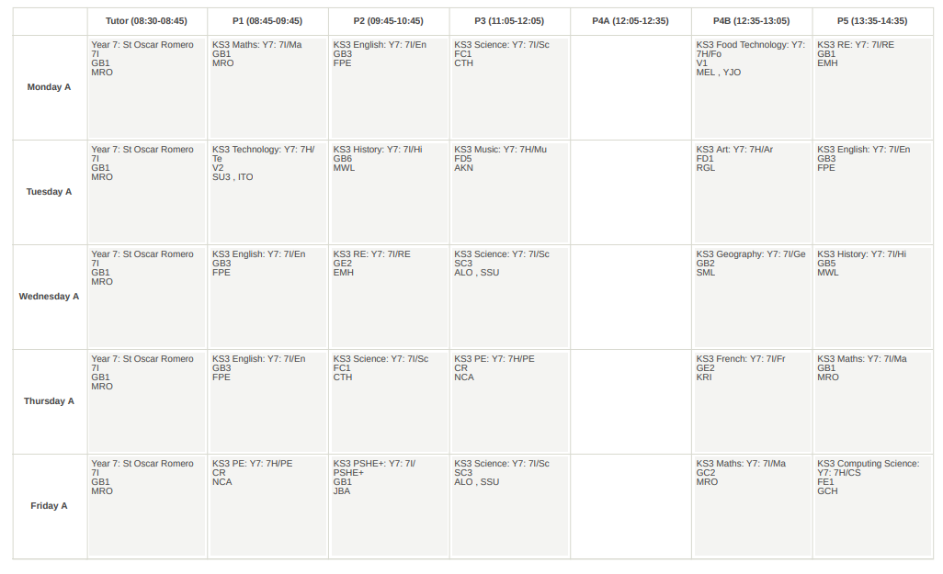
If this was your timetable:

Which days would you need to bring your P.E. kit?

What lesson is on Tuesday Period 4?

Which room is Computer Science in?

Our School Uniform

Do’s and Don’ts:
- Skirts must be worn at knee length
- Any trouser that is a jersey style fabric for example, a legging or any denim is strictly not allowed. Trousers that are slim fit are acceptable as long as they are a trouser and not a jersey style legging or denim.
- Cords or canvas type trousers are not permitted
- Shirts must be worn tucked in
- No sweatshirts or cardigans
- Plain black polishable shoes. No fashion shoes, boots, trainers or other sports shoes
- No make-up or false eyelashes
- No false nails or acrylic nails or nail varnish
- Earrings and nose piercings. We do not allow piercings including temporary clear ones or a plaster covering the piercing. All must be removed.
- No jewellery at all***
- Only natural coloured hair dye is permitted
- All pupils must bring a school bag everyday to carry sports kit and classroom equipment. This is an expectation.
***a religious medal, cross, crucifix on an appropriate chain is permitted – but must be out of sight.

Items of uniform that I need to wear:

- Traditional black school blazer with school badge on the left pocket
- Plain black school trousers (worn with plain black socks) or plain black school knee length pleated skirt (worn with opaque black tights)
- Plain white school shirt with top buttoning collar
- School year group tie
- Plain black sensible, polishable shoes
- Optional – plain black v-neck jumper

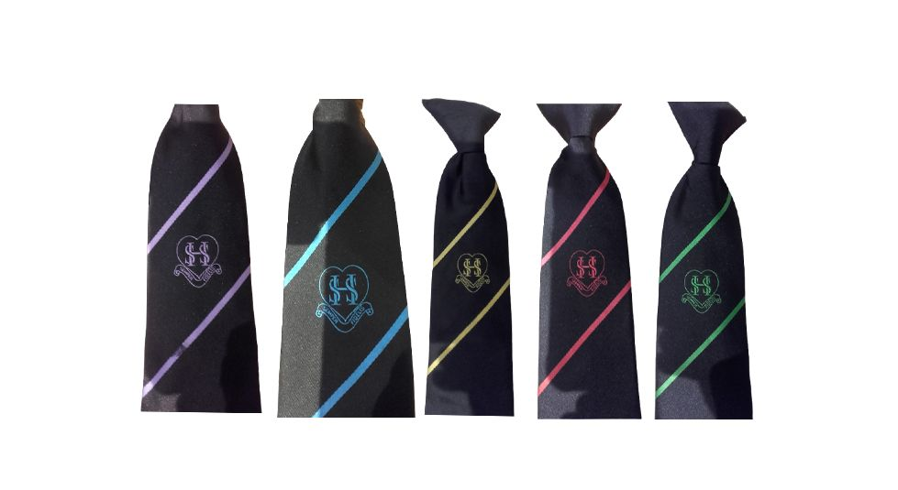
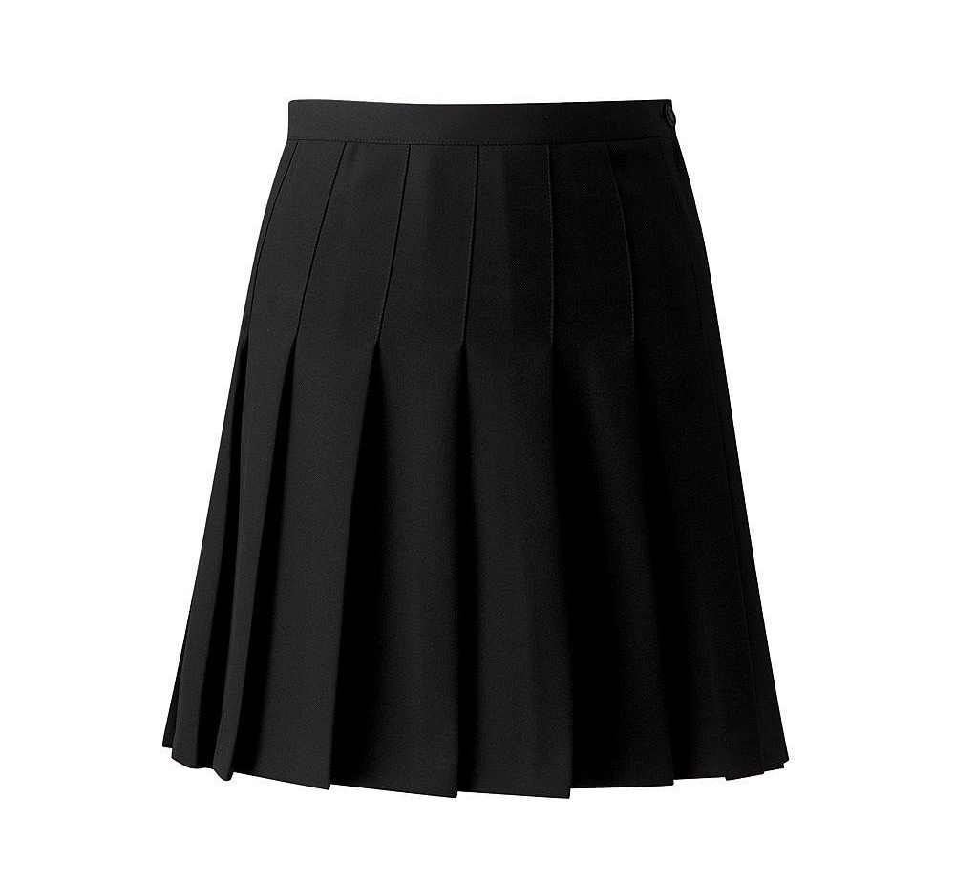
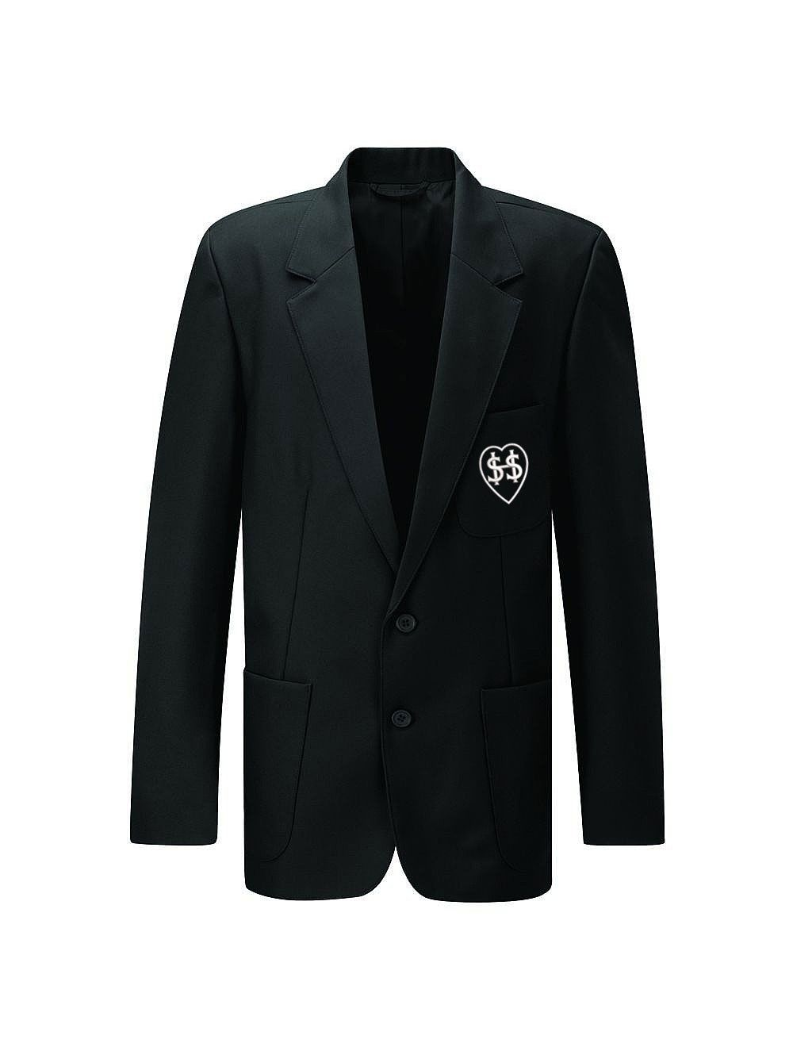
School Blazer School Skirt School Tie
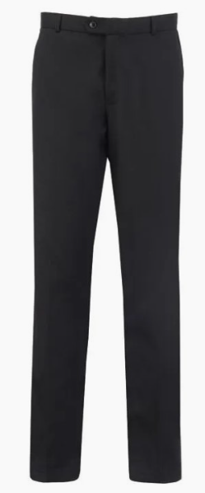
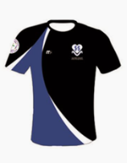


School Trousers PE Top PE Shorts

Equipment you need to bring with you everyday

You will need to bring some equipment with you to school and you need to make sure that you have them in every lesson.

SCHOOL BAG | 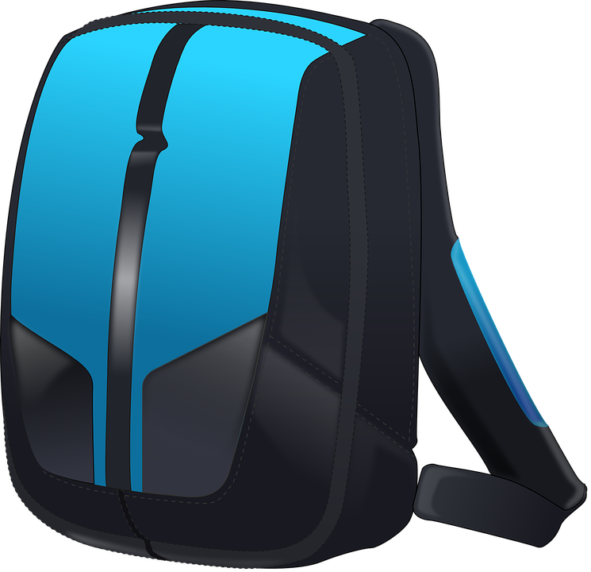 | You will need a school bag that is able to hold an A4 folder
PENS |  | Blue or black ball point pens so you can write in your lessons
PENCILS |  | Pencils so that you can draw diagrams or pictures in your lessons
RUBBER | 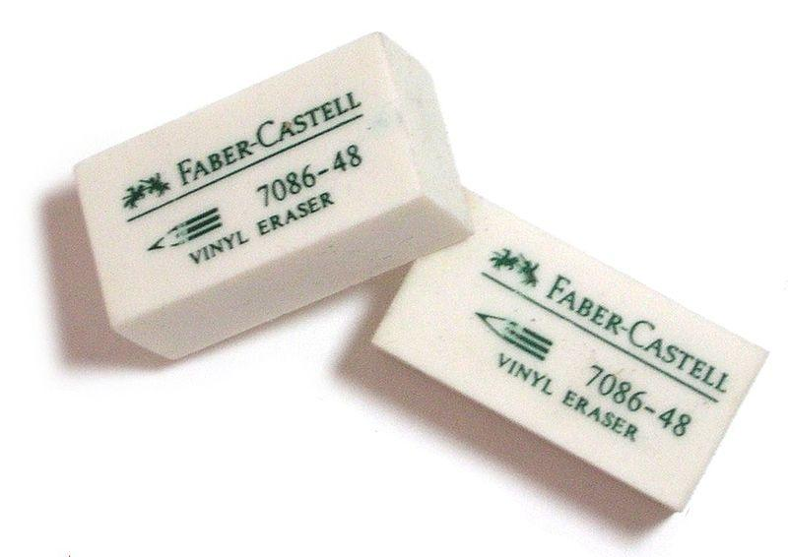 | Erasers so you can rub out any mistakes
SHARPENER |  | Pencil sharpener so you can sharpen your pencils when they become blunt
PENCIL CASE | 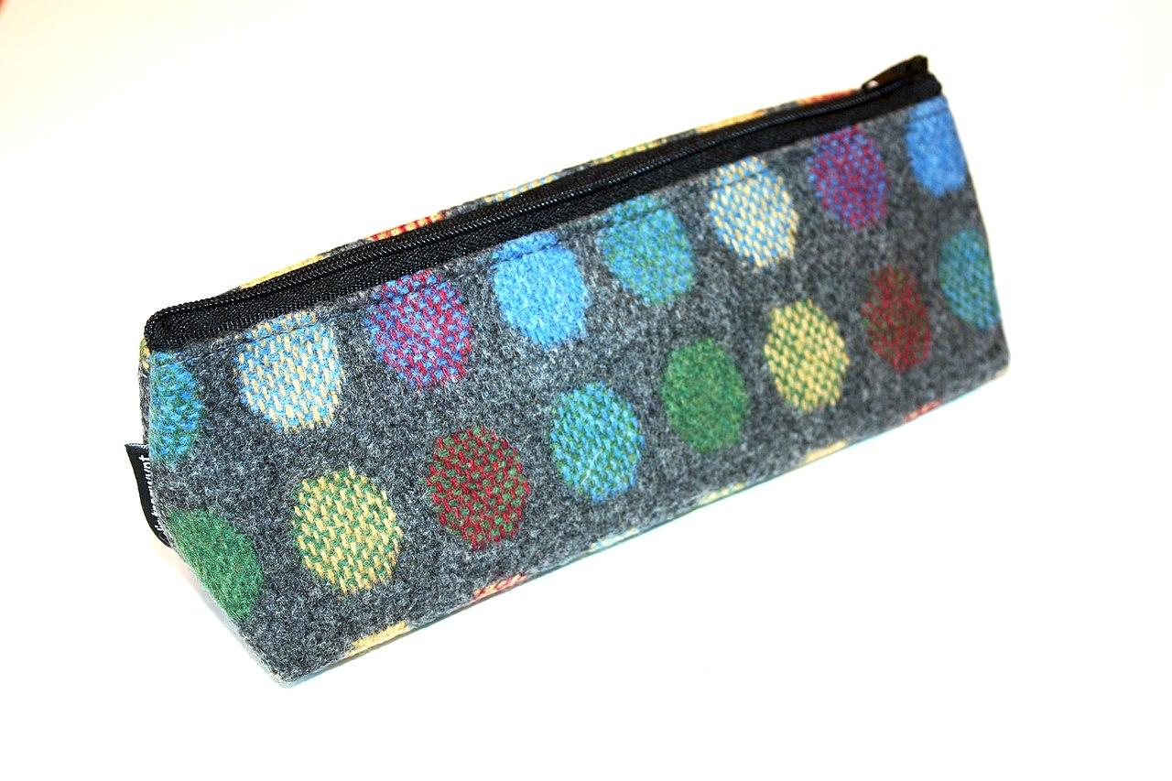 | Pencil case to store all of your equipment in one place
SCHOOL PLANNER | 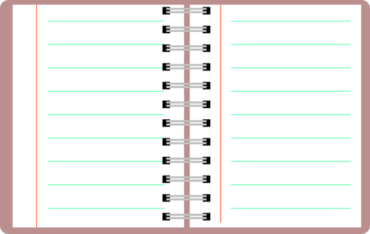 | School Planner this will be given to you by school, but it’s like a diary

Key people





Miss Jackson Mrs Dwyer Miss Humble Mr Smith


Miss Harris

Head Teacher | Mrs L Dwyer
Assistant Headteacher, DSL & Behaviour | Mr S Smith
Pupil Engagement Officer (PEO) | Miss K Jackson
Safeguarding Officer | Miss B Humble
SENDCO | Miss K Harris

How do you feel?
You probably have lots of feelings about moving from primary school to secondary school.Use two different coloured highlighters, highlight the phrases that you are looking forward to in one colour; use a different colour for those you are worried about.

Making new friends | Learning a new timetable
Dinner time | Meeting my new tutor
Finding way around | Being on time
Having a different uniform | Learning new subjects
Getting to school | Meeting new people.
Being with friends | School rules
Joining clubs | Homework
Meeting my new teachers | Being able to do the work
Being with older pupils | Getting changed for sport / PE
Break times | Being more independent

Can you identify two strengths you have that will help with the transition to secondary school?

Some things to help you with your worries

What to do if?
Scenario | Strategies
I am late for school…. | Parents call school and inform them of the reason, on arrival sign in with the attendance officer and go straight to lessons.
I am lost in school…. | Ask any member of school staff or a prefect for help.
I find the dining hall noisy or uncomfortable… | Speak to your PEO
I feel I am being bullied…. | Speak to your PEO, Form Tutor or Safeguarding Officer
I have forgotten my planner…. | Speak to your Form Tutor or PEO
I don’t understand what is being taught in the lesson… | Put your hand up and ask the teacher for help
I feel anxious…. | Speak to your PEO

Imagine you are working for an advice column for a magazine or online forum and write a response to the concern below.

Dear Ask for Advice,

I am really worried about starting secondary school, what is the best thing to do?
Nina, age 11

Dear Nina,

From

Travelling to Secondary School

When you start secondary school, you might need to be able to get yourself to school for the first time. Perhaps you will have to walk farther than you did before, need to take a new route or get on the school bus.

How will you get to school?

Use the space below to draw a map of your route or write down any bus details that you will need.

Developing Friendships

Starting secondary school brings lots of opportunities to make new friends, but meeting so many new people can be overwhelming. So, how do you get to know people and build new friendships?

Circle the things that you think will help you to meet new friends.

Offering to help  people | Being kind | Avoiding eye  contact | Shouting
Trying out new  clubs | Gossiping | Staying with the people you know | Complimenting others
Chatting | Keeping quiet | Listening to others | Smiling
Starting rumours | Finding things in common | Keeping yourself to yourself | Introducing yourself
Frowning | Sharing | Staring at the ground | Supporting someone

Think of three questions you could ask a new friend:

Think of three interesting things you could tell a new friend about yourself:

A Trusted Person
It is a really good idea to have someone that you can talk to if you're worried about anything, they cannot promise to keep everything to themselves, especially if you are in danger, they have to make sure that they tell someone else who can help you. This is scary, but you MUST trust them that they are helping you.

We will help you find someone that you trust in when you get here.

Write around the image, the qualities a trusted adult should have. You can label/ add to the drawing if you like e.g. a big heart to be kind.



Quiz

- What time does the school day start and end?
- Does the school have houses? If so, what are they called?
- What is the name of the headteacher at Sacred Heart School?
- What are the expectations around uniform and PE kit at your new school?
- Write down three things you could get an A5 for.
- What is the name of your Pupil Engagement Officer?

