

Transition Pack

My name:

My new secondary school:
Outwood Academy Bydales



To get to know your new school and find key information you can go on your school website.
Website address – www.bydales.outwood.com

What my new school looks like
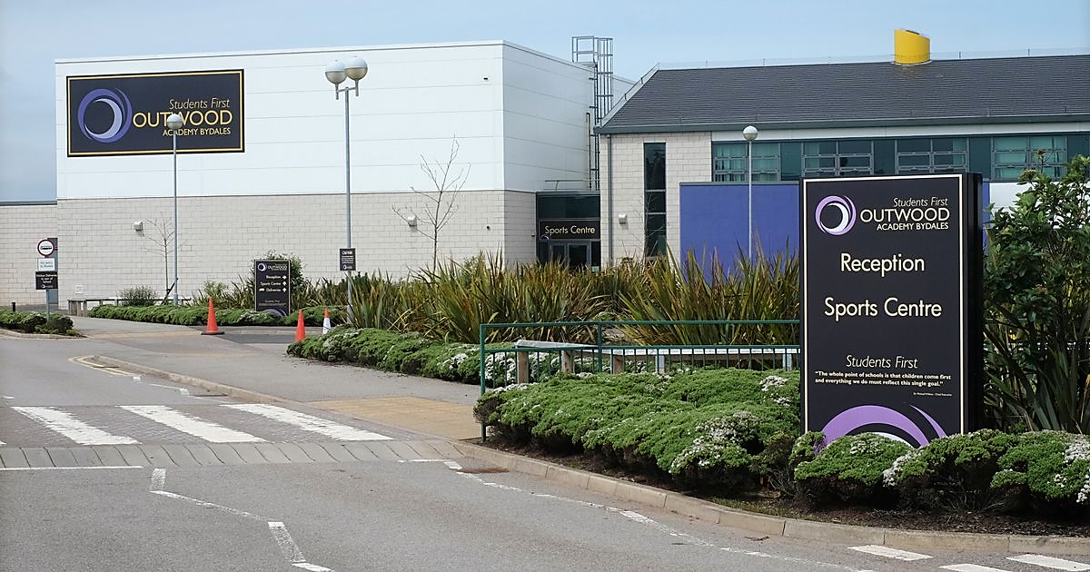

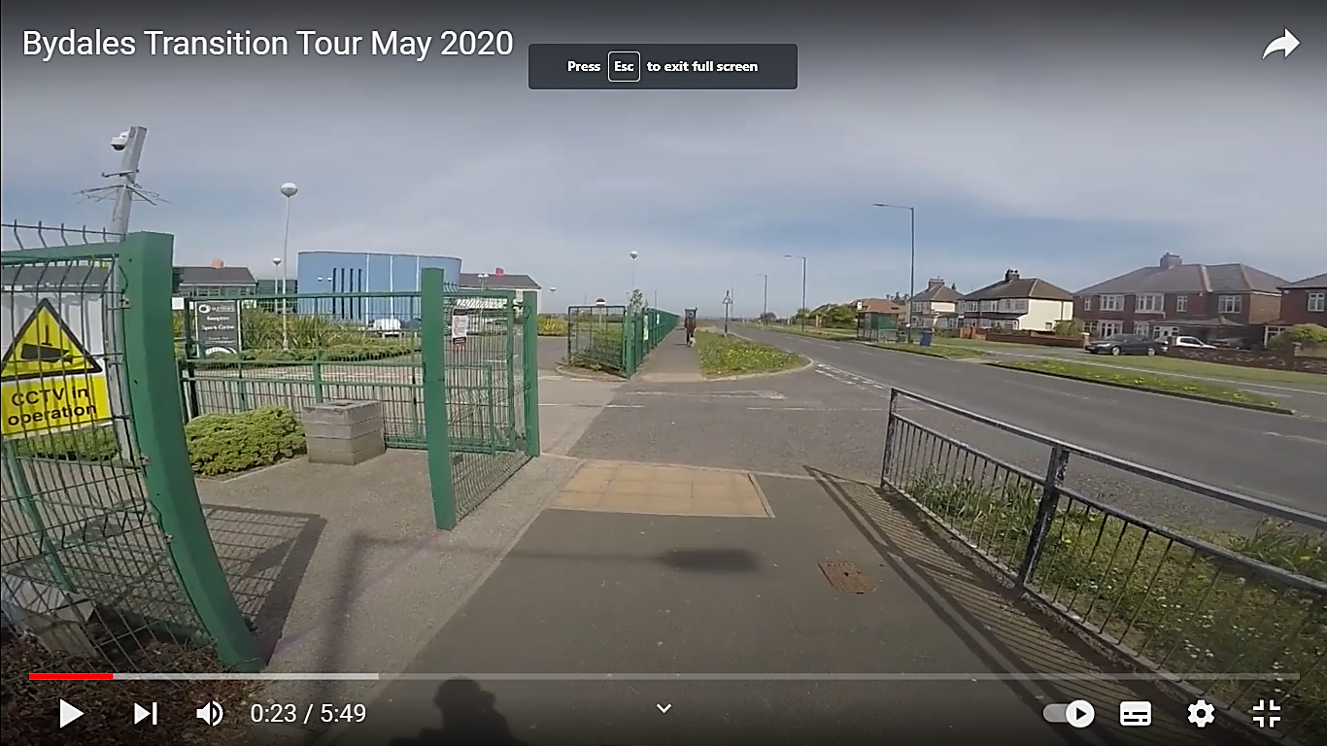
School Gate Entrance

Cycling to school:
Cyclists dismount at purple line at school gate entrance.

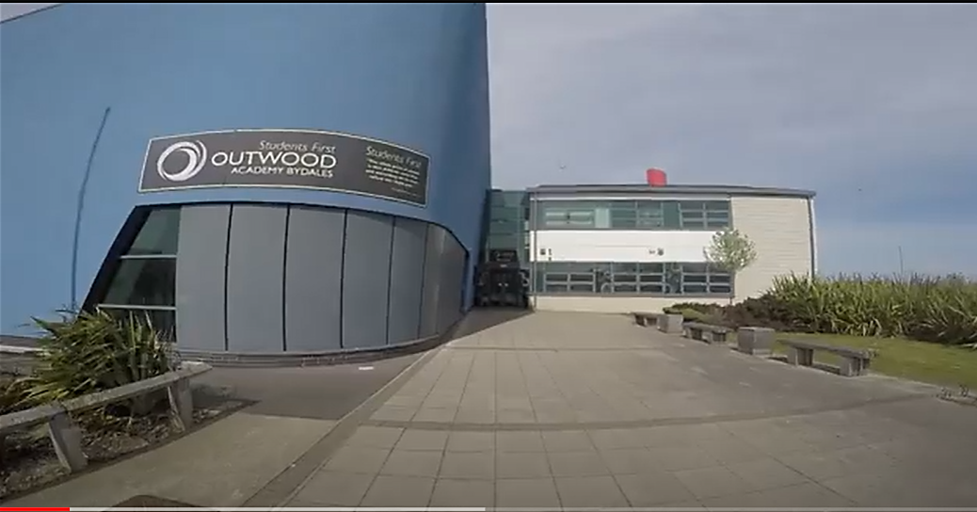

Main Entrance Reception

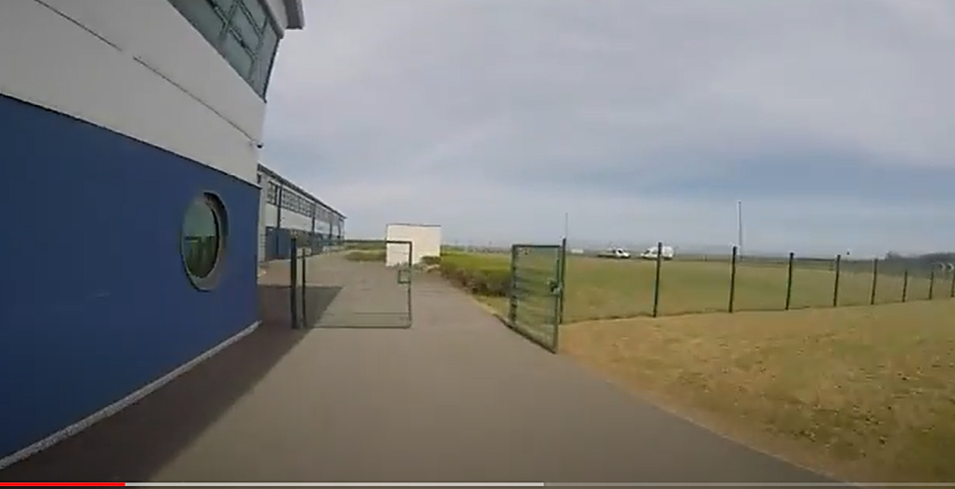
At the purple line (near the Student Entrance), cyclists can get back on their bikes to cycle safely to the bike sheds.

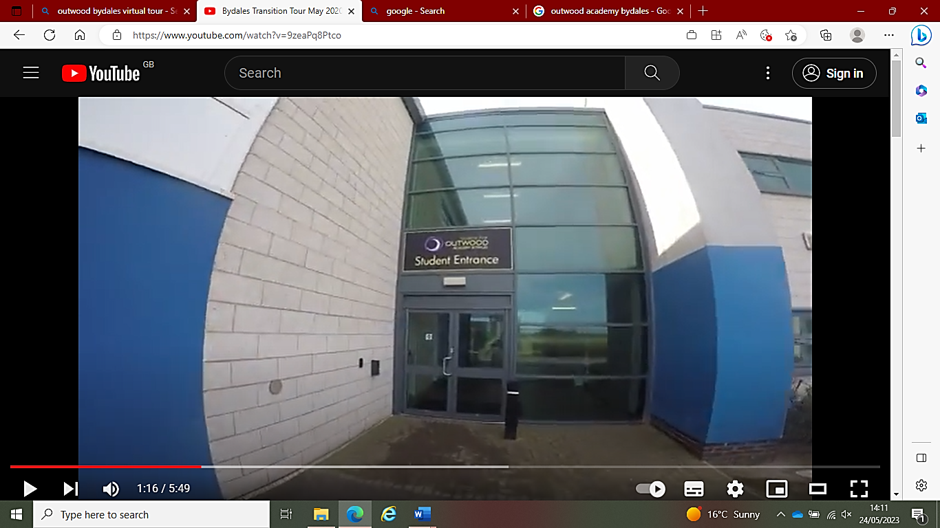
Student Entrance

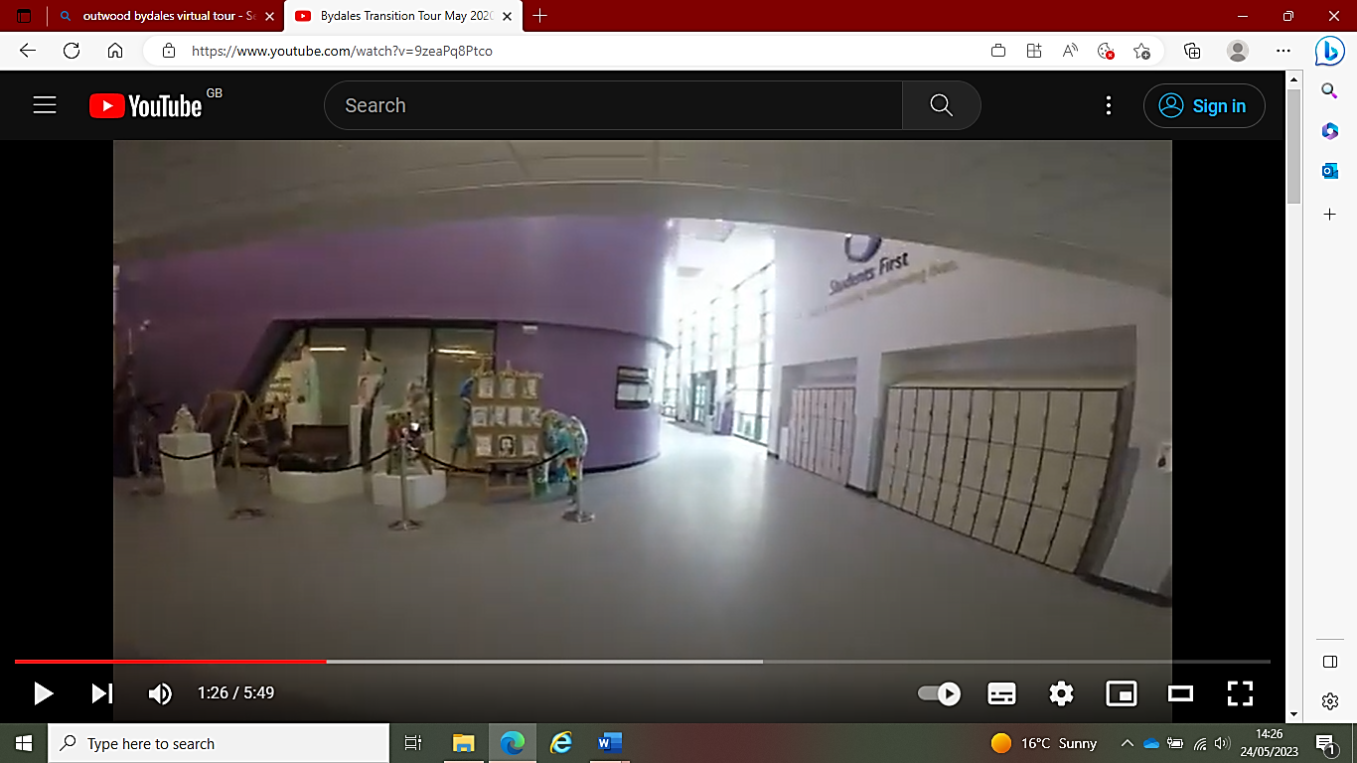

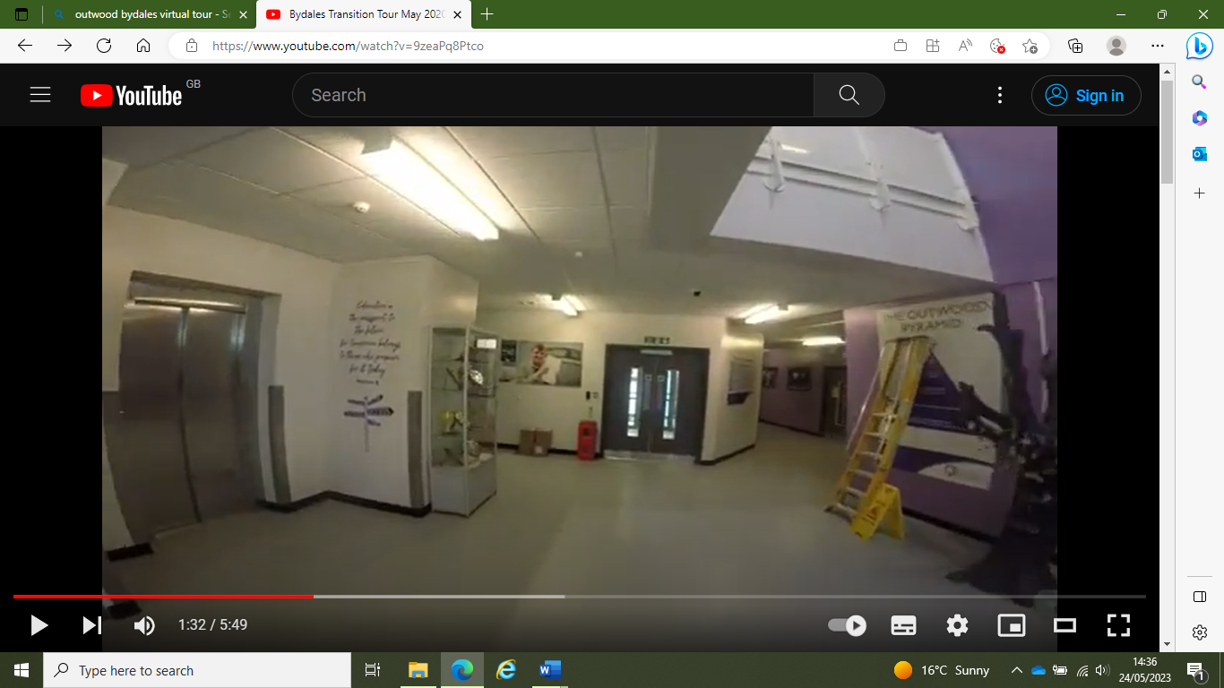
Corridor to Assembly Hall

Lift

Door to main reception
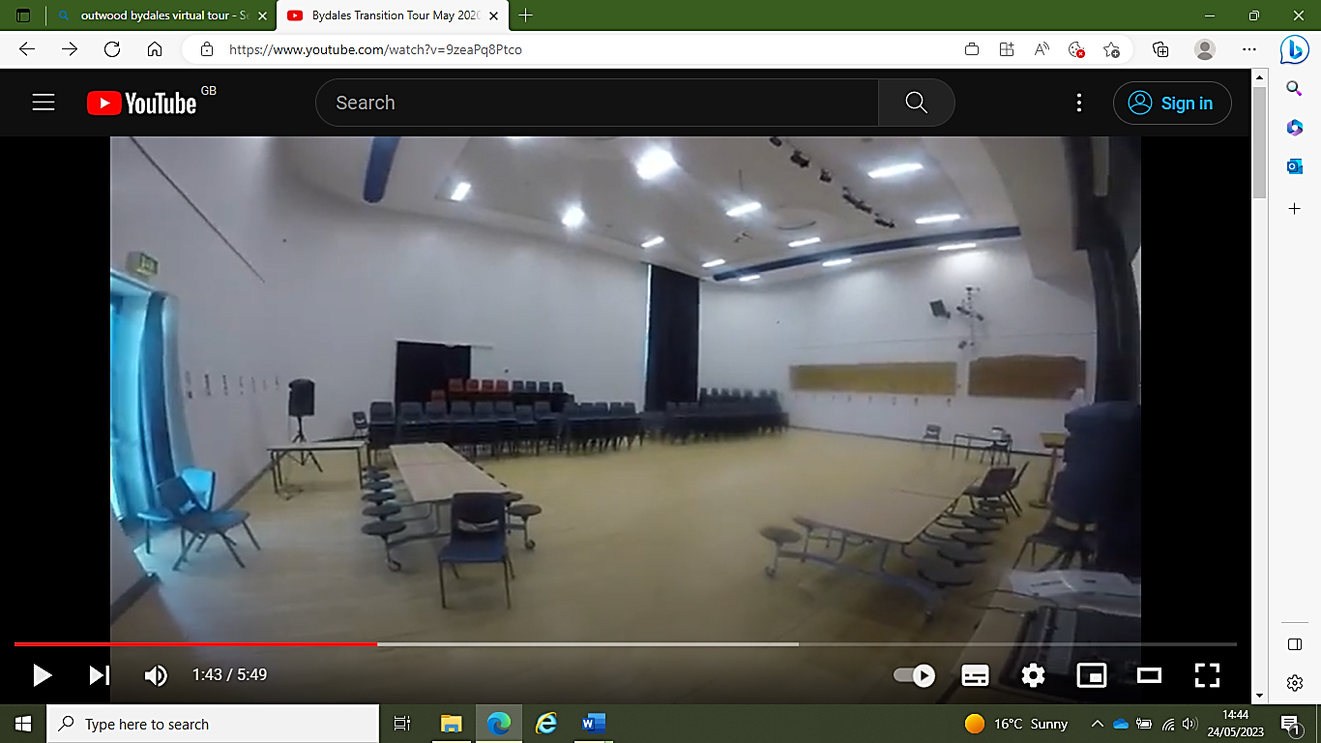

Assembly Hall

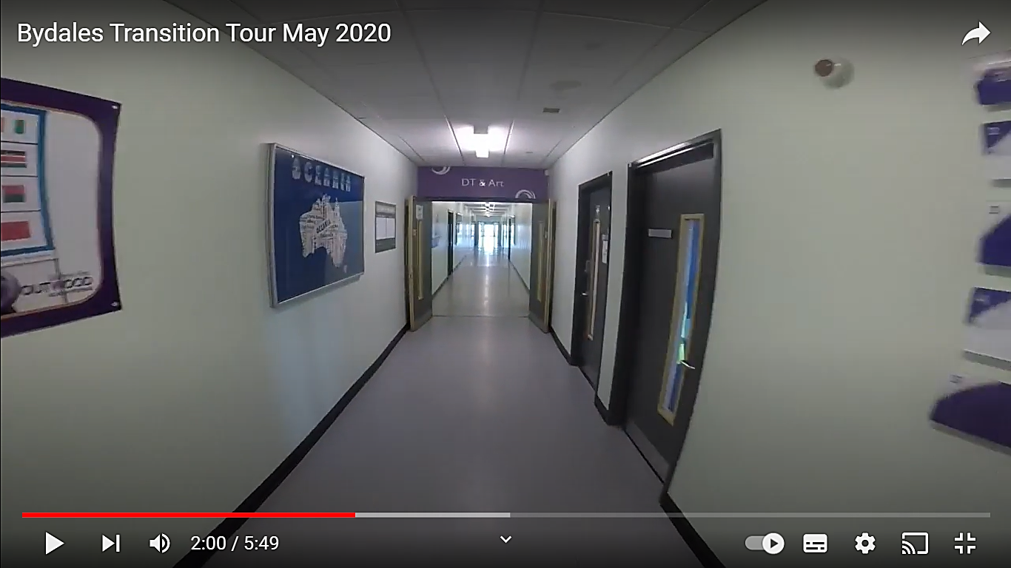
DT & Art Corridor
Assembly Hall
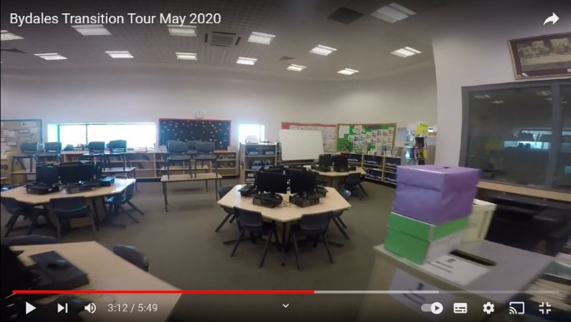
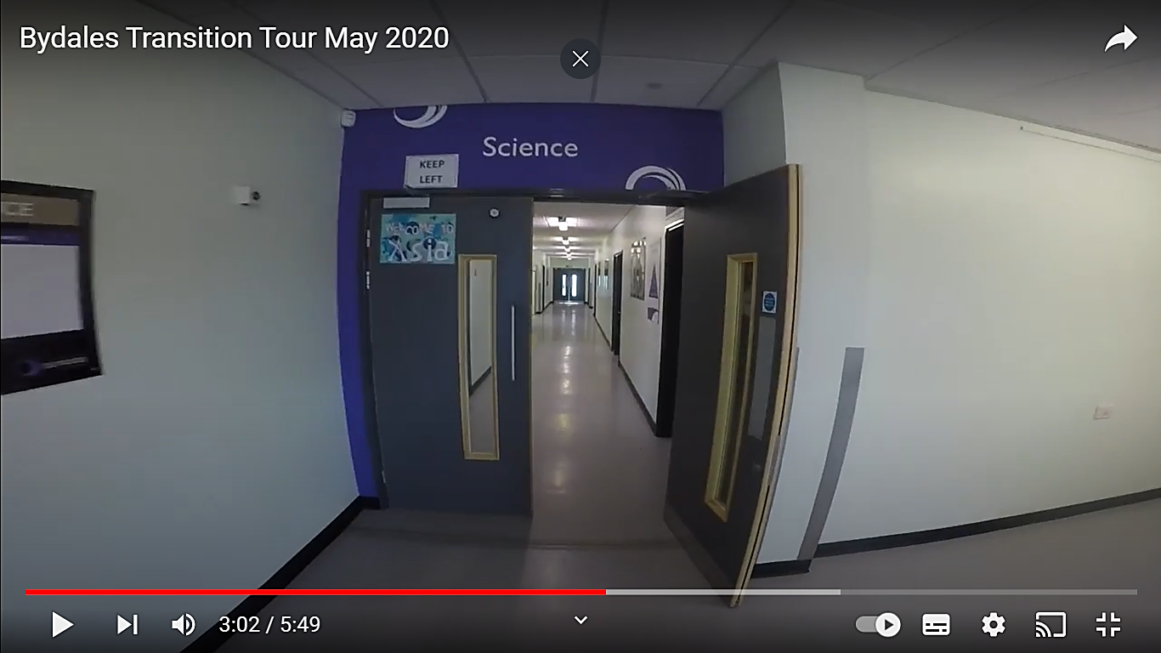
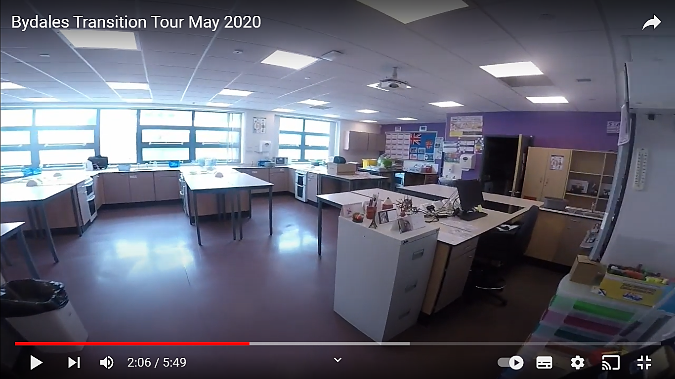
Some schools have videos online that show you different areas which can help you work out how to get around.
Art Classroom
Science Corridor (Upstairs)
Art Classroom

Finding my way around

Its normal to be a little worried about getting lost. Lots of students might get a bit lost as they get to know their new school. It’s a new adventure! If you aren’t sure how to get somewhere, you can find a teacher or ask another student which way to go.
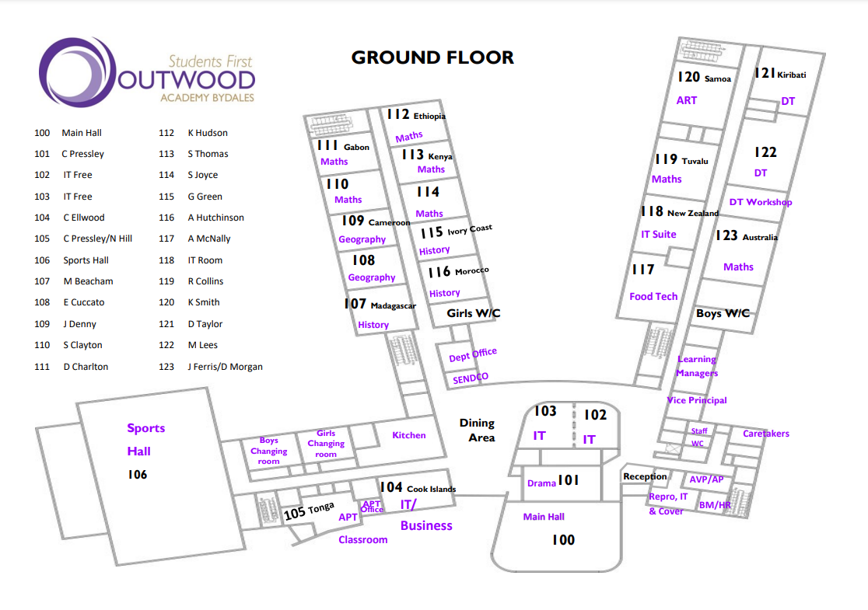
Here is a map of my new school:

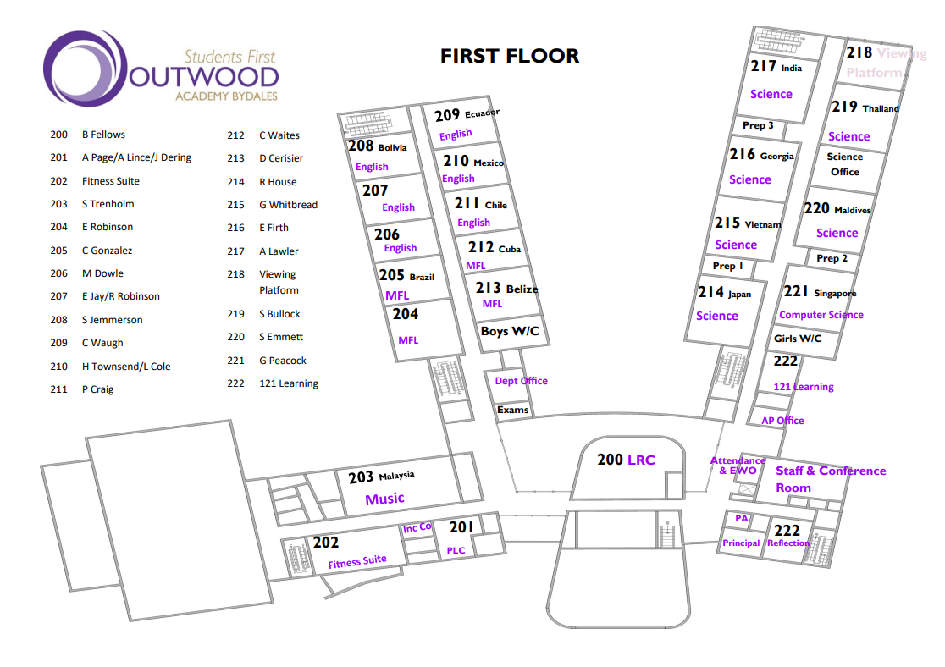

Finding my way around

Choose different colours and colour in:

Place in School | Colour on map
The door I will use to come in
Toilets
Dinner Hall
Main Office
Library
Sports Hall
Form room
Add anything else that is important to you……..

Timetable
Here is an example of what my Year 7 timetable will look like:
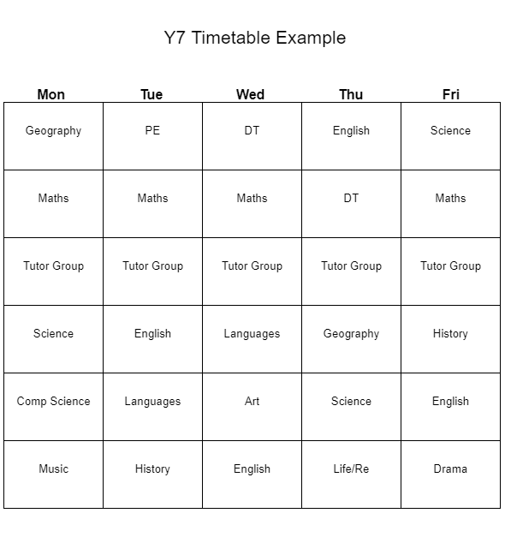
P1
8:25 – 9:25

P2
9:25 – 10:25

Tutor
10:25-11:00

P3
11:30 - 12:00

P4
12:00 – 13:30
Lunch 12:30 – 13:00
P5
13:30 – 14:30
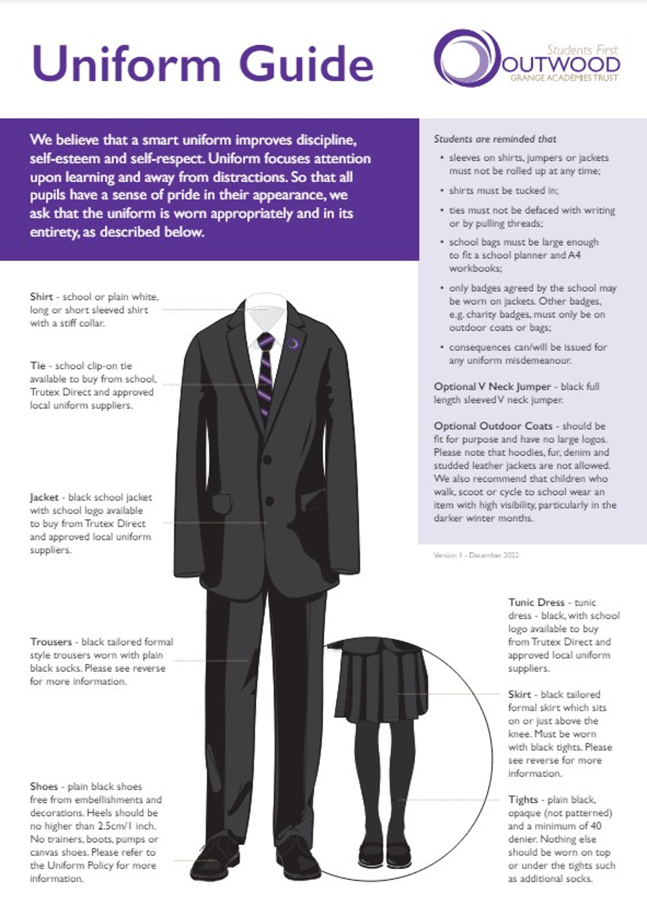
School Uniform
This is what my school uniform will be when I got to secondary school
Key People
Here are the names and photos of key staff members that will be important to me at secondary school:
Name and Job | What do they look like? | Where can you find them?
Miss Robinson  SENDco | 
Mrs Boyes  Inclusion Coordinator | 
Tutor

