

Transition Pack

My name:

My new secondary school:


To get to know your new school you can go on your school website.
Website address – www.nunthorpe.co.uk

What my new school looks like

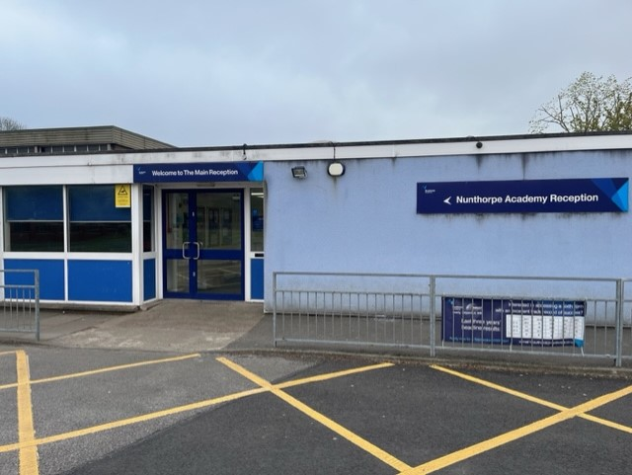

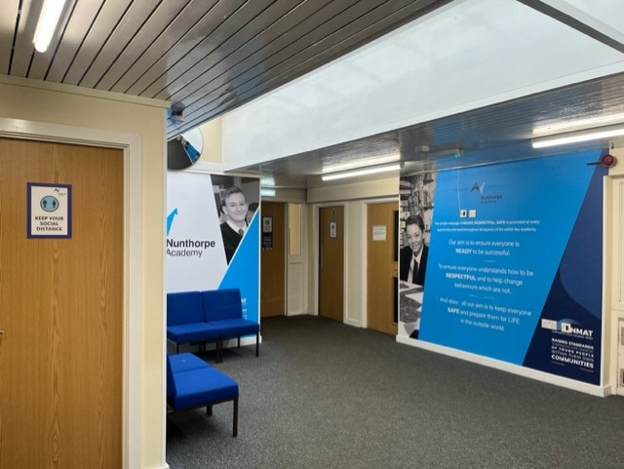

Reception

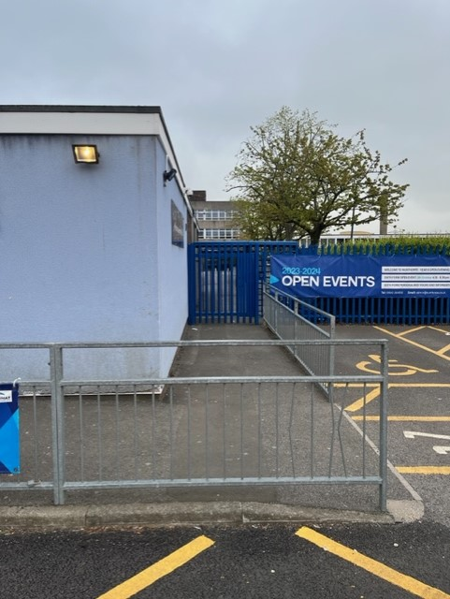

Year 7 – Turnstile Entrance

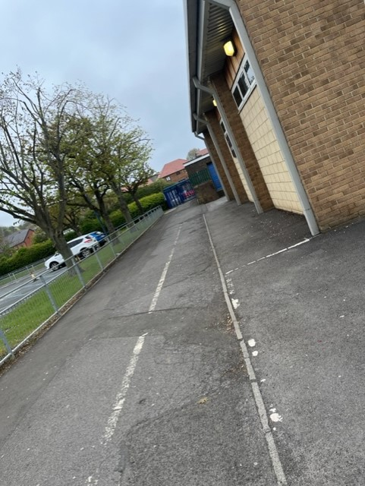

Student Walkway

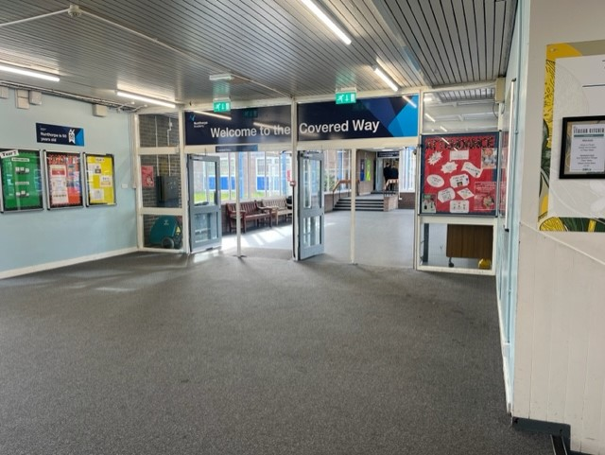

Covered Way

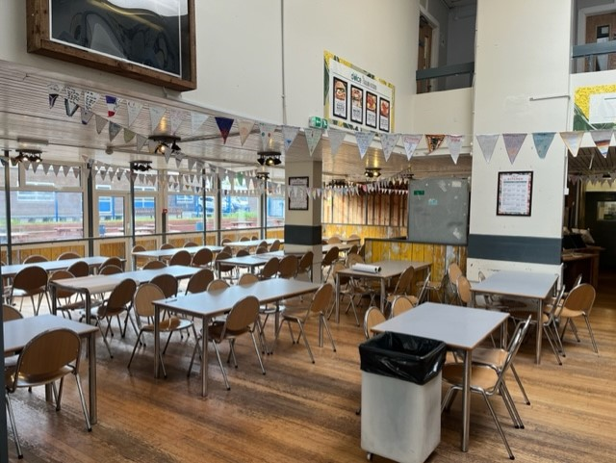

Dining Hall

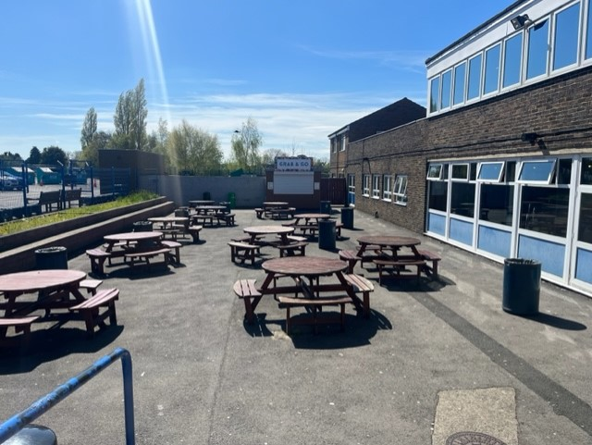

Year 7 Picnic Area

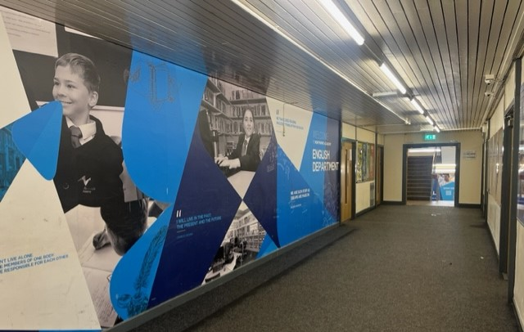

English

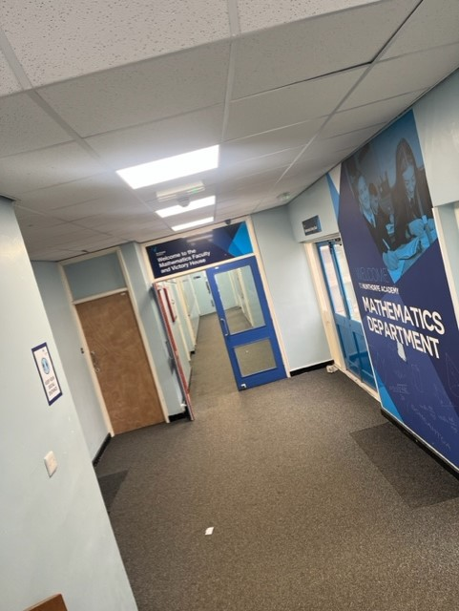

Maths

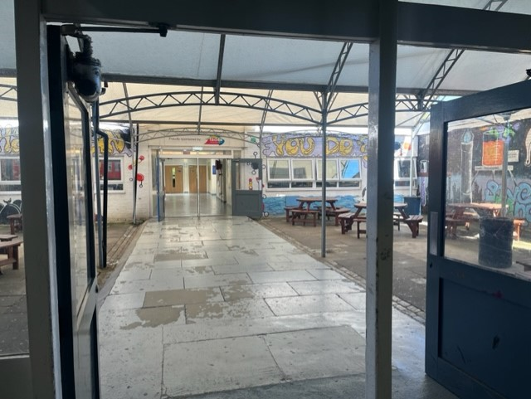

Science Quad

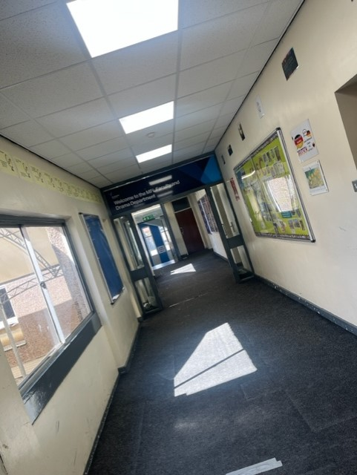

MFL

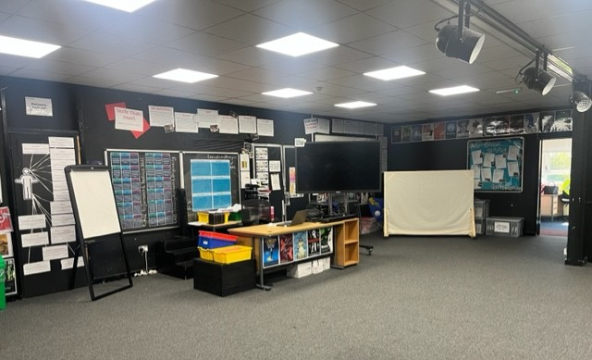

Drama

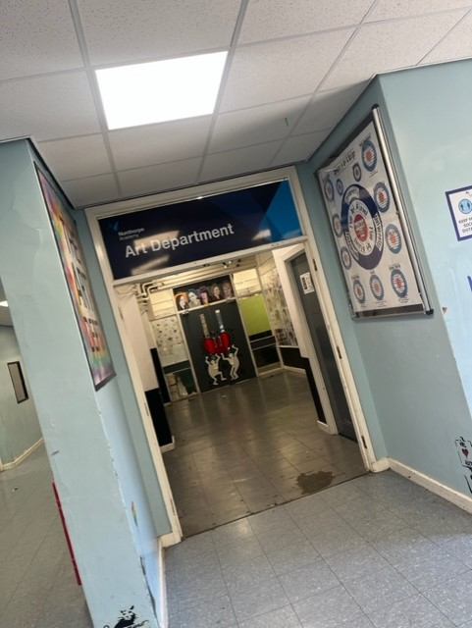

Art

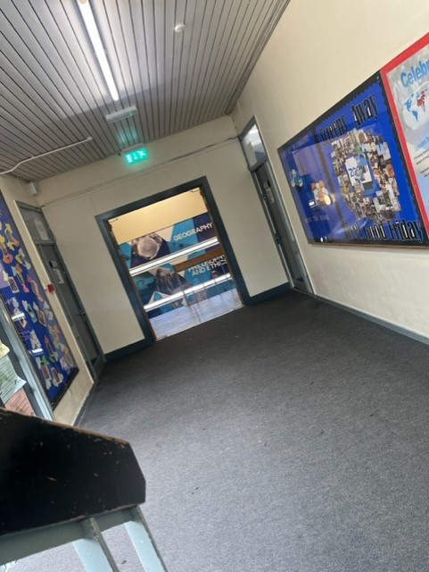

Humanities

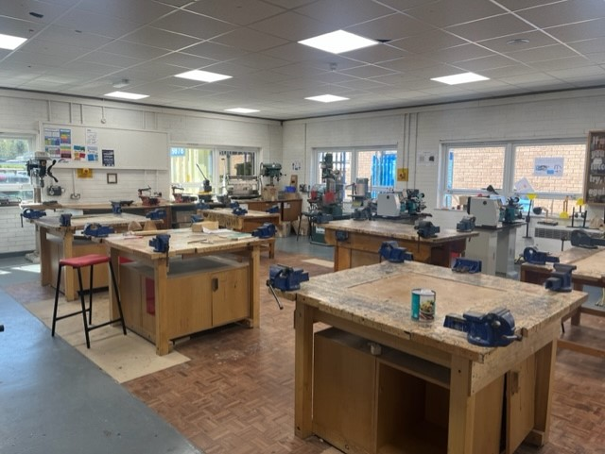

Technology

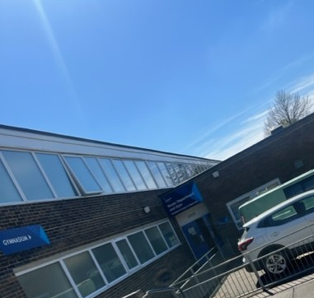

Music

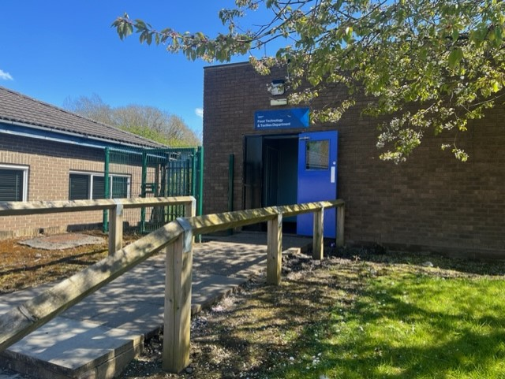

Food Technology

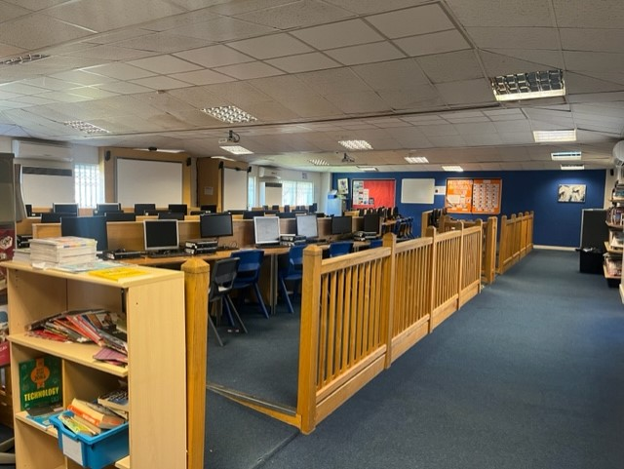

ELZ

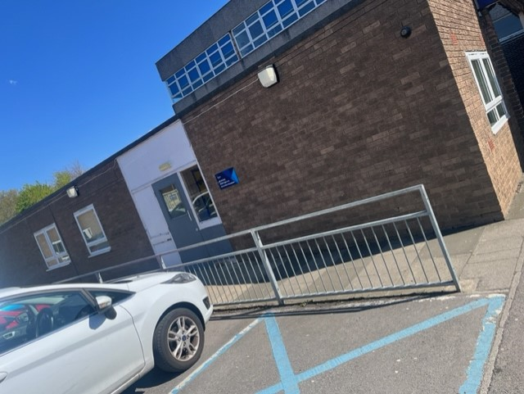

Inclusion Entrance

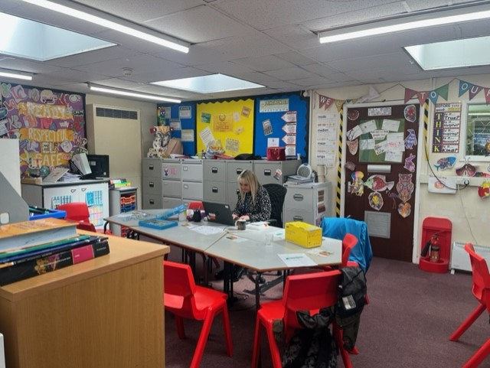

Inclusion Classroom

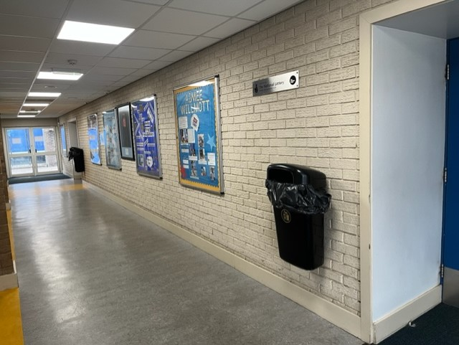

Sport Corridor

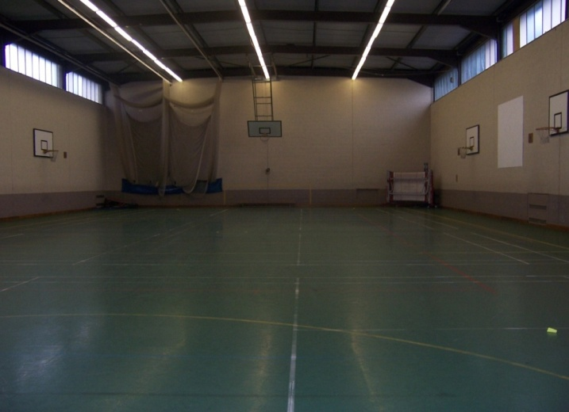

Sports Hall

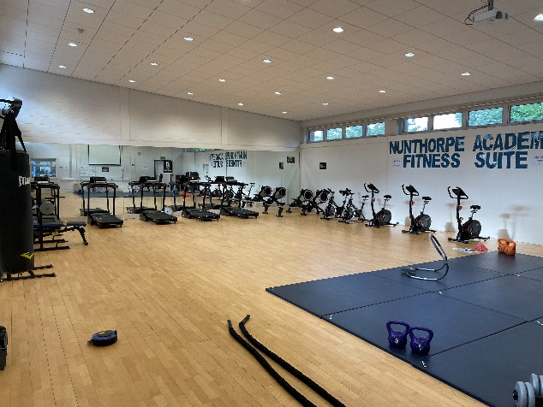

Fitness Suite

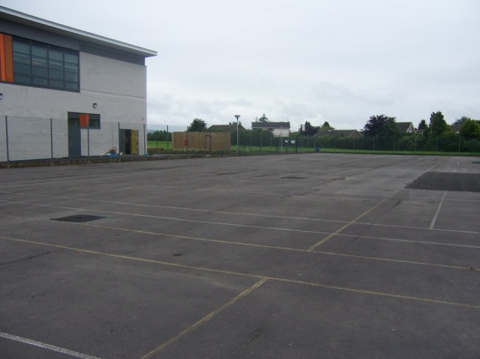
Tennis Courts

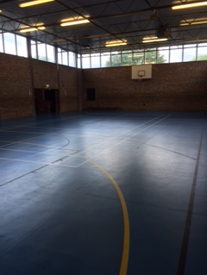

Gym

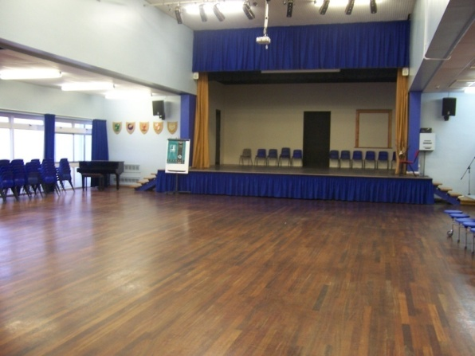
Main School Hall

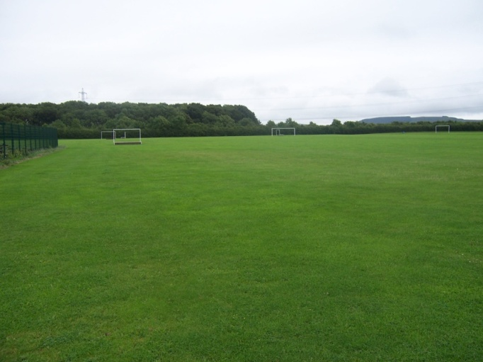

Field

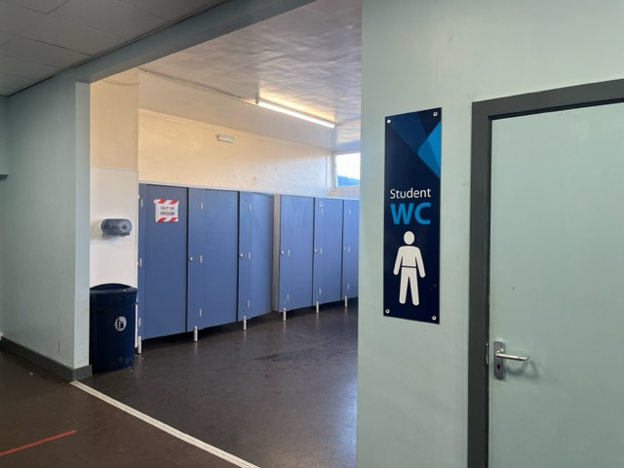
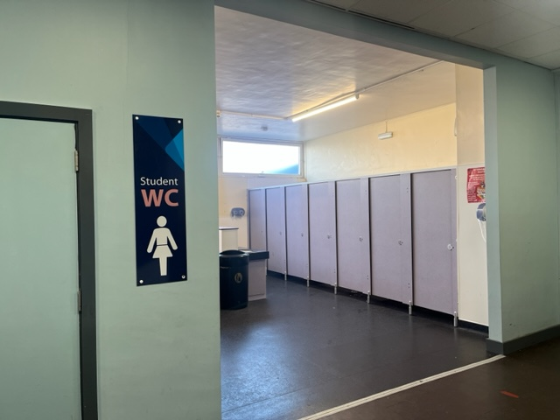
Toilets

Finding my way around

Here is a map of my new school:
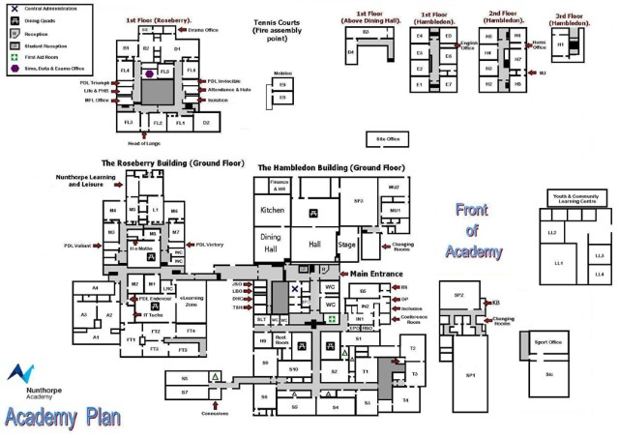
Finding my way around

Its normal to be a little worried about getting lost. Lots of students might get a bit lost as they get to know their new school. It’s a new adventure! If you aren’t sure how to get somewhere, you can find a teacher or ask another student which way to go.

Choose different colours and colour in:

Place in School | Colour on map
The door I will use to come in
Toilets
Dinner Hall
Main Office
Library
Sports Hall
Form room
Add anything else that is important to you……..

Timetable
This is the timings of the school day:
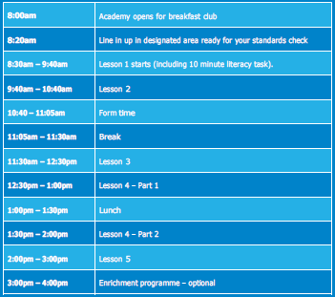
My timetable will show me what classes I have, when and where I need to be. Like this -
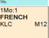
This is week 1.
Monday.
Period 1.
The lesson is French.
The classroom is M12.
This is the teacher. Teachers names are shortened.

Here is an example of what my timetable will look like:
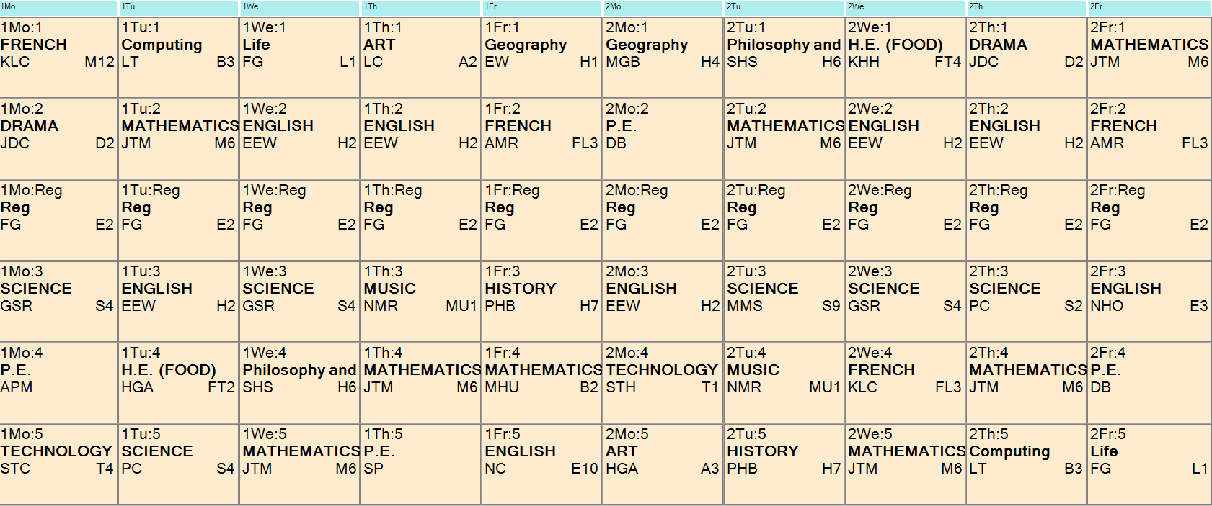

School Uniform
This is what I will wear to school:
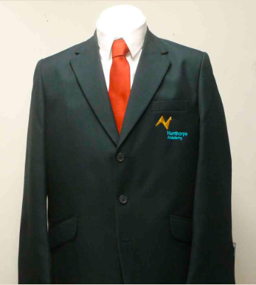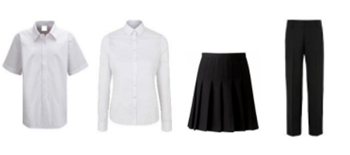

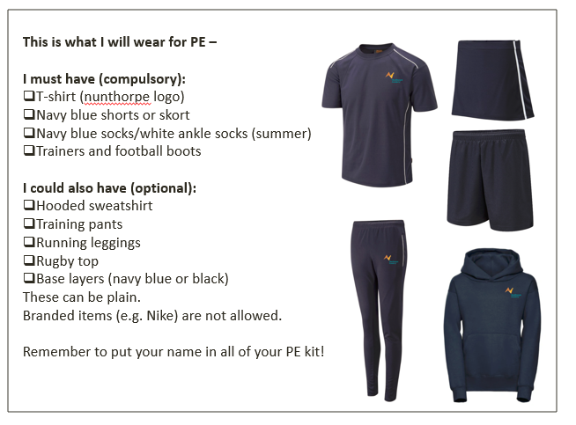

Key People
Here are the names and photos of key staff members that will be important to me at secondary school:
Name | Who are they? | Where can you find them?
Mrs Kell   | Head of School
Mrs Knowles   | Year 7 Pastoral Manager
Mrs Brosnan   | Assistant Vice Principal and SENCO
Mrs Murray   | Transition Lead
Mr Yale   | Transition Lead

Notes

