

Transition Pack

My name:

My new secondary school:


To get to know your new school you can go on your school website.
Website address – www.normanby.outwood.com

What my new school looks like
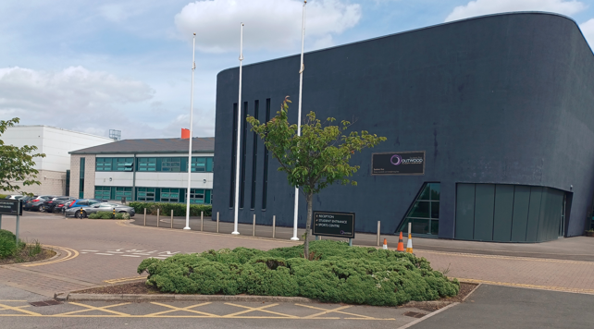

Here is where I will come into school in the morning.
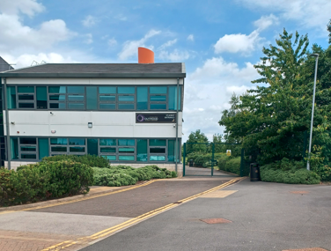

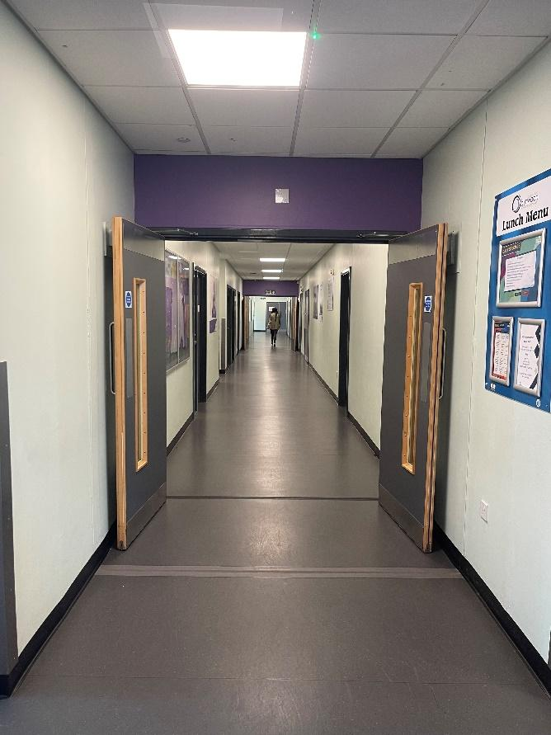
Corridors
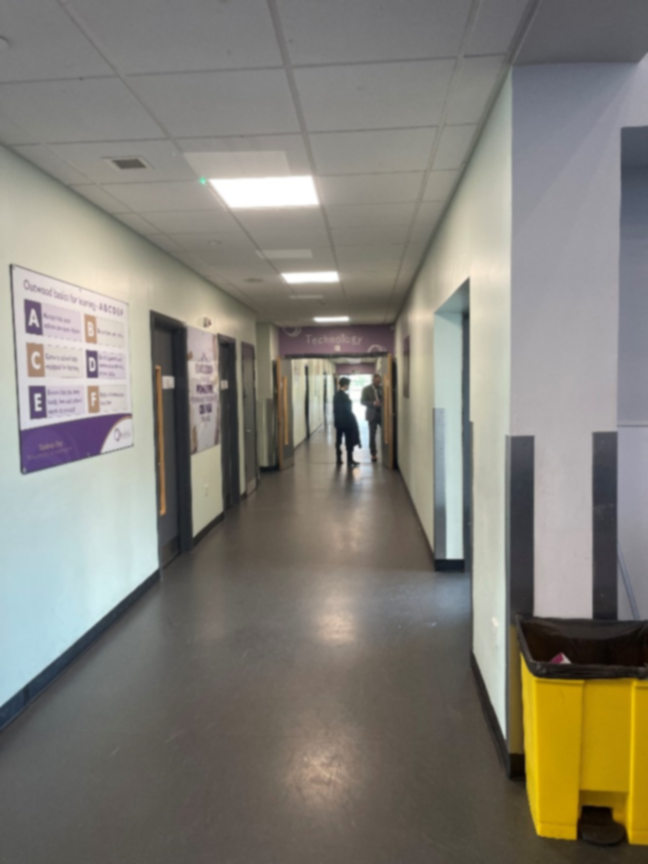

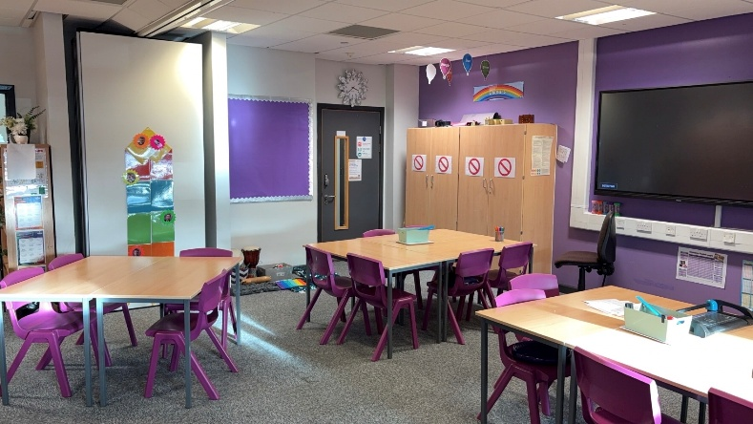
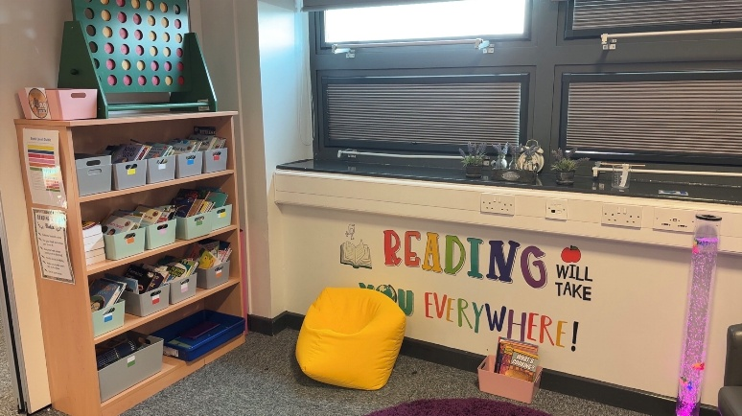
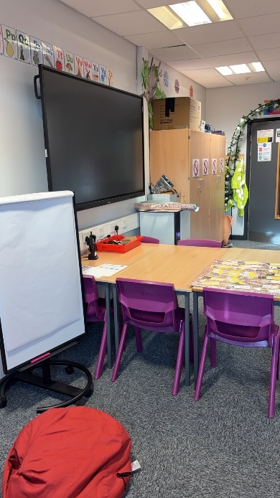
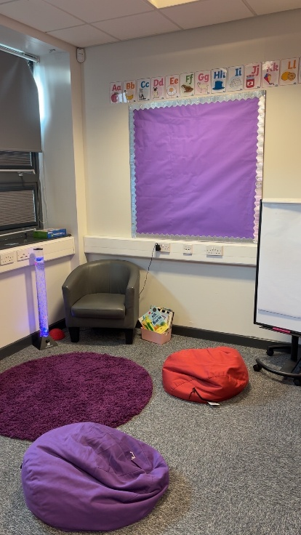
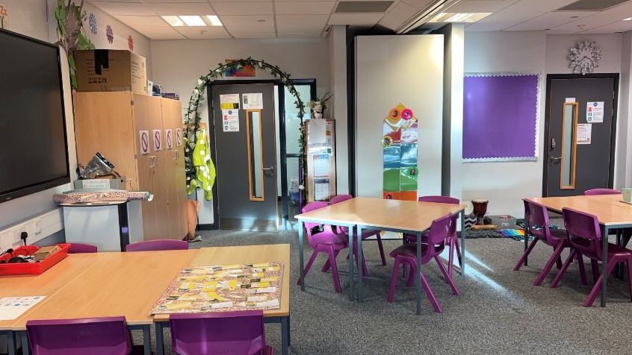
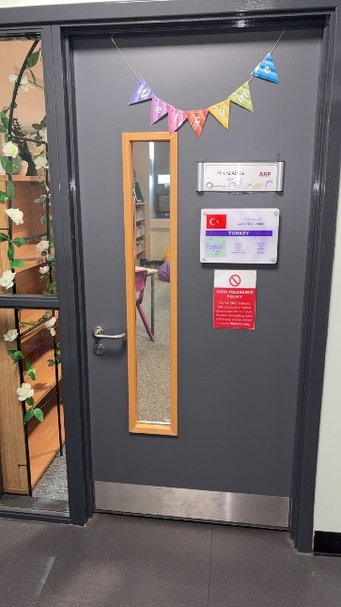
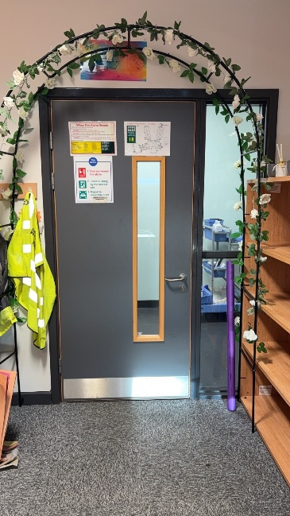
Your learning space

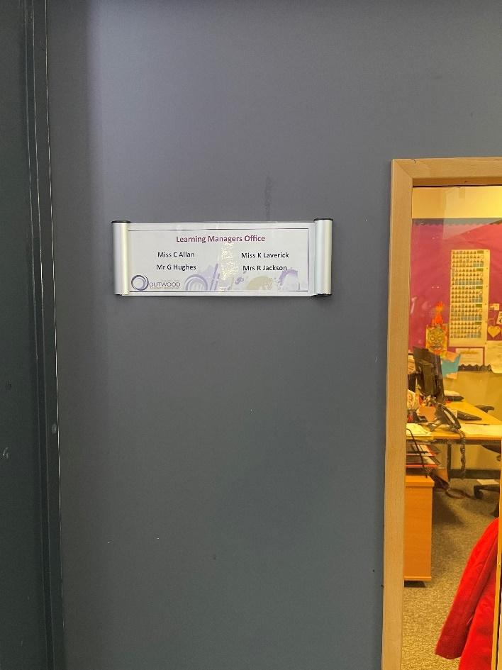
Learning Managers Office
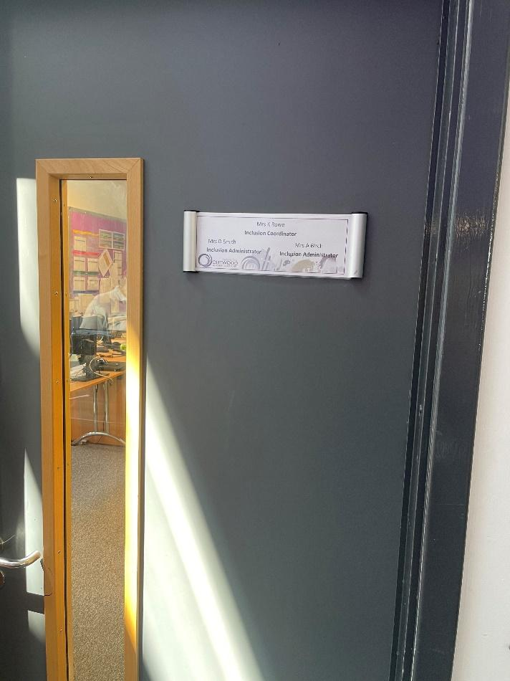
Inclusion Office
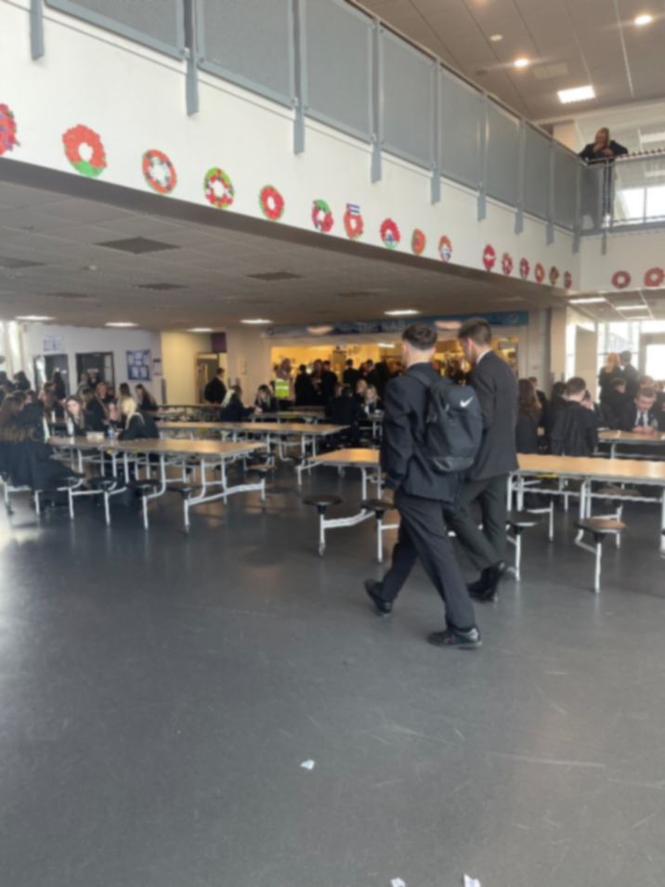
Dining Hall
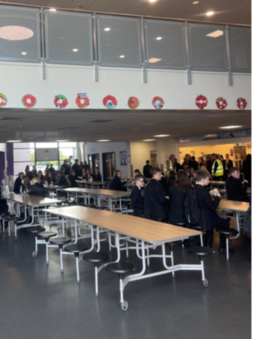
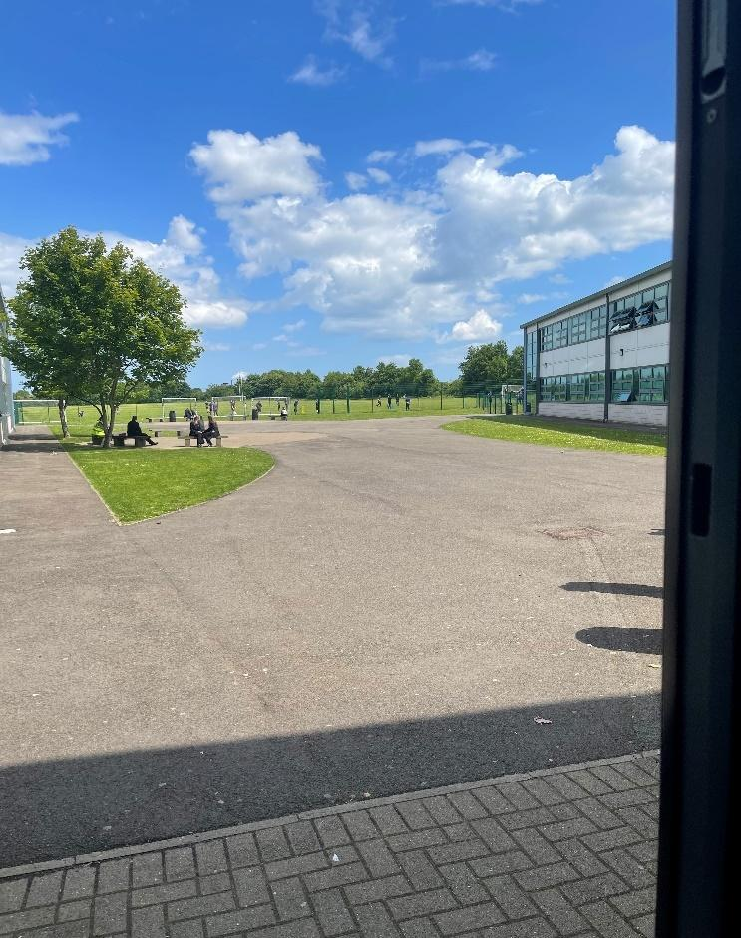
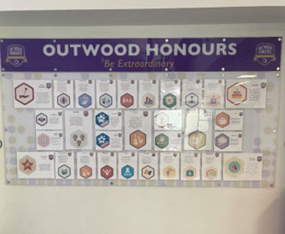

Finding my way around
Its normal to be a little worried about getting lost. Lots of students might get a bit lost as they get to know their new school. It’s a new adventure! If you aren’t sure how to get somewhere, you can find a teacher or ask another student which way to go.

Here is a map of my new school:
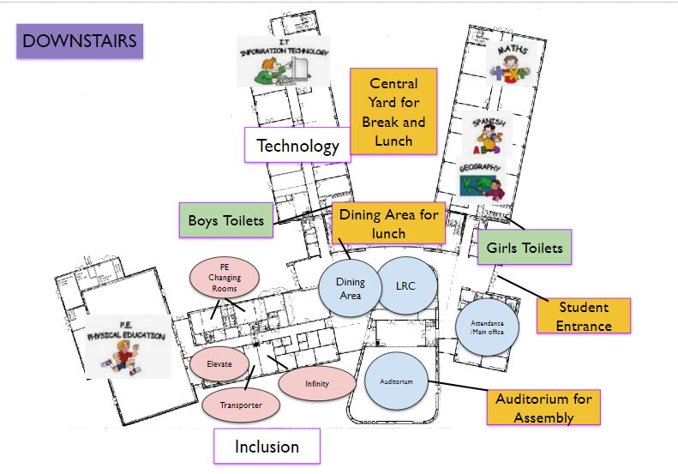
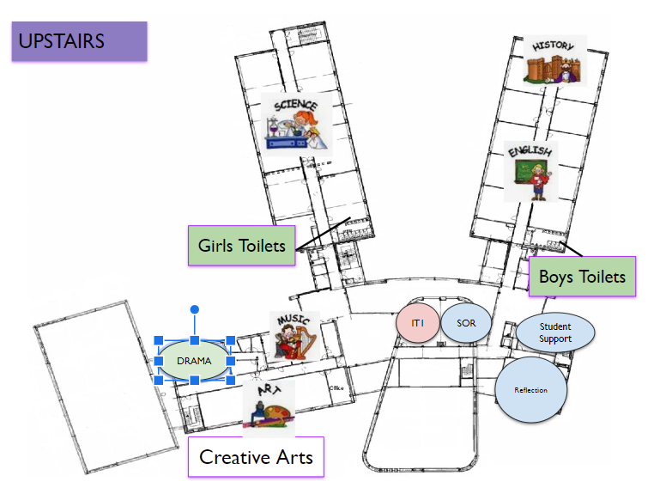
Finding my way around

Choose different colours and colour in:

Place in School | Colour on map
The door I will use to come in
Toilets
Dinner Hall
Main Office
Library
Sports Hall
Form room
Add anything else that is important to you……..
Timetable

My School Day
8.25-8.45 | Tutor
8.45-9.45 | Period 1
9.45-10.00 | Break
10.00-11.00 | Period 2
11.00-12.00 | Period 3
12.30-1.00 | Lunch
12.00-1.30 | Period 4
1.30-2.30 | Period 5

Here is an example of what my timetable will look like:
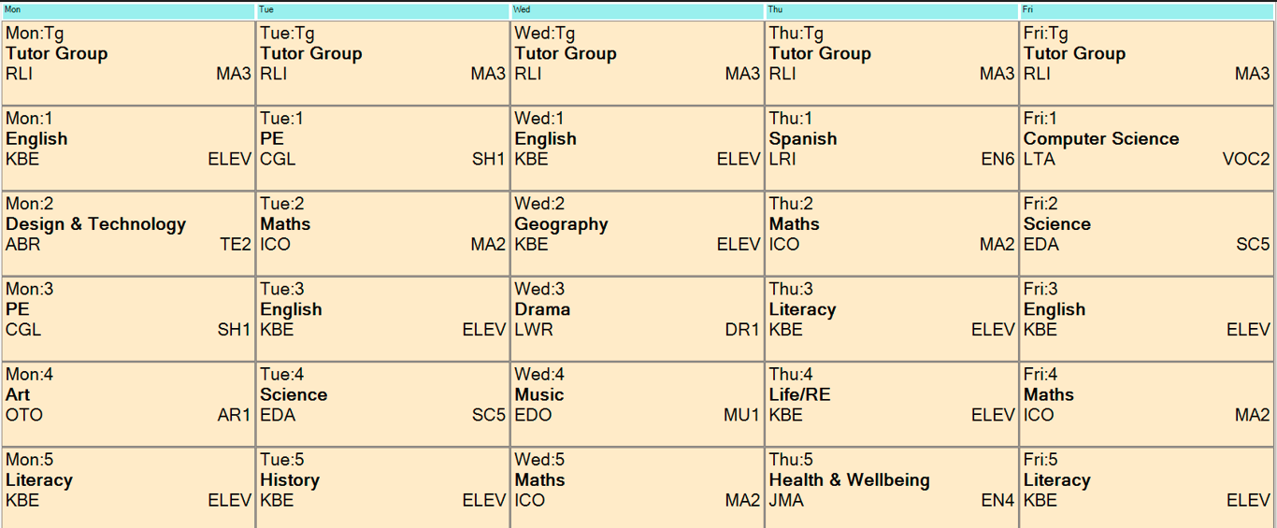
School Uniform
This is what I will wear to school:

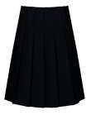

Key People
Here are the names and photos of key staff members that will be important to me at secondary school:
Name | Who are they? | Where can you find them?
Dr Robinson | Principal
Mrs Dawson | SENDCO
Mrs Ritchie | Pastoral Lead
Mrs Jackson | Learning Manager
Mr Ward | SLT Link for Year 7
Notes

