

Transition Pack

My name:


My new secondary school:
Outwood Academy Redcar

To get to know your new school you can go on your school website.
Website address – www.redcar.outwood.com
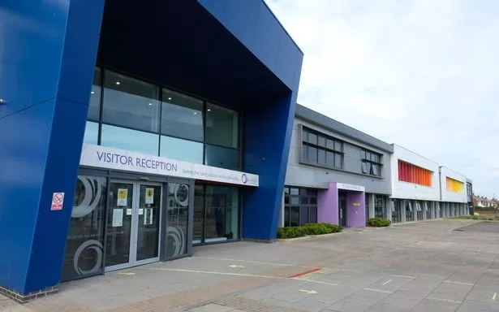
What my new school looks like

Student Entrance
Reception

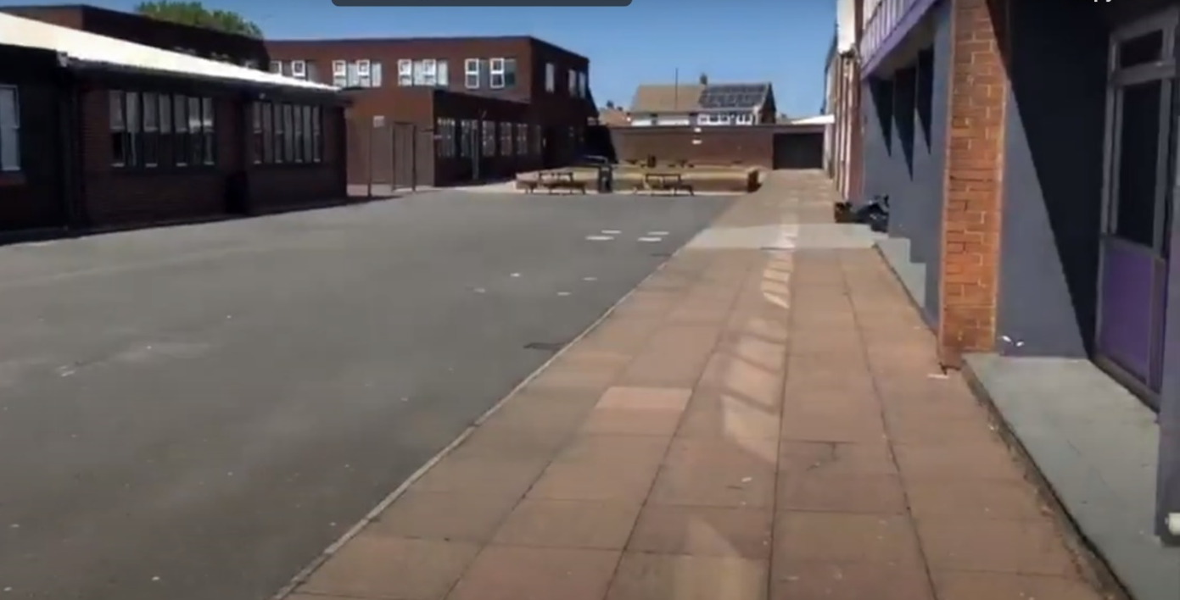
Outdoor Activity Yard
Plenty of outdoor space for break and lunch times.

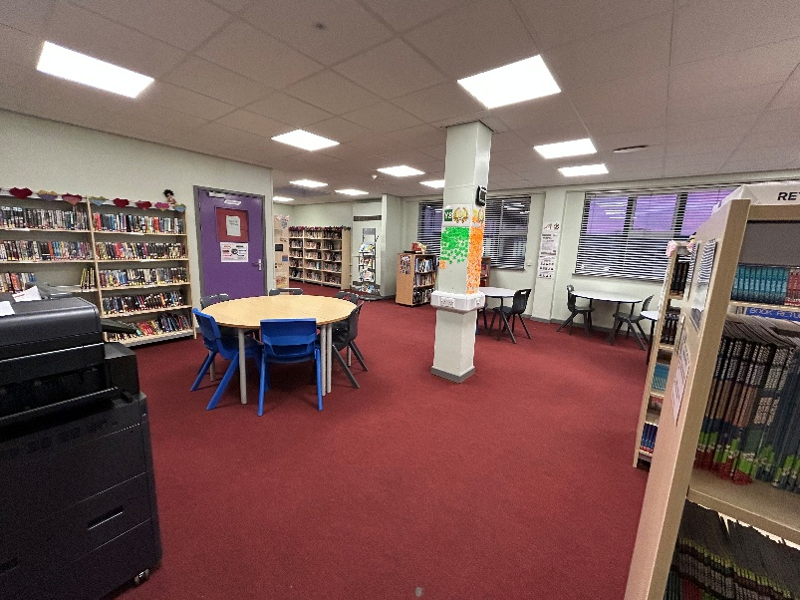

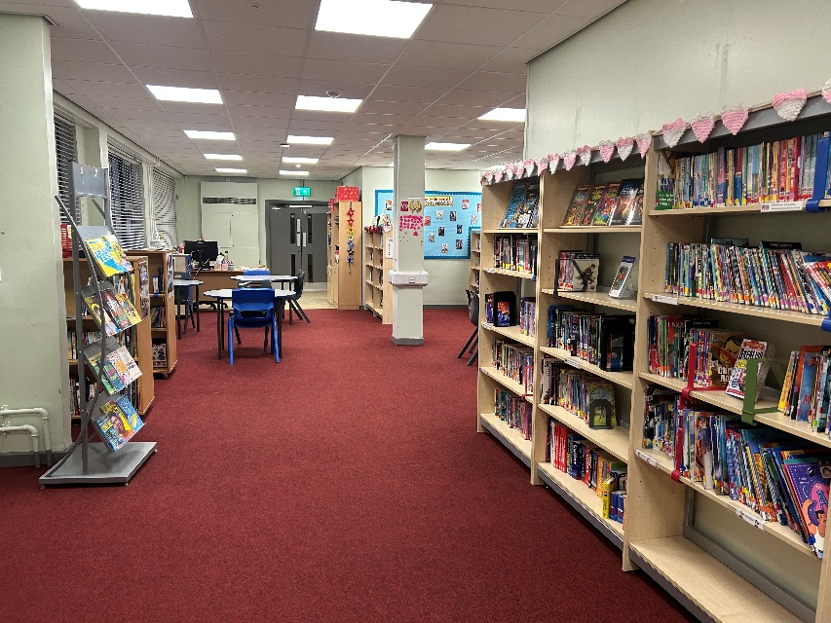

Learning Resource Centre

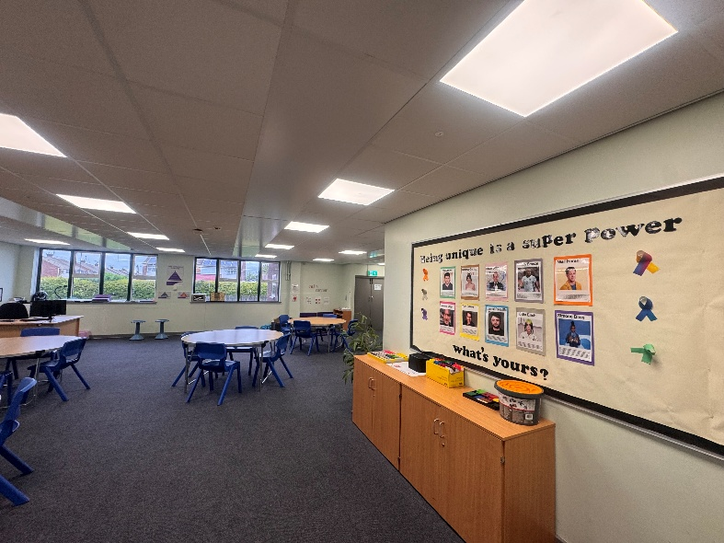
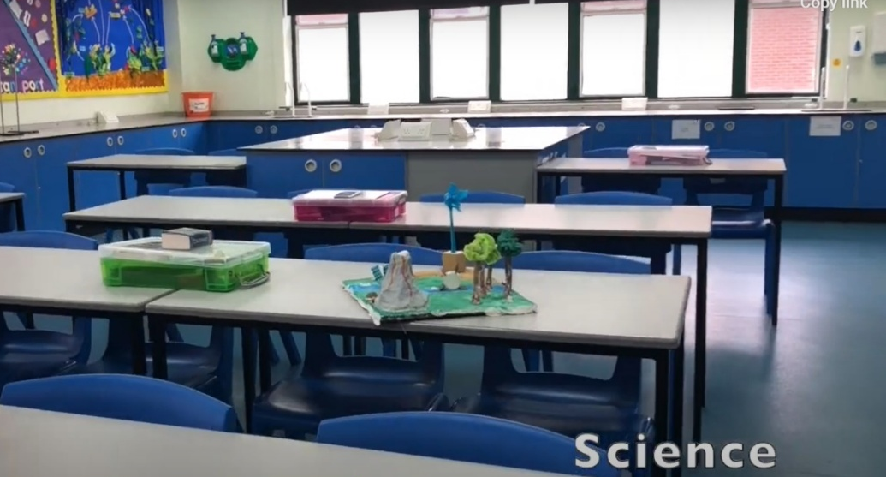
The Bridge
Science Classroom
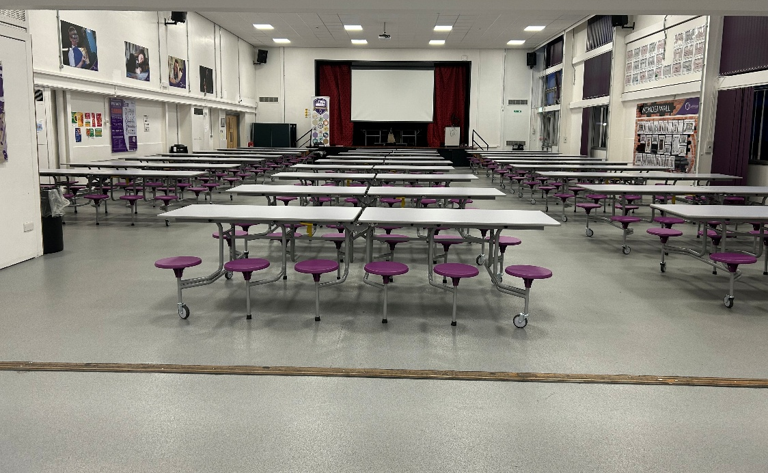

Main Hall
Used for lunch time and assembly

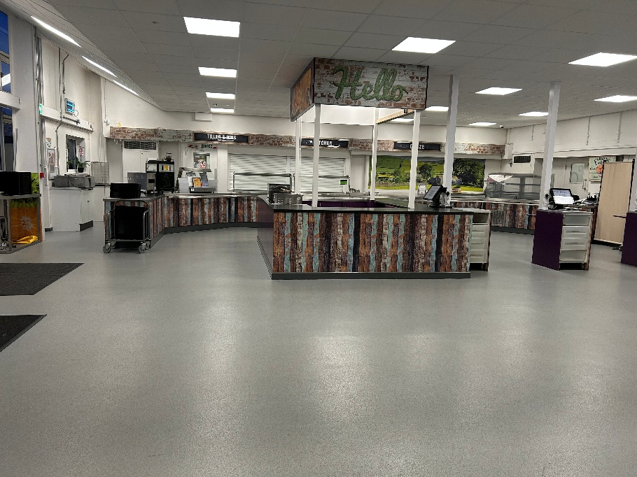

Canteen
Selection of set meals, salad bar, fresh sandwiches and grab ‘n’ go snacks

Finding my way around
It’s normal to be a little worried about getting lost. Lots of students might get a bit lost as they get to know their new school. It’s a new adventure! If you aren’t sure how to get somewhere, you can find a teacher or ask another student which way to go.

Here is a map of my new school:
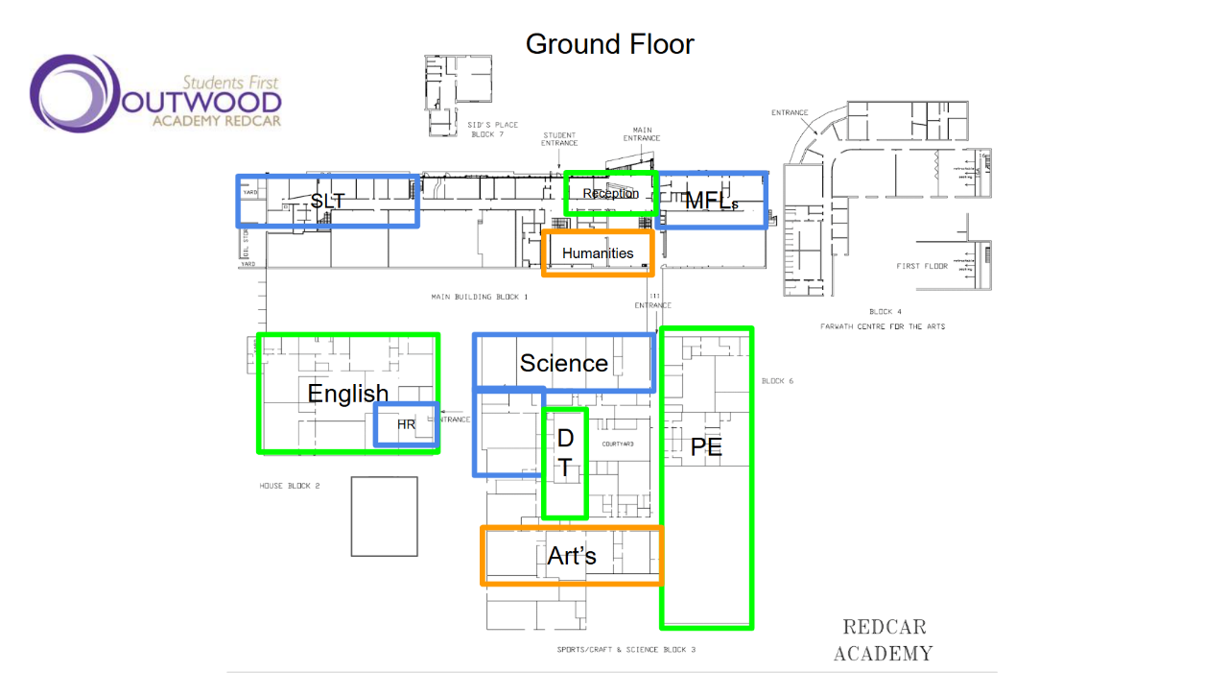

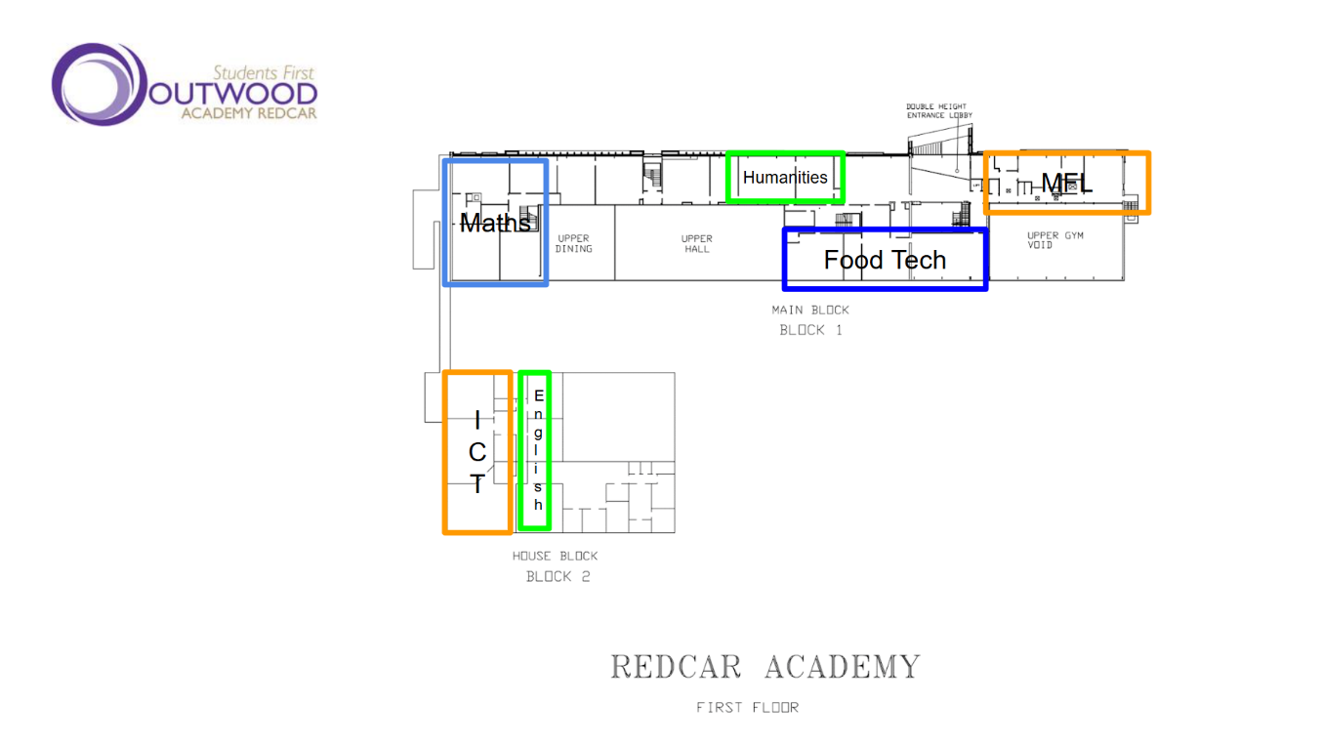
Finding my way around

Choose different colours and colour in:

Place in School | Colour on map
The door I will use to come in
Toilets
Dinner Hall
Main Office
Library
Sports Hall
Form room
Add anything else that is important to you…

Timetable
Here is an example of what my timetable will look like:
 | Monday | Tuesday | Wednesday | Thursday | Friday
8.30-9.00 | Tutor | Tutor | Tutor | Tutor | Tutor
9.00-10.00 | Period 1 | Period 1 | Period 1 | Period 1 | Period 1
10.00-11.00 | Period 2 | Period 2 | Period 2 | Period 2 | Period 2
11.00-11.25 | Break | Break | Break | Break | Break
11.25-12.25 | Period 3 | Period 3 | Period 3 | Period 3 | Period 3
12.25-12.55 | Period 4 | Period 4 | Period 4 | Period 4 | Period 4
12.55-13.25 | Lunch | Lunch | Lunch | Lunch | Lunch
13.25–13.55 | Period 4 | Period 4 | Period 4 | Period 4 | Period 4
13.55-14.55 | Period 5 | Period 5 | Period 5 | Period 5 | Period 5
14:55–15:45 | Enrichment | Enrichment | Enrichment | Enrichment | Enrichment

At Outwood Academy Redcar the school day is as follows:
8:30 am – 9:00am - Tutor
9:00 am – 10:00 am - Period 1
10:00 am - 11:00 am - Period 2
11:00 am – 11:25 pm - Break
11:25 pm - 12:25 pm - Period 3
12:25 pm - 13:55 pm - Period 4 / Lunch
13:55 pm - 14:55 pm – Period 5
Breaks
Y7, Break – 11:00am – 11:25am, Lunch - 12:55pm
Y8, Break - 11:00am – 11:25am, Lunch – 13:25pm
Y9, Break - 11:00am – 11:25am, Lunch – 12:25pm
Y10, 11:00am – 11:25am, Lunch - 13:25pm
Y11, 11:00am – 11:25am, Lunch - 12:25pm

Subjects

Art
Biology
Chemistry
Computer Science & iMedia
Design Technology
English
Geography
Health & Social Care (KS4)
History
Maths
Modern Foreign Languages (MFL)
Music
Performing Arts
Physical Education (PE)
Religious Studies
Sports Studies (KS4)

Enrichment Examples

Redcar offers some fantastic enrichment sessions, such as:
Girls Football Club
Boys Football Club
Fitness Club
Dodgeball Club
Table Tennis
LGBTQ+ Club
MFL Film Club
The World from a Lens
Music Club
Art Club
Science Club
Sparx Homework Club

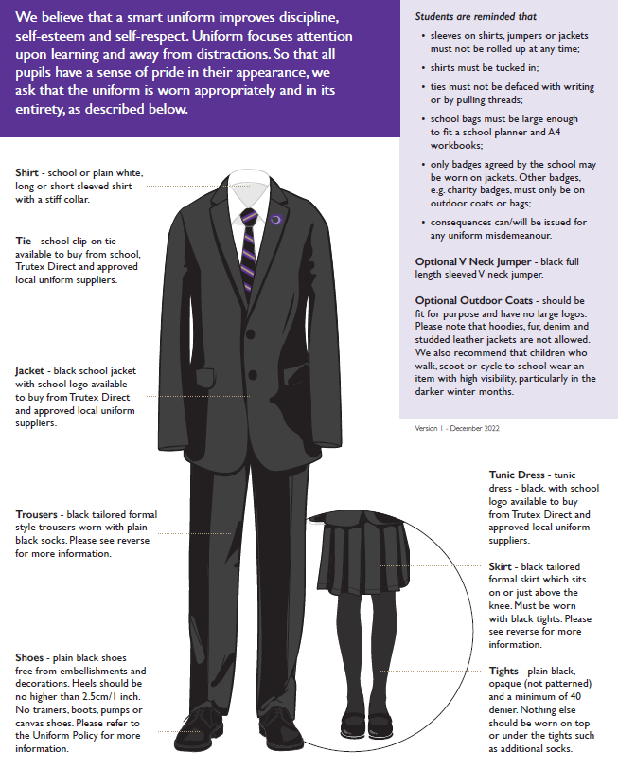
School Uniform
Key People
Here are the names and photos of key staff members that will be important to me at secondary school:
Name | Who are they? | Where can you find them?
Mrs McLaughlin | Learning Manager | KS3 Learning Manager Office, on duty and in your lessons praising your brilliant work
Ms Chapman | SLT Link | Duties and in your lessons, praising your brilliant work
Mrs Trattles | Principal | Duties and in your lessons, praising your brilliant work
Notes

