

Transition Pack

My name:

My new secondary school:


To get to know your new school you can go on your school website.
Website address – www.stpeters.npcat.org.uk

You can even watch a video tour of tour of the school:
www.stpeters.npcat.org.uk/transition/tour-of-the-school

What my new school looks like
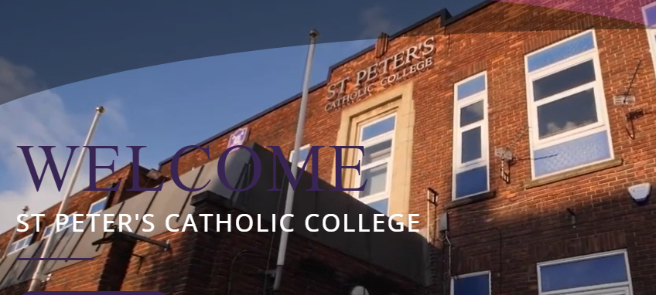
Here’s where I will come into school.
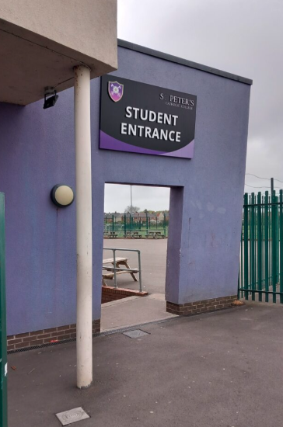

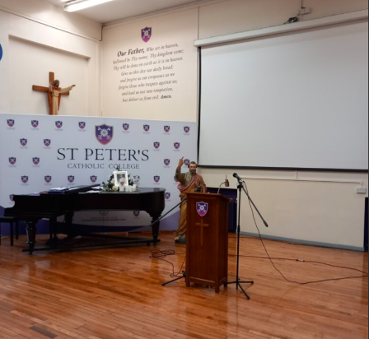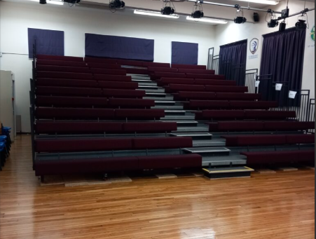
Where I will go for assembly.
Where I will go for lunch

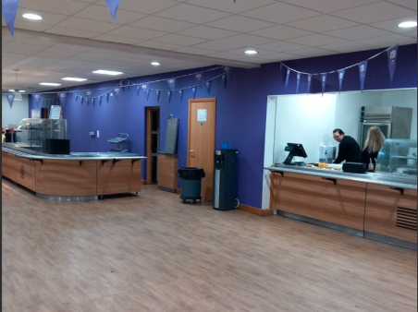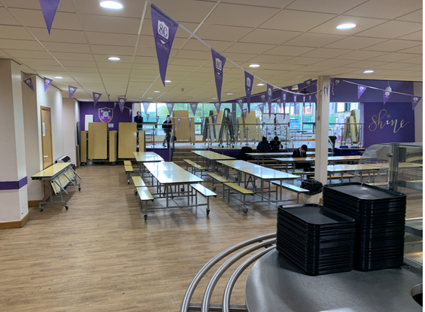
Where I will go at break

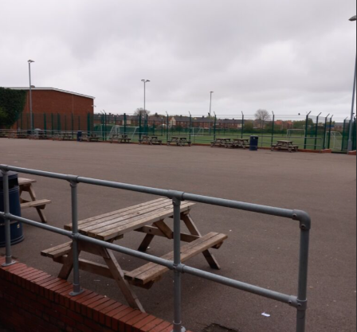

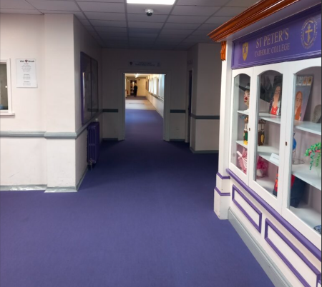
Main corridor

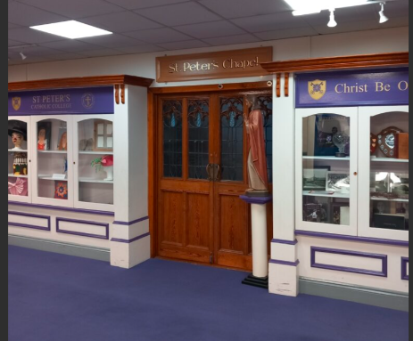
The Chapel

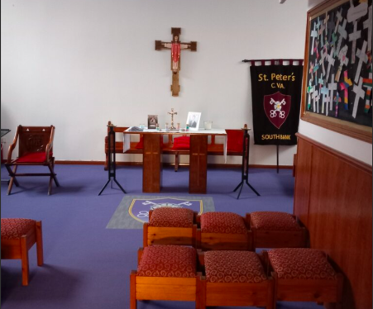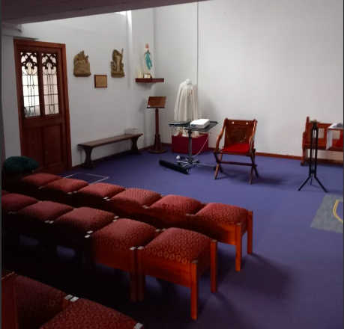
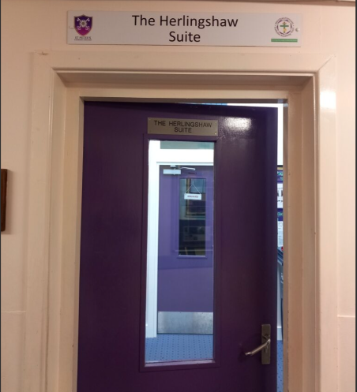
The Herlingshaw suite

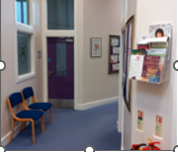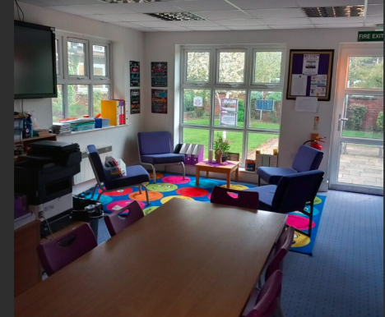

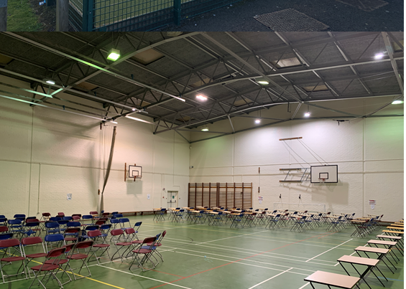
The Sports Hall

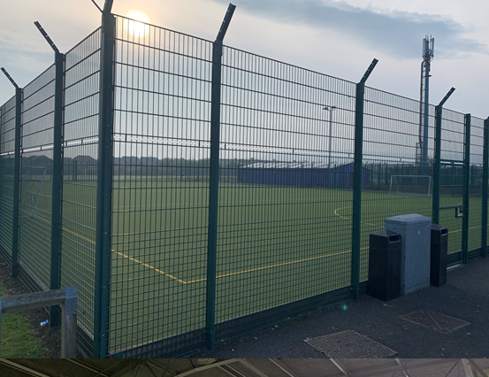
Outside sports area
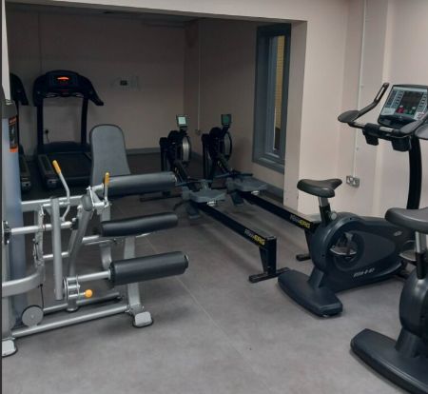
The gym

Classrooms
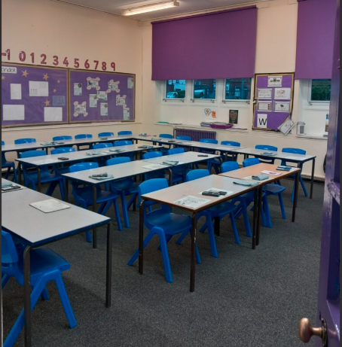
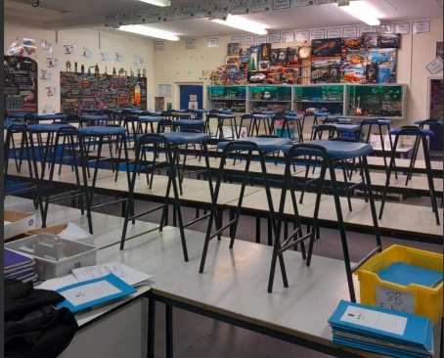
Science Classroom

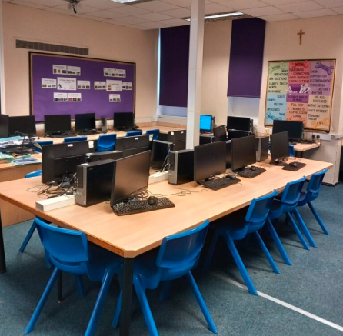
IT Classroom

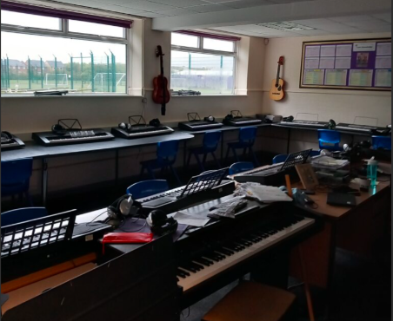
Music Classroom

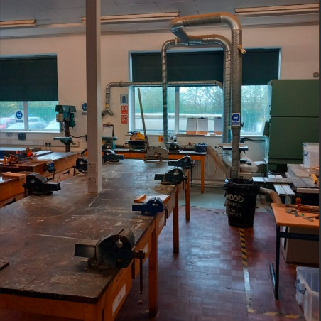
Technology Classroom
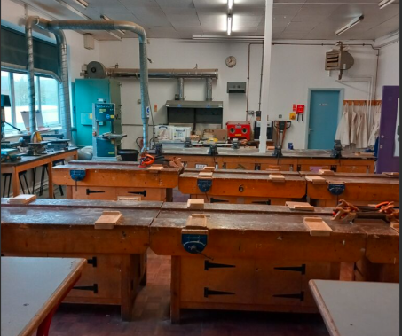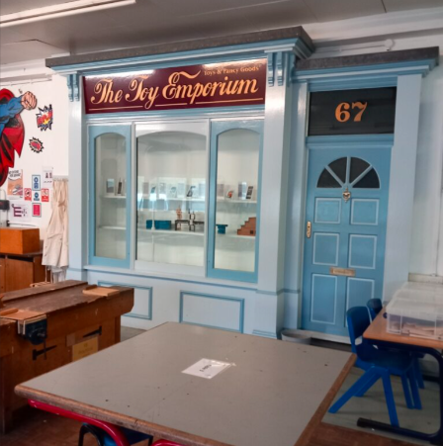

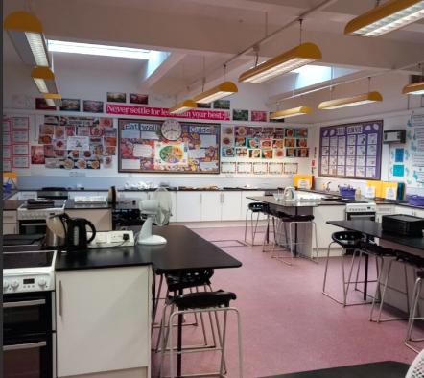
Food Technology
Classroom
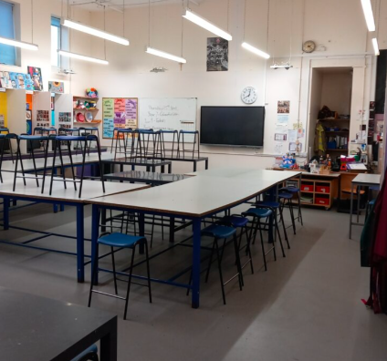
Art Classroom

Finding my way around
Its normal to be a little worried about getting lost. Lots of students might get a bit lost as they get to know their new school. It’s a new adventure! If you aren’t sure how to get somewhere, you can find a teacher or ask another student which way to go.

Here is a map of my new school:
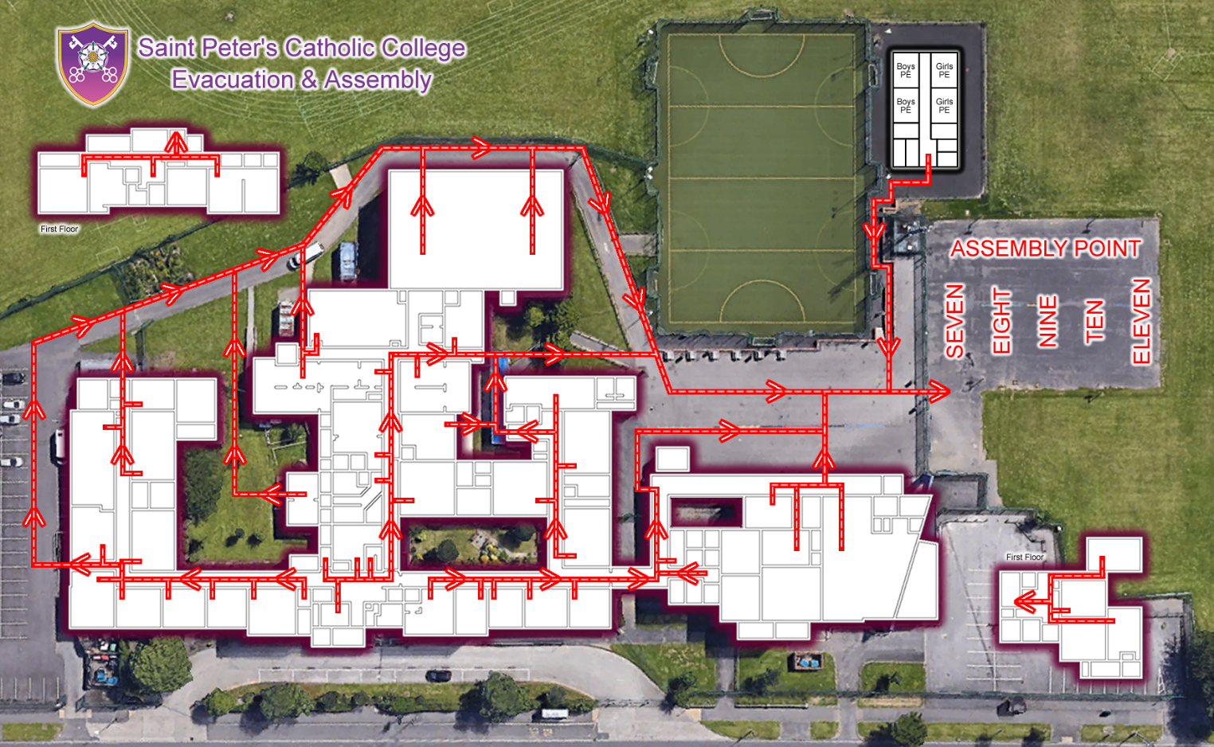

Finding my way around

Choose different colours and colour in:

Place in School | Colour on map
The door I will use to come in
Toilets
Dinner Hall
Main Office
Library
Sports Hall
Form room
Add anything else that is important to you……..

Timetable
My school day –
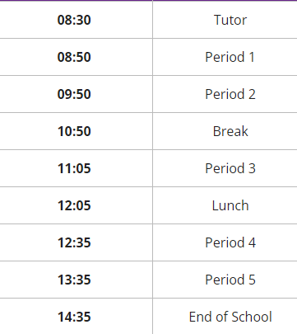

My timetable will show me what classes I have, when and where I need to be. Like this -
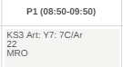
The class is 7C.
The lesson is Art.
The room number is 22

This is the teacher. Teachers names are shortened.
MRO is short for Mr Robertson.

My full timetable will look like this. There will be a week A and week B timetable.
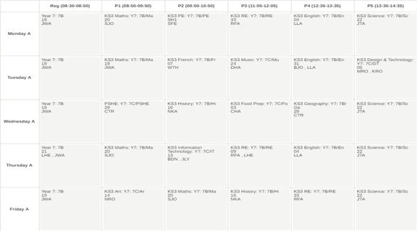
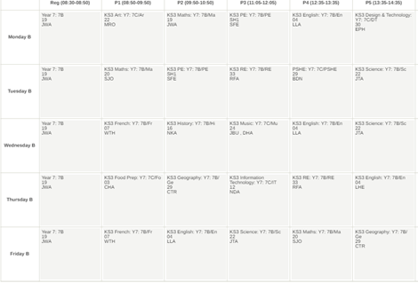

School Uniform
This is what I will wear for school:
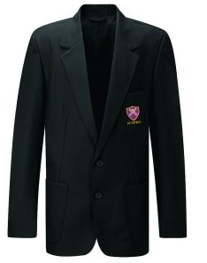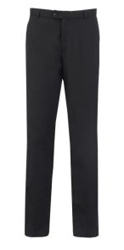

This is what I will for PE:
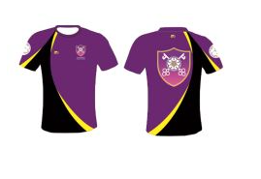

Key People
Here are the names and photos of key staff members that will be important to me at secondary school:
Name | Who are they? | Where can you find them?
Mrs Garthwaite   | Headteacher
 | Head of Year
 | SENDCo
  Mr Robertson | Year 7 SLT Link

Notes

